


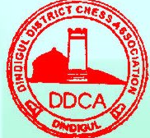

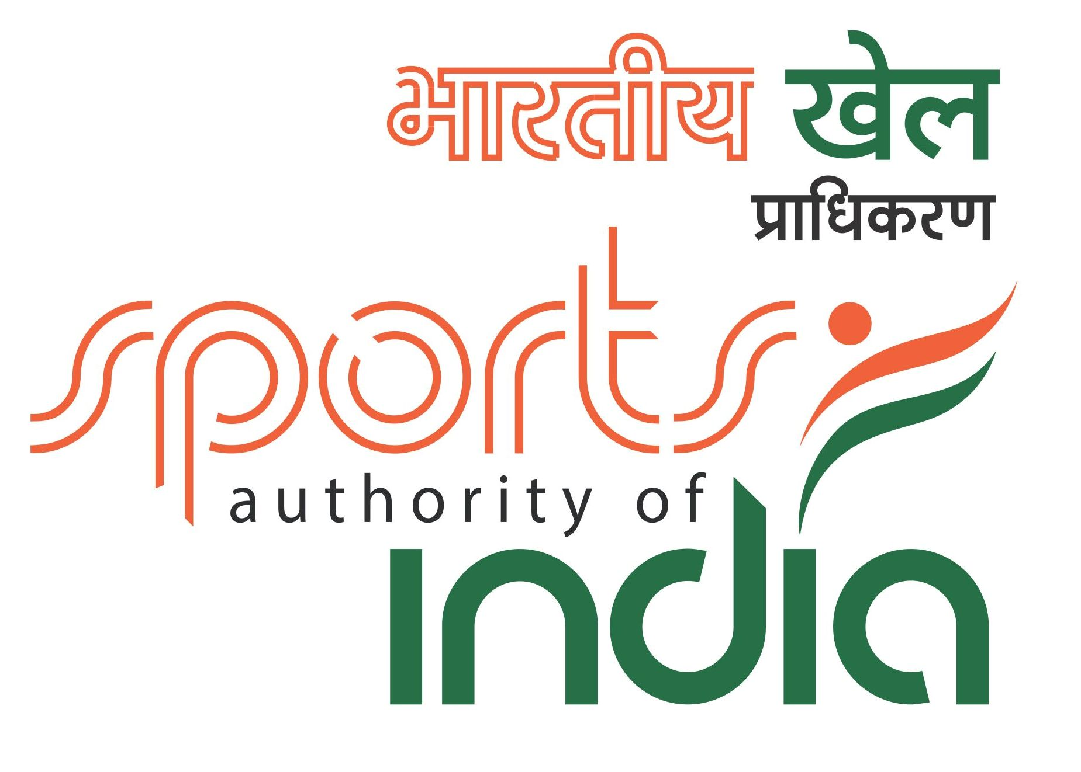

PSNA College of Engineering & Technology
45th National Junior (U-19) Chess Championship-2015
&
30th National Junior (U-19) Girls Chess Championship-2015

(AICF Event Code:113110/113111/TN/2015)
(TNSCA Approval No :N-01&02/2015-16 )
(DDCA Approval number-02/2015-16)
Organized by
PSNA College of Engineering & Technology
&
Golden Knights Chess Academy
In association with
Dindigul District Chess Association
Under the aegis of
Tamil Nadu State Chess Association
On behalf of
All India Chess Federation
From 23rd July 2015 to 31st July 2015
Venue - : PSNA College of Engineering & Technology, Kothandaraman Nagar,
Dindigul, Tamil Nadu
TOURNAMENT SCHEDULE
Date | Schedule | Time
23rd July 2015 | Arrival | 10.00 A.M.
23rd July 2015 | Inauguration | 11.00 A.M.
23rd July 2015 | Managers’ Meeting | 12.00 Noon
23rd July 2015 | 1st Round | 3.30 P.M.
24th July 2015 | 2nd Round | 9.30 A.M.
24th July 2015 | 3rd Round | 3.30 P.M.
25th July 2015 | 4th Round | 9.30 A.M.
26th July 2015 | 5th Round | 9.30 A.M.
26th July 2015 | 6th Round | 3.30 P.M.
27th July 2015 | 7th Round | 9.30 A.M.
28th July 2015 | 8th Round | 9.30 A.M.
29th July 2015 | 9th Round | 9.30 A.M.
30th July 2015 | 10th Round | 9.30 A.M.
31th July 2015 | 11th Round | 9.30 A.M.
31th July 2015 | Prize Distribution | 3.00 P.M.
31th July 2015 | Departure | 4.00 P.M.

Prizes:
Total Cash Prize Fund is Rs. 1,00,000/- for Open |  | Total Cash Prize Fund is Rs. 1,00,000/-  for Girls
1st Prize | Rs. 22,000/- | 1st Prize | Rs. 22,000/-
2nd Prize | Rs. 17,000/- | 2nd Prize | Rs. 17,000/-
3rd Prize | Rs. 14,000/- | 3rd Prize | Rs. 14000/-
4th Prize | Rs. 10,000/- | 4th Prize | Rs. 10,000/-
5th Prize | Rs. 7,500/- | 5th Prize | Rs. 7,500/-
6th Prize | Rs. 6,000/- | 6th Prize | Rs. 6,000/-
7th Prize | Rs. 5,000/- | 7th Prize | Rs. 5,000/-
8th, 9th & 10th Each | Rs. 2,700/- | 8th, 9th & 10th Each | Rs. 2,700/-
11th to 18th Each | Rs. 1,300/- | 11th to 18th Each | Rs. 1,300/-

Age: Participants should have been born on or after 01.01.1996

Age Proof: Each participant must produce a valid certificate to prove his/her age. Certificates from Schools are not enough. Certificates should preferably be from the Panchayat, Municipality or Corporation obtained soon after birth. Players without date of birth certificates will not be allowed to participate.

** The date of birth certificates registered within one year of the birth of the child alone will be recognized and allowed to participate. No state Association shall recommend any player who doesn’t come under the above criteria. Any player who is aggrieved by this stipulation can appeal to AICF with proper documentary proof and the AICF’s decision in this regard will be FINAL and BINDING.

If any doubt arises about the claimed age of a player, the Tournament Committee has the right to refer the player during the championship for a due evaluation of age by competent medical experts. A player, if declared over-age by such experts, shall not continue in the championship and shall be reported to AICF. Protest about the age of players may be made to the Chief Arbiter in writing along with a fee of Rs. 1000/- per player. This will not be refunded. No protest about over age of a player will be entertained after 2nd round of the championship.

Only the Coach or Manager deputed by participating State Chess Association can lodge such protests. The Tournament Committee has the right to decide the day, time and place for such medical evaluation of age. AICF/organizers will have the right to refer any player to the medical evaluation of age at any time during the tournament. Players refusing to take the test as decided by the Tournament Committee shall be deemed to have failed the test and shall be disqualified from the Championship.

Eligibility: Every affiliated State Association of AICF may nominate/recommend the players in following manner subject to age limit.

(1) In each category (Open & Girls), every affiliated State Association/Institution of AICF can nominate four players. If any association/Institution fails to send its quota, the vacancies so caused will not be filled.
(2) Top four players each from 44th National Under-19 Chess Championship 2014 and 29th National Under–19 Girls Chess Championship 2014, as seeded players there in respective categories subject to age limit.

Rank | Open | Girls
1 | IM Sunilduth Lyna Narayanan | -------------
2 | Harsha Bharathakoti | Michelle Catherina P
3 | IM G Akash | WFM Monnisha GK
4 | IM Aravindh Chithambaram Vr | Nandhidhaa PV

(3) Top two players each (as below) from 2014 National Under-17 (Open & Girls) Chess Championships, as seeded players in respective categories.
Rank | Open | Girls
1 | Aradhya Garg | WFM Varshini V
2 | Pranavananda V | WFM Mahalakshmi M

(4) The winners of 2014 National Under-15 Chess Championships, as seeded players in respective categories.
Rank | Open | Girls
1 | IM Aravindh Chithambaram Vr | WFM Vaishali R

(5) In addition to the above, the following States can field additional seats as normal entry, as their players had won Gold, Silver and Bronze medals in the previous National Under-19 Chess Championships and these nominations from the State Associations shall be given only from the Rank list of their respective State championships with proof and not to anybody else.

Rank | Open | Girls
1 (Gold) | Kerala - 3 | Tamil Nadu - 3
2 (Silver) | Telangana - 2 | Tamil Nadu - 2
3 (Bronze) | Tamil Nadu - 1 | Tamil Nadu - 1
(6) The AICF Secretary has a discretionary seat in each category.
(7) Any player who remits the prescribed special entry fee of Rs. 4,000/- duly recommended by concerned affiliated State Association of AICF.
(8) Any current 2014 World Champion from India in any category subject to age Limit.
(9) Any Indian among Top 3 in the World Junior Championships 2014, subject to age limit.
(10) Any Indian among Top 3 in Asian Junior Championships, subject to age limit.
(11) 2014 Asian Under 18 Champion.
(12) 2014 World under 18 No. 2 and 3.
(13) Four players approved by the AICF will be selected from areas where no State Chess Association exists.

(14) The Champion in the 2014 National Under-17 Girls’ Championship and the Winner & the Runner-up of the 2014 National Under-19 Girls Championship are eligible to play as seeded players in the ‘Open’ section subject to age limit
(15) The host association is entitled to field two additional players in each category.
(16) The host association is entitled to field one additional player in case of odd number of entries in each category.
(17) All GMs/IMs are seeded in Open section and WGMs/WIMs are seeded in girls section subject to age limit.
(18) 2014 National Premier Champion and 2013 Under 25 champion are seeded, subject to age limit.
(19) Only Indian Nationals are eligible to participate in this championship.
Entry Fee: Ordinary entry fee: Rs. 1,300/- Special Entry: Rs. 4,000/-

There is 50% concession in the entry fee for participants from North Eastern States, Andaman & Nicobar Islands.

All entries including special entries should come through the concerned affiliated State Association of AICF. However, the AICF will have the right to accept or reject any special entry without assigning any reason thereof.
The entry form along with entry fee by Demand Draft in favor of “Dindigul District Chess Association” payable at ‘Dindigul’ has to be sent to : Mr. S.S.Manigandan, S/O S.Sangaiah, 276, N.S.K Street, Bethaniyapuram, Madurai-625016, Tamil Nadu. Mob: 09944564728

Late Fee: The last date of receipt of entry is 18.07.2015. Entries received after the last date will attract a late fee of Rs. 250/-. However, no entry will be entertained after 22.07.2015.
Lodging: Free dormitory accommodation will be provided to seeded/ selected players (normal entries) and one accompanying official (Manager) nominated by the concerned State Chess Association for each state. Special entries and other accompanying persons should make their own arrangement for their stay.
Boarding: A lump sum Rs.1000/= (Rupees one thousand only) will be paid by the AICF through the organizers towards the boarding expenses only to the affiliated State chess association’s seeded and selected players who play this championship under normal entry fee.
Dress Code: Please be informed that as per rules and regulations of the college, players and accompanying persons are not allowed to move in the college premises/playing hall with shorts or short pants. They have to wear full pants only.
Tournament Committee: AICF or its representative, two members from different participating associations, Secretary and two members of the Tamil Nadu State Chess Association, constitute the Tournament Committee.
System of Play: The championship will be 11 round Swiss system played as per FIDE laws of chess. Rate of Play shall be 90 minutes each with an increment of 30 seconds per move from
move number one. In the absence of digital clocks the time control shall be 2 hours each straight finish.

Zero Tolerance: The “zero tolerance” rules will be followed (i.e.): “Any player who arrives at the chessboard after the start of the session shall lose the game. Thus the default time is zero minutes.
Chess Clock: Each participating State Association must provide at least two chess clocks in working order for every 4 players entered into the championship.
Tie-break: Buchholz tie break system will be applied.

Protest: Protest, if any, against the decision of the Chief Arbiter shall be made in writing with a Protest fee of Rs. 500/- within 30 minutes of the occurrence of the incident/completion of the game. The protest fee will be refunded, if the appeal is upheld.
Appeals Committee: Before the commencement of the tournament, a five member Appeals Committee shall be formed by the AICF / organizers. All the members and Reserves shall be from the different States. No member of the Committee can vote on dispute in which a player from his own state is involved and in such case the reserves shall take his place in the committee.

Disqualification: No participant will leave the venue before the Prize Distribution function without the permission of the Chief Arbiter. The participants disregarding the rule will be suspended for one year.

Interpretation: On any point not covered under these rules, the decision of the Tournament Committee shall be final and binding on all matters. The Tournament Committee has every right to make any addition or amendment to these rules, without prior notice. However, such changes will be approved by the AICF. Such changes will, however be displayed in the tournament hall.
Arrears: All arrears of affiliation fee/tournament fee including those of current year must be cleared by the Affiliated Association at the time of submitting the entries; otherwise the entries are liable to be rejected.
AICF/TNSCA/DDCA/ the organizers Golden Knights Chess Academy reserve the right to admit or reject any entry without assigning reason thereof.
AICF/TNSCA/DDCA/ the organizers Golden Knights Chess Academy reserve the rights of admission to the Tournament Hall and lodging places.

AICF Registration: All participants in the National Championship should be registered with AICF for the year 2015-16. Application forms are available in the website www.aicf.in. Those who have already obtained registration cards from AICF website for 2015-16 should send photo copy of the same. Those who have paid the AICF Registration fee but are yet to receive the AICF Registration card should send a photo copy of the acknowledgement for having paid the fee to organizers of earlier tournaments or to their association. Those who have not registered with
AICF for the year 2015-16 should send an amount of Rs. 250/- towards AICF registration fee along with duly filled and signed AICF player’s registration form plus one passport size photo.

TNSCA Registration: TNSCA registration is compulsory. TNSCA Registration fee is Rs. 100/- for the year 2015-2016. Players registering with TNSCA should submit duly filled and signed TNSCA Players Registration form along with a copy of their Date of Birth certificate and one passport size photograph. The date of birth certificates registered within one year of birth of the player alone will be recognized and allowed to participate.
E-Mail id: All unrated players without fide id and playing in a rating tournament for the first time, must compulsorily furnish their e-mail id during registration. Otherwise, their entry will be rejected.
ORGANISING COMMITTEE
Chairman : Rtn. MPHF. R.S.K. Raguraam, Chairman, PSNA CET
Convener : Mr. S. Abdul Nazer, Secretary, Dindigul District Chess Association
Organizing Secretary : Mr. S. Ganesh Babu IA, Secretary, Golden Knights Chess Academy
Advisory Committee
Mr. R.S.K. Raguraam : Chairman, PSNA CET
Mr. P. Chinnakalai : Registrar, PSNA CET
Mr. V. Hariharan : Secretary, All India Chess Federation
Mr. R. Anantharam : Chairman, Arbiters’ Commission, AICF
Mr. G. Sundararajan : President, Dindigul District Chess Association
Mr. S. Abdul Nazer : Secretary, Dindigul District Chess Association
Mr. J. Vijay : Physical Director, PSNA CET
Mr. G. Sabapathy : President, GKCA
Mr. K. Palanisamy : Vice President, GKCA
Mr. S. Sangaiah : Vice President, GKCA
Mr. Jeyaraman : Vice President, GKCA
Mr. Ramanathan : Vice President, GKCA
Contact Persons
- S. Ganesh Babu (Secretary, GKCA) : 099445 64728
Email: goldenknightschessacademy@gmail.com & ganeshbabu.chess@gmail.com
- R. Anantharam, International Arbiter (Tournament Coordinator) : 094431 55852
Email: vranantharam@gmail.com
Reaching the venue:
PSNA College is situated in the Dindigul - Palani Main road.
Distance from DIndigul Bus stand- 11.6 km, Distance from Railway Station – 12.8 km.
Hotels (Near Bus Stand)
- Hotel Mangai – 9842117111 2. Hotel Paarvathy’s – 0451-2420117,2420118
3. Hotel Priyam – 0451-2421921 4. Hotel Sky Park – 0451-2434565,2441340
5. Hotel Maha Jyothi- 0451-2434313 6. Parsons Court- 0451-6451111
7. Hotel Sree Baalaaji Bhavan – 0451-2434464, 2427454, 8220724444

ENTRY FORM
To,
The Organising Secretary,
National Junior Chess Championships -2015

Dear Sir,

Sub: Entry for 45th National Junior (U-19) Open and 30th National Junior (U-19) Girls Chess Championships - 2015.
Kindly enroll the entry of our players for the National Under-19 Open and Girls Chess Championships - 2015.
Particulars of the Entry fee paid/being paid by Demand Draft in favor of “Dindigul District Chess Association“ payable at Dindigul.
Amount: Rs. D.D. No. Date, Bank & Branch:
__________ __________ _________ ______________________________________
We understand that the Championship is held for only AICF Registered Players. All team members, whose particulars are given below, will abide by the Rules & Regulations of AICF.

No. | Name of Player | FIDE ID | Rating | Date of Birth | Ordinary/Special  Amount (Rs.)
Open ( Boys)
1
2
3
4
Girls
1
2
3
4
 | Manager
1
(Copy of age proof should be enclosed)

________________
Signature
____________________________
Name of Secretary with Seal

____________________________
Name of State unit:
(Affiliated to All India Chess Federation)
Place : Date :

