
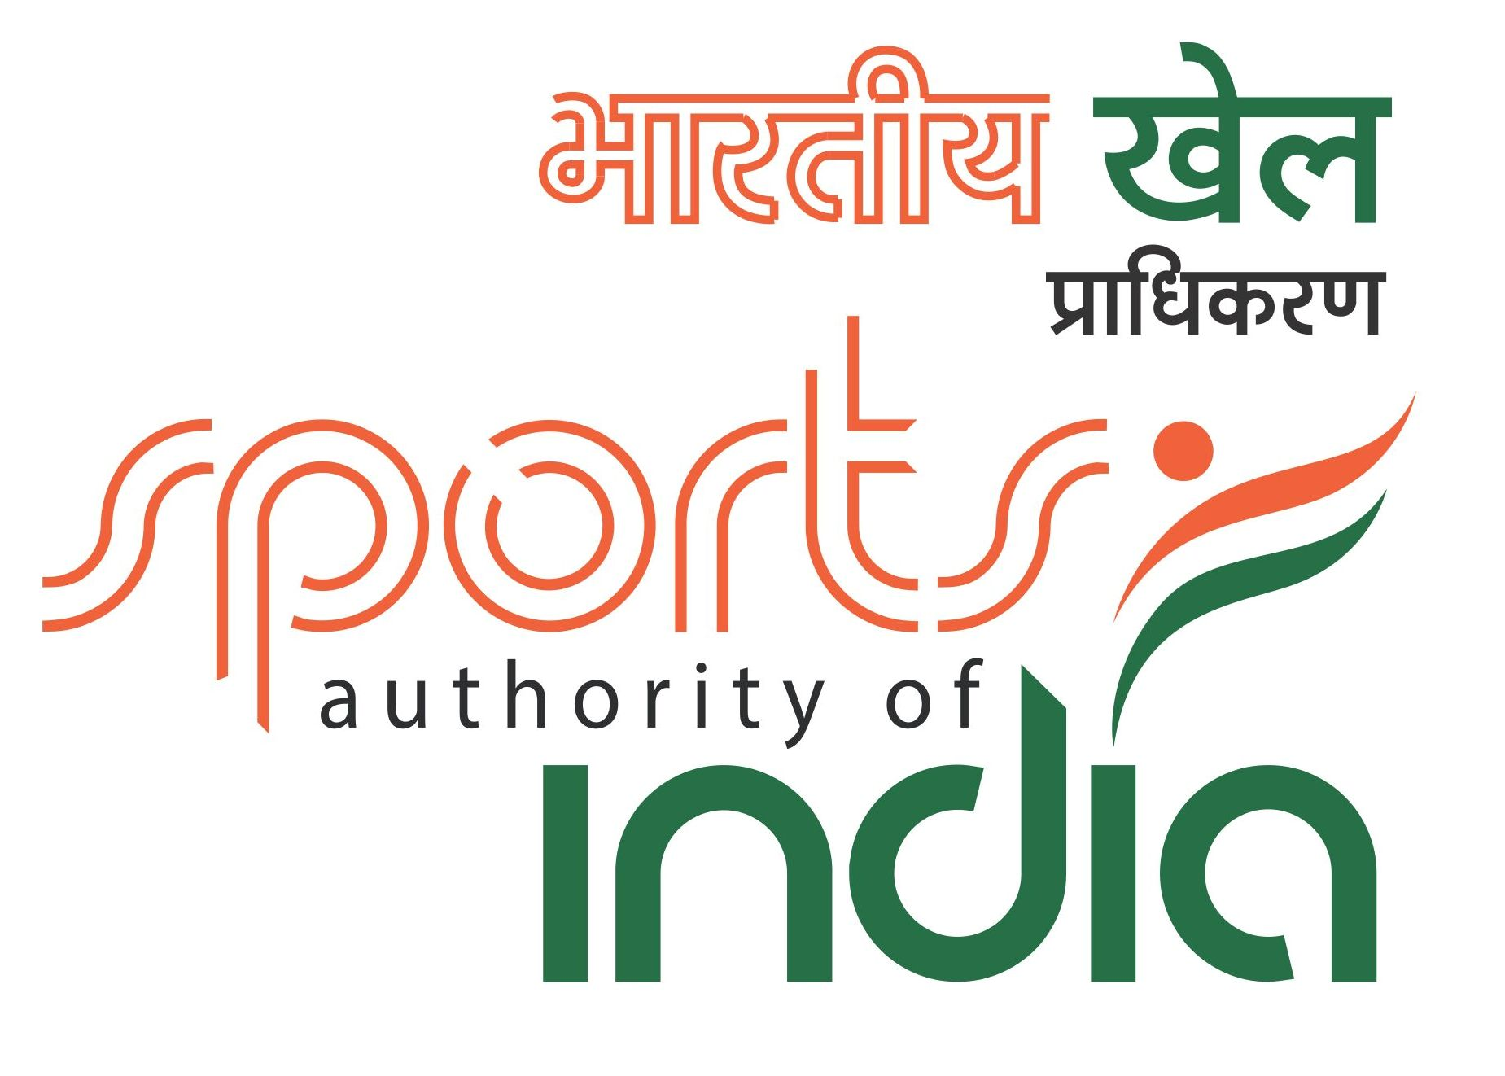

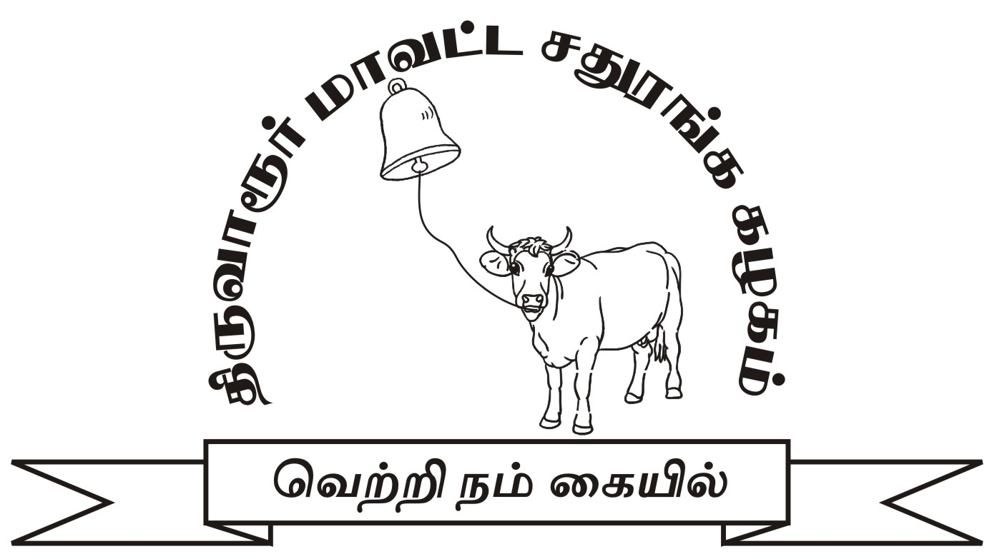

53rd National Premier Chess Championship –2015
(AICF Event Code No. 113986/ TN / 2015 & (TNSCA Approval No. N03/15-16)
14.11.2015 – 28.11.2015
Organised by
Tiruvarur District Chess Association
Under the aegis of
Tamil Nadu State Chess Association
On Behalf of
All India Chess Federation
Venue: Kasi’s Inn, 91,25A’ Thilagar 2nd Street, Velankanni Bye Pass Road, Tiruvarur 610 001, Tamilnadu. (Ph: 04366-251020,21,22)
Total Prize Fund: Rs.10,00,000 (Rs. ten lakhs)
1st Prize | 2,50,000 |  | 8th Prize | 50,000
2nd Prize | 1,40,000 |  | 9th Prize | 45,000
3rd Prize | 1,00,000 |  | 10th Prize | 40,000
4th Prize | 80,000 |  | 11th Prize | 35,000
5th Prize | 70,000 |  | 12th Prize | 30,000
6th Prize | 60,000 |  | 13th Prize | 25,000
7th Prize | 55,000 |  | 14th Prize | 20,000

In case of tie, prize money will not be shared

Tournament Schedule

14.11.2015 | 6.00 AM | Arrival
14.11.2015 | 6.00 PM | Inauguration
14.11.2015 | 8.00 PM | Players' Meeting
15.11.2015 | 10.00 AM | 1st Round
16.11.2015 | 10.00 AM | 2nd Round
17.11.2015 | 10.00 AM | 3rd Round
18.11.2015 | 10.00 AM | 4th Round
19.11.2015 | 10.00 AM | 5th Round
20.11.2015 | 10.00 AM | 6th Round
21.11.2015 | Rest Day
22.11.2015 | 10.00 AM | 7th Round
23.11.2015 | 10.00 AM | 8th Round
24.11.2015 | 10.00 AM | 9th Round
25.11.2015 | 10.00 AM | 10th Round
26.11.2015 | 10.00 AM | 11th Round
27.11.2015 | 10.00 AM | 12th Round
28.11.2015 | 10.00 AM | 13th Round
28.11.2015 | 05.00 PM | Closing Ceremony

Entry Fee:
Entry fee of Rs. 1,500/- should be sent by DD favouring Tiruvarur District Chess Association, payable at Tiruvarur to Mr. R.K.Balagunashekaran, Secretary, Tiruvarur District Chess Association, 2/373 N, Kambar Street, Silambu Nagar, Thandalai, Tiruvarur 610 004, with a copy to AICF.
Last date of entry: 31st October,2015
Registration of Players: All the participants who participate in the National Championship should get their names registered with AICF. Registration forms will be available at the venue on payment of Rs. 250 for the year 2015 - 16. Those who are already registered should produce proof. No unregistered player will be entitled to participate in the Championship.
Players from Tamil Nadu need TNSCA Players’ registration for the year 2015-16 with payment of Rs.100/-. Already registered players should produce proof.
Tournament Regulations: The Championship shall be played under the laws of FIDE Laws of Chess and under all play all Round robin system. The Time control is 90 minutes each for the first 40 moves and 30 minutes each for the remaining game, with an addition of 30 sec per move from move number one. Clocks will be set in such a way that 30 minutes of second time control will be added only after one of the players overstep the first time control.
Eligibility:
Current National champion (S.P. Sethuraman) 1
Top four Elo rated players of India (July,2015-list) 4
Immediate past National Challenger,2015 (Nagpur) 9
Note: If national champion is among the top four Elo rated players, then top 10 players from National Challenger will qualify. Further, if any of the top four Elo rated players do not participate, the seat will be filled from the National Challengers, as per the ranking.
Tie-Break: Direct encounter, Sonneborn Berger (sum of scores of opponents, whom a player has defeated plus sum of half the scores of the opponents, whom the player has drawn), number of victories, number of victories with Black pieces. In case of tie, cash prizes will not be shared.
Zero Tolerance: The zero tolerance rule will be followed (i.e) “Any player who arrives at the chess board after the start of the session shall lose the game. Thus the default time is zero minute.”
Board and Lodging: As per AICF Rules, the players representing the Institution members will have to take care of their own board & lodge. And the players representing State Associations will be provided by the organisers with Rs.10,000/- towards board & lodge. However, the organising committee has decided to provide free Board & Lodge to all the players. Hence the players representing the State Associations will not be paid Rs.10,000/-.
Tournament Committee: The tournament committee, comprising the Chief Arbiter, Secretary of the AICF or his Representative and the Secretary and two members of the host Association shall be constituted before the commencement of the tournament.
Protests: Protests if any, against the decision of the Chief Arbiter, shall be made in writing with protest fee of Rs.500/- within 30 minutes of the occurrence of the incident. The amount shall be refunded if the appeal is upheld.
Appeals Committee: Before the commencement of the tournament, a five members appeal committee shall be formed by AICF/Organizers. All members and the reserves shall be from the different states/affiliated Units. No member of the committee can vote on dispute in which a player from his own state/affiliated Unit is involved and in such cases the reserve(s) shall take his/their place in the committee.
Disqualification: No participant will leave the venue before the prize distribution ceremony, without the permission of the Chief Arbiter. The participants disregarding this rule will be suspended for one year.
Interpretation: For interpretation of rules and deciding any point not covered by rules, the decision of the tournament committee shall be final and binding. The tournament committee has every right to make any addition or amendment to these rules without prior notice. However, such changes, after approval by AICF, will be displayed at the championship venue.
Qualified players are requested to send their contact details, bio-data and photographs to the organizing secretary by e-mail at the earliest.
For Further Details Please Contact:
Mr. R.K.Balagunashekaran. Secretary, Tiruvarur District Chess Association,
2/373 N, Kambar Street, Silambu Nagar, Thandalai, Thiruvarur 610 004,
Cell No: 9442115117 E-mail: orkeyb@gmail.com

