
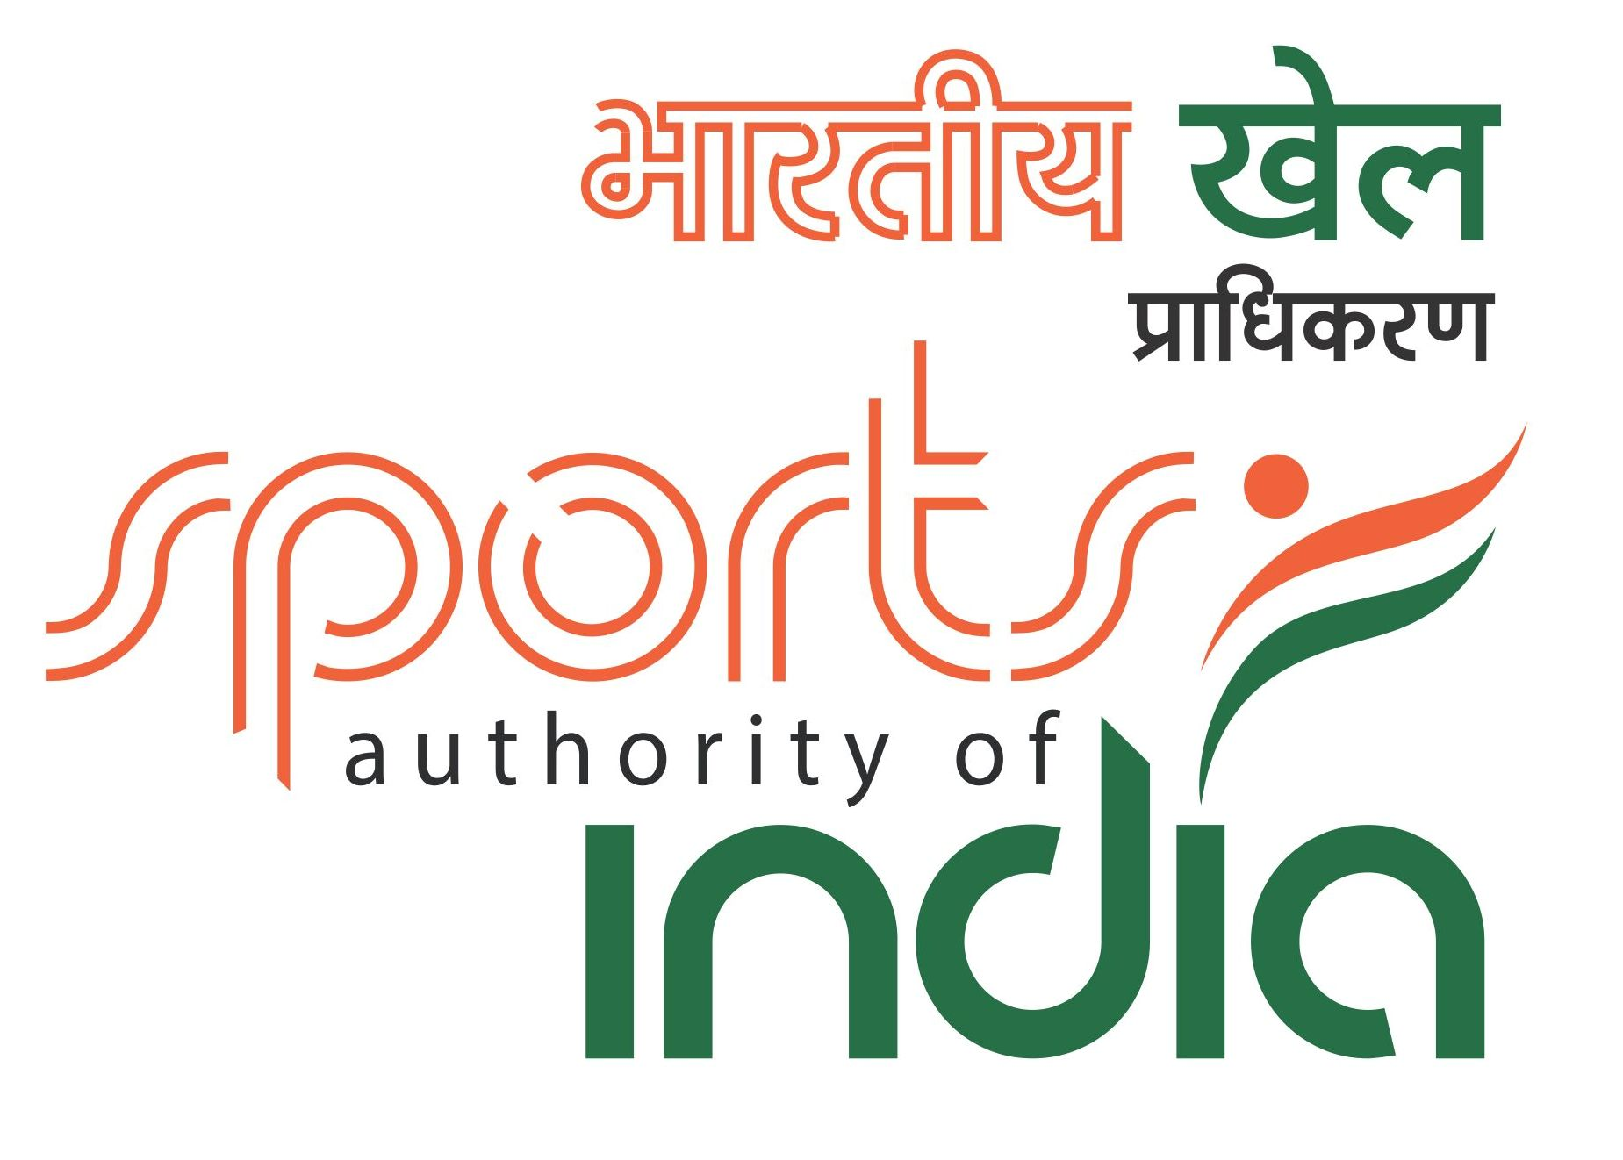

BEL OFFICERS CLUB 26th NATIONAL UNDER-17 OPEN & GIRLS
CHESS CHAMPIONSHIPS 2015
Organized by
UNITED KARNATAKA CHESS ASSOCIATION (Regd.)
www.karnatakachess.com
On behalf of
ALL INDIA CHESS FEDERATION
www.aicf.in
AICF Event Code : 119429 / 119430 / KAR / 2015
Venue : BEL Officers Club, Jalahalli post, Bengaluru-13
Date : 03.10.2015 to 11.10.2015
SCHEDULE
Arrival | : | 3rd Oct 2015
Managers’ Meetings | SATURDAY | 3rd Oct 2015 | 1000hrs
Inauguration | SATURDAY | 3rd Oct 2015 | 1100 hrs
Round 1 | SATURDAY | 3rd Oct 2015 | 1400 hrs
Round 2 | SUNDAY | 4th Oct 2015 | 0930 hrs
Round 3 | SUNDAY | 4th Oct 2015 | 1530 hrs
Round 4 | MONDAY | 5th Oct 2015 | 0930 hrs
Round 5 | TUESDAY | 6th Oct 2015 | 0930 hrs
Round 6 | TUESDAY | 6th Oct 2015 | 1530 hrs
Round 7 | WEDNESDAY | 7th Oct 2015 | 0930 hrs
Round 8 | THURSDAY | 8th Oct 2015 | 0930 hrs
Round 9 | FRIDAY | 9th Oct 2015 | 0930 hrs
Round 10 | SATURDAY | 10th Oct 2015 | 0930 hrs
Round 11 | SUNDAY | 11th Oct 2015 | 0930 hrs
Prize Distribution Ceremony | SUNDAY | 11th Oct 2015 | 1500 hrs

Age Limit: Players should be born on or after 1.1.1998
Age Proof: Each participant must produce a valid certificate to prove his/her age.
Certificates from School are not valid. Certificates should preferably be from the Panchayat, Municipality or Corporation obtained soon after birth. Players without date of birth certificates will not be allowed to participate.

** The date of birth certificates registered within one year of the birth of the child alone will be recognized and allowed to participate. No state association shall recommend any player who doesn’t come under the above criteria. Any player who is aggrieved by this stipulation can appeal to AICF with proper documentary proof and the AICF’s decision in this regard will be FINAL and BINDING.
If any doubt arises about the claimed age of a player, the Tournament Committee has the right to refer the player during the championship for a due evaluation of age by competent medical experts. A player if declared over-age by such experts, shall not continue in the championship and the matter shall be reported to AICF. Protest about the age of players may be made to the Chief Arbiter in writing along with a fee of Rs. 1000/- per player. This will not be refunded.
No Protest about over age of a player will be entertained after 2nd round of the championship.
Only the Coach or Manager deputed by participating State Chess Association can lodge such protests. The Tournament Committee has the right to decide the day, time and place for such medical evaluation of age. AICF / organizers will have the right to refer any player to the medical evaluation of age at any time during the tournament. Players refusing to take the test as decided by the Tournament Committee shall be deemed to have failed the test and shall be disqualified from the Championship.

Zero Minute Rule: The “zero tolerance” rules will be followed (i.e.); “Any player who arrives at the chessboard after the start of the session shall lose the game. Thus the default time is zero minutes”.

Eligibility: Subject to age limit the following players can participate:
- Two players in each category from every affiliated State Association of AICF. If any Association fails to send its quota, the vacancies so caused will not be filled.
- Top four players from 2014 National under 17 (Boys & Girls) Chess Championships are eligible to participate as seeded players in their respective categories.
- The top two players from 2014 National U-15 Boys and Girls Championship are eligible to participate as seeded players in their respective categories.
- The Champions from 2014 National under 13 (Open & Girls) chess championship are eligible to participate as seeded player in their respective category.
- Current World Champion in any category subject to age stipulation.
- 2014 World No.2 & 3 under 16 and under 18 category.
- 2014 Asian U-18 top three rankers subject to age stipulation.
- 2014 Asian Under-16 Champion.
- The AICF Secretary has a discretionary seat in each category in this Championship.
- Any other player who remits the prescribed Special Entry Fee of Rs. 4,000/-
- Host The United Karnataka Chess Association is entitled to fill one additional player in each category.
- Current National Champion in any higher category subject to age stipulation.
- Two players in each category approved by AICF will be permitted from areas where no State Association exists.
- The winner and runner up of 2014 National U-17 girls’ Championship are eligible to play in open section subject to age stipulation.
- The winner of 2014 National Under-15 girls’ Championship is eligible to play in open section.
- If the number of participants at the start of the championship is an odd number in a category, the host association can add one entry to make it even.
- In addition to the above, the following state can fill additional seats, as their players had won Gold, Silver and Bronze medals in the previous National Under- 17 Chess Championship.
Open: Delhi - 3, Andhra Pradesh – 2 and Tamil Nadu – 1
Girls: Tamil Nadu - 6

- Only Indian Nationals are eligible to participate in the championships
Entry Fee: Ordinary Entry Rs. 1,000/- Special Entry Rs. 4,000/-.
There is a 50% concession in the entry fee for participants from North Eastern States and Andaman & Nicobar Islands.

All entries including Special entries should come through the concerned State Association. However, the AICF will have the right to accept or reject any entry without assigning any reason. The entry form should be sent together with the attested copy of original date of birth certificate (Birth Certificates from Panchayat /Municipality/Corporation only) and the entry fee by a crossed Demand Draft drawn in favour of United Karnataka Chess Association payable at Bengaluru.

Entries and Enquiries should be sent to:-
The Organising Secretary
United Karnataka Chess Association,
C/o Hotel Aruna Anandh Deluxe Lodge
No.7, 1st Cross, Annamma Temple Extension
Northern side of Sangam Complex & Eastern side of Majestic Bus station,
Bangalore-560009
Ph: no.+91 9611832665, +918105940013 email id: ukcachess@gmail.com

Late Fee: Entries received after 25th Sep 2015 will be subject to a late fee of Rs. 250/- per player. However no entry will be entertained after 3 p.m. on 30th Sep 2015.

Cash Prizes: The Cash Prizes will be awarded to 20 players in each category amounting to Rs. 2,00,000/- in all as under.
Prize |  |  | Boys |  | Girls
1 |  |  | 20,000 |  | 20,000
2 |  |  | 15,000 |  | 15,000
3 |  |  | 12,000 |  | 12,000
4 |  |  | 10,000 |  | 10,000
5 |  |  | 8,000 |  | 8,000
6 |  |  | 6,000 |  | 6,000
7 |  |  | 5,000 |  | 5,000
8th |  |  | 4,000 |  | 4,000

9th 3,000 3,000
10th 2,000 2,000
11th to 20th 1,500 each 1,500 each

System of Play: The Championship will be played under FIDE’s Laws of Chess and the Swiss system. Totally eleven rounds shall be played.

Session: The rate of play shall be 90 minutes with an increment of 30 seconds per move from move number one
.
Chess Clocks: Each participating State Chess Association must provide at least one clock in working order for every two players entered into the Championship.

Tie Break: Buchholz tie-break system will be applied. 1) Buchholz Cut 1, 2) Buchholz Cut 2, 3) Sonneborn Berger, 4) Buchholz Median, In case of tie, cash prizes will not be shared.

Tournament Committee: A representative of the AICF, two members from different participating Associations and two members of the host Association will serve as the Tournament Committee.

Protest : Protest, if any, against the decision of the Chief Arbiter shall be made in writing with a protest fee of Rs.500/-within 30 minutes of the occurrence of the incident. The protest fee will be refunded if the appeal is upheld.

Appeals Committee: Before the commencement of the tournament, a five member appeals committee shall be formed by the AICF/organizers. All the members and reserves shall be from different states. No member of the Committee can vote on a dispute in which a player from his own States is involved and in such case(s) the reserve member(s) shall take his place in the committee.

Disqualification: No participant will leave the venue before the Prize Distribution function without the permission of the Chief Arbiter. The participants disregarding this rule will be suspended for one year.

Interpretation: For interpretation of the rule(s) and deciding any point not covered by the above rules of the tournament, the decision of the Tournament Committee shall be final and binding on all. The Tournament Committee has every right to make any addition or amendment to these rules, without prior notice. However, such changes should be approved by the AICF. Such changes will, however, be displayed in the tournament hall.

Registration of Players: All participants in the National Championship should be registered with AICF for the year 2015-2016. Application forms are available at the website aicf.in . Those who have already obtained registration cards from AICF Website for 2015-16 should send photo copy of the same. Those who have paid the AICF Registration fee but are yet to receive the AICF Registration card should send a photo copy acknowledgement for having paid the fee to organizers of earlier tournaments or to their association. Those who have not registered with AICF for the year 2015-2016 should send an amount of Rs.250/- towards AICF registration fee along with the duly filled and signed AICF player’s registration form plus one passport size photo.

Arrears: All arrears of affiliation fee/tournament fee including those of current year must be cleared by the Affiliated Association at the time of submitting the entries; otherwise the entries are liable to be rejected.

Lodging: Free Dormitory accommodation will be provided to seeded/ selected players (normal entries) and one accompanying official (Manager or coach) nominated by the concerned State Chess Association for each State. Request for official accommodation must reach before 25th Sep 2015 otherwise players/officials have to make their own arrangements.

Boarding: A lump sum of Rs.1000/- (Rupees One Thousand only) will be paid by the AICF through the organizers towards the boarding expenses only to the affiliated state chess associations’ players who play this championship under normal entry (qualified and seeded players).

For Details Contact :
Registration- Arvind Shastry - 09611832665, 08105940013
Hanumantha.R- 094485053030, 07829700466
Accomodation - Prasannakumar- 09901800665
Durgesh.K - 09980409870

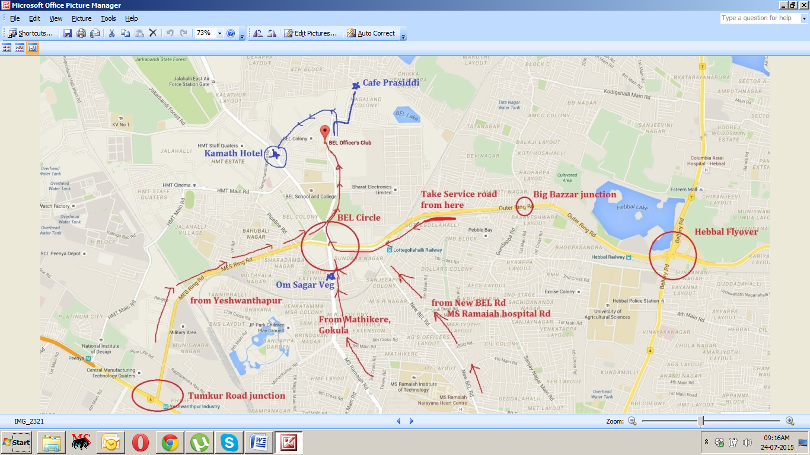

26th National Under-17 OPEN & GIRLS CHESS CHAMPIONSHIPS - 2015
Entry Form

To
The Organising Secretary
United Karnataka Chess Association,
C/o Hotel Aruna Anandh Deluxe Lodge
No.7, 1st Cross, Annamma Temple Extension
Northern side of Sangam Complex & Eastern side of Majestic Bus station,
Bangalore-560009
Ph: no.+91 9611832665, +918105940013 email id: ukcachess@gmail.com

Dear Sir,

Sub: Entries for 26th National Under-17 Open & Girls Chess Championship - 2015

Kindly enrol the entry of our players for the 26th National Under-17 (Open & Girls) Chess
Championships -2015. Entry fee has been paid by DD favouring United Karnataka Chess Association payable at Bengaluru. We understand that the Championship is held only for All India Chess Federation (AICF) registered players. All the team members will abide by the Rules and Regulations of the (AICF).

Sl.  No. | Name of the Player | FIDE  Rating | Date of  Birth | Ordinary  / Special  Entry Rs.  & DD No. | AICF Reg  . Amt. In Rs. 250/- & DD No. | Mobile  No. / Res.  No.
1
2
3
4
5
6

Secretary/Seal
State Chess Association/Affiliated to All India Chess Federation

For Online transfer send to “United Karnataka Chess Association” Corporation Bank, Srinagar Branch, Bangalore. SB A/c No-021500101023520 IFSC Code: CORP0000215.

Demand draft shall be in favour of “United Karnataka Chess Association” payable at Bengaluru and have to be sent to The Organising Secretary, United Karnataka Chess Association, C/o Hotel Aruna Anandh Deluxe Lodge, No.7, 1st Cross, Annamma Temple Extension, Northern side of Sangam Complex & Eastern side of Majestic Bus station, Bangalore-560009. Ph: no.+91 9611832665, +918105940013. Email : ukcachess@gmail.com

Sl# | Hotel Name and Address | Budget Range | Distance from Venue BEL Officer’s Club
1. | Mövenpick Hotel & Spa Bangalore  115 Gokula Extension, HMT Road  (near BEL Circle) | 560054 Bangalore  Ph: +91 80 4300 1000  | hotel.bangalore@moevenpick.com | 9000-15000 | 1 Kms
2. | Hotel Krishinton  993, Near IISc D- Gate  M.S. Ramaiah main Road, Mathikere  Bengaluru, Karnataka 560054  Ph: +91 80 4259 5959 www.krishinton.com | 3500-6000 | 2 Kms
3. | Akshara Regency  ADB Building, Gokula 1st Stage, 1st Phase, Opp.Old Post Office  4/20, 1st Main Rd, Mathikere Extension , Bengaluru, Karnataka 560054  +91 80 2337 7747 | 700-1500 | 2 Kms
4. | Hotel Sagar Comforts  Mathikere Extension Bengaluru, 560054  Ph: 9731505532 | 080-23377746 | 700-1500 | 2 Kms
5. | Hotel Nandan Residency  Mathikere Extension Bengaluru, 560054  Ph: 9731505532 | 080-23377746 | 700-1500 | 2 Kms
6. | Hotel Udupi Park Inn  28, 2nd Cross, Anjaneya Temple Road, Opp. Yeshwantpur Railway Station  Yeshwantpur Bengaluru,  Karnataka 560022 Phone: +91 80 4171 7611 | 800-1500 | 3 Kms
7. | Kaveri Deluxe Lodge  19, SNR Plaza, Near Jain Temple  1st Main Rd, H Gurumurthy ReddyColony, Yeshwanthpur, Bengaluru, Karnataka 560022  +91 80 2347 0550 | 1000-1500 | 3 Kms
8. | Hotel Grand Bee  37/1, Railway Parallel Road, Yeshwanthpur  Bengaluru, Karnataka 560022  +91 80 2357 5000  www.hotelgrandbee.com | 1600-2700 | 3 Kms
9. | Sri Venkateshwara Lodge  Triveni Road, Near-Vijaya Bank  Yeshwanthpur Bengaluru, Karnataka 560022  Phone +91 80 2337 0155 | 450-600 | 3.5 Kms
10. | Atlaantic Inn  Opp Ground, Fun World, Snow City  140, JC Nagar Main Rd  Palace Guttahalli  Bengaluru, Karnataka 560006  Ph: 080 4154 0603 | 1500-3500 | 8 Kms

