



29th National U-9 Chess Championship – 2015
(Boys & Girls)

11th June – 19th June 2015

AICF Event Code:112924 /112925/GUJ/2015
Organized By
Gujarat State Chess Association

Under the Aegis of
All India Chess Federation

: VENUE :

Gujarat State Co-operative Bank.
Sahakar Bhavan, 132’ ring road, Pallav Cross Road,
Naranpura, Ahmedabad 380013

Venue Partner:



Tournament Schedule
Particulars | Date | Day | Time
Managers Meeting | 11th June 2015 | Thursday | 13:30 hrs.
Inauguration | 11th June 2015 | Thursday | 15:30 hrs.
Round - 1 | 11th June 2015 | Thursday | 16:00 hrs.
Round - 2 | 12th June 2015 | Friday | 09:00 hrs.
Round - 3 | 12th June 2015 | Friday | 16:00 hrs.
Round – 4 | 13th June 2015 | Saturday | 09:00 hrs.
Round - 5 | 14th June 2015 | Sunday | 09:00 hrs.
Round - 6 | 14th June 2015 | Sunday | 16:00 hrs.
Round - 7 | 15th June 2015 | Monday | 09:00 hrs.
Round - 8 | 16th June 2015 | Tuesday | 09:00 hrs.
Round - 9 | 17th June 2015 | Wednesday | 09:00 hrs.
Round - 10 | 18th June 2015 | Thursday | 09:00 hrs.
Round - 11 | 19th June 2015 | Friday | 09:00 hrs.
Prize Distribution | 19th June 2015 | Friday | 16:00 hrs.
Departure | 19th June 2015 | Friday | 19:00 hrs.

Prizes
The cash prizes will be awarded to 20 players in each category amounting to Rs.1,50,000/- as below

Rank | Boys | Girls
1 | 20,000 | 20,000
2 | 15,000 | 15,000
3 | 10,000 | 10,000
4 | 6,000 | 6,000
5 | 4,000 | 4,000
6 | 3,000 | 3,000
7-12 | 1,500 each | 1,500 each
12 to 20 | 1,000 each | 1,000 each

ZERO TOLERANCE: The “zero tolerance” rule will be followed (i.e.): “Any player who arrives atthe chessboard after the start of the session shall lose the game. Thus the default time is zero minutes.”

AGE LIMIT: Players Born On or After 01.01.2006
Age Proof: Each participant must produce a valid certificate to prove his/her age. Certificates from School are not valid. Certificates should preferably be from the Panchayat, Municipality or Corporation obtained soon after birth. Players without date of birth certificates will not be allowed to participate.
NOTE: The birth certificates registered within one year of the birth of the child will be recognized and allowed to participate. No State Association shall recommend any player who doesn’t come under the above criteria. Any player who is aggrieved by this stipulation can appeal to AICF with proper documentary proof and the AICF’s decision in this regard will be FINAL and BINDING.

If any doubt arises about the claimed age of a player, the tournament committee has the right to refer the player during the championship for a due evaluation of age by competent medical experts. A player if declared overage by such expert shall not continue in the championship and the matter shall be reported to AICF. Protest about the age of players may be made to the Chief Arbiter in writing along with a fee of Rs.1,000/- per player. This fee claimed will not be refunded.
No protest about over age of player will be entertained after 2nd round of the championship. Only the coach or manager deputed by participating State Chess Association can lodge such protests. The tournament committee has the right to decide the day, time and place for such medical evaluation of age.
AICF / organizers will have the right to refer any player to the medical evaluation of age at any time during the tournament. Players refusing to take the test as decided by the tournament committee shall be disqualified from the championship.

Eligibility: Subject to age limit following players can participate.
1) Two players in each category from every affiliated State Association of AICF. If any association fails to
send its quota, the vacancies so caused will not be filled.
2) Top four players from 2014 National Under-9 (Boys and Girls) Chess Championship are eligible to
participate as seeded players in the respective categories subject to age stipulation.
3) The Top two rankers of 2014 National Under-7 (Boys and Girls) Chess Championship are eligible to
participate as seeded players in respective categories.
4) 2014 World Champion in any category subject to age stipulation.
5) 2014 World number 2 & 3 under 8 & 10 categories, subject to age stipulation.
6) 2014 Asian Under-10 top three rankers subject to age stipulation.
7) 2014 Asian Under-8 champion subject to age stipulation.
8) The AICF secretary has a discretionary seat in each category in this championship.
9) Any other player who remits the prescribed special entry fee Rs.4,000/-
10) In each category, the host association is entitled to fill one additional player.
11) Current National Champion in any higher category.
12) Two players in each category approved by AICF will be permitted from areas where no state association
exists.
13) The winner and runner-up of 2014 National Under-9 Girls are eligible to play in open section.
14) The winner of 2014 National Under-7 Girls is eligible to play in open section.
15) The host chess association is entitled to one additional entry if the number of the participants at the start
of the championship is an odd number.
16) In addition to the above, the following states can fill additional seats, as their players had won Gold, Silver and Bronze medals in the previous (2014) National Under-9 Chess Championship: Open: Maharashtra(Gold)-3; Tamil Nadu (Silver)-2; Andhra Pradesh (Bronze)-1: Girls: Tamil Nadu (Gold)-3; Maharashtra (Silver & Bronze)-2+1. And these entries from the State Associations shall be given only from the Rank list of their respective State Championships with proof and not to anybody else.
17)Only Indian Nationals are eligible to participate in the championship.
Tournament Committee: AICF or its representative, two members from different participating associations and two members of the host association will serve as the Tournament Committee.

System of play: The championship will be played under the FIDE Laws of Chess and Swiss system. Totally eleven rounds shall be played.

Time Control: 90 minutes + 30 second increment per move from move number 1.

Chess Clock: Each participating state association must provide at least one DGT chess clock in working order for every two players entered into the championship.

Tie Break: Buchholz tie-break system will be applied. In case of tie, cash prizes will not be shared.

Protest: Protest, if any, against the decision of the chief arbiter shall be made in writing with a protest fee of Rs.500/- within 30 Minutes of the occurrence of the incident. The protest fee will be refunded if the appeal is upheld.

Appeals Committee: Before the commencement of the tournament, a five member Appeals Committee shall be formed by the AICF/organizers. All the members and reserves shall be from the different states. No member of the committee can vote or argue in which a player from his own state is involved and in such case(s), the reserve member(s) shall take his place in the committee.

Disqualification: No participant will leave the venue before the prize distribution function without the permission of the Chief Arbiter. The participants disregarding this rule will be suspended for one year.

Interpretation: For interpretation of the rule(s) and deciding any point not covered by the above rules of the tournament, the decision of the tournament committee shall be final and binding on all. The tournament committee has every right to make any decision or amendment to those rules, without notice. Such changes will however be displayed in the tournament hall.

Registration of Players: All participants in the National Championship should be registered with AICF for the year 2015-16. Application forms are available in the website www.aicf.in those who have already obtained registration cards from AICF Website for 2015-16 should send photo copy of the same. Those who have paid the AICF Registration fee but are yet to receive the AICF Registration card should send a photo copy of the acknowledgment for having paid the fee to organizers of earlier tournaments or to their association. Those who have not registered with AICF for the year 2015-16 should send a amount of Rs.250/- towards AICF registration fee along with the duly filled and signed AICF player’s registration form plus one passport size photograph.

Arrears: Arrears of affiliation fee / tournament fee including those of current year, must be cleared by the affiliated association at the time of submitting the entries, otherwise the entries are liable to be rejected.

Registrations & Accommodation:
Entries/Entry Fee: All entries including special entries should come through the concerned State Association. However AICF will have the right to accept or reject any entry without assigning any reason. The Entry form should be sent together with attested copy of original date of birth certificate (Birth Certificates from Panchayat / Municipality / Corporation only accepted)

Entry Fee Structure: Ordinary entry: Rs.700/- • Special entry: Rs.4000/-
There is a 50% concession in the entry fee for participants from North Eastern States, Andaman & Nicobar Island. The entries will be accepted by Demand Draft via Speed Post. Please include a Xerox Copy of Birth Certificate with your entry.

Online entries via (without any extra charge, subject to AICF approval) www.brainpowerchess.com

Demand Draft Entries: Demand Draft should be drawn in favour of "Gujarat State Chess Association" payable at Ahmedabad. Entry sent via Demand Draft should be sent by speed post only at: Gujarat State Chess Association, C/o. Rifle Club, Nr. Bhavan’s College, Khanpur, Ahmedabad-380001.
Email: bhavesh.chess@gmail.com OR you can transfer entry fee directly to our bank account. Details of bank account are as under:

Bank : Bank of Baroda
Branch : Dariapur Branch, Ahmedabad
Saving A/c. No. : 03230100024766
RTGS/NEFT/IFSC : BARB0DARIAP

Now you can register yourself by just a click away. For online registration of 29th National U-9 (Boys & Girls) Chess Championship 2015 is just few clicks away.



For the first time for player’s convenience we are giving a platform to pay entry fees online without any additional cost. Kindly upload your birth certificate on following website. Note: We adhere privacy policy and your data would not be shared with anyone. Please refer website for more terms and conditions.

Follow the link given below to register online or visit www.brainpowerchess.com
http://brainpowerchess.com/events/u-9-national-selection/

Late fee: Please note entry fee structure is valid on till 1st June 2015. Thereafter a late fee of Rs.250/- per player will be levied. No entry will be entertained after 6th June 2015 (up to 18:00 hrs.)
Boarding: A lump sum Rs.1000/-(Rupees one thousand only) will be paid by the AICF through the organizers towards the boarding expenses only to the affiliated State Association’s seeded and selected players who play this championship under normal entry fee.
Accommodation:
Accommodation equivalent to a 3 star dormitory facility on 6 sharing basis will be provided to the ordinary entry fee player and one accompanying manger nominated by the concerned State Chess Association. To avail this facility each state player and the manager have to inform the authorities for their accommodation before 1st June 2015 (up to 18:00 hrs.) Special entries and other accompanying people will have to make their own accommodation arrangement.

For special or accompanying accommodation confirmation, kindly send emails on accomodation@brainpowerchess.com. Once the email will be sent from your side receive the confirmation with your room number and the bed number via email from the same email address.

Free Accommodation Partner: GUJARAT STATE CO-OPERATIVE BANK

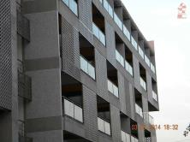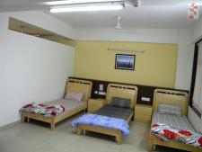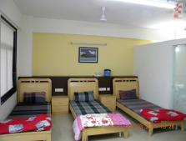
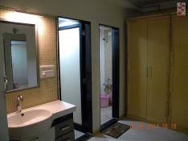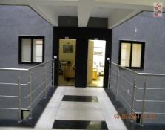
Terms and Conditions:

- No Non-Veg food allowed in the premises. If someone is caught eating Non-Veg Food strict actions will be taken.
- Smoking, Alcohol and Gutkha is banned in the premises.
- One parent will be allowed to stay with players on chargeable basis.
- Organizers have the right to send players and parents to other accommodation once the premise is fully occupied. Hence the occupancy will be on first come first basis.
- This accommodation is not for donor entries. They will have to manage on their own.
- 6 sharing basis.

Hotel Partners:

Name | Contact No.
Hotel Salute | Sajjan Purohit  (M): 07575061451
Hotel Kadamb Inn | Sajjan Purohit  (M): 07575061451
Hotel Kalash Residency | Sajjan Purohit  (M): 07575061451
Hotel Kalash Inn | Sajjan Purohit  (M): 07575061451
Hotel Crystal | Sajjan Purohit  (M): 07575061451
Hotel Kanchan Palace | Sajjan Purohit  (M): 07575061451

Rates: Approx. 2,000/-

For queries regarding accommodation and Special package deals log on to www.brainpowerchess.com.
Home cook food available for players on payment basis at your accommodation.
More details
Contact: Brain Power Chess Academy (M): 07878783264

Note: Accommodation bookings on www.brainpowerchess.com.,are completely for your convenience and it’s an additional service which has nothing to do with Organizers and AICF.
Organizing Committee
Bhavesh Patel
Hon. Secretary, Gujarat State Chess Association
bhavesh.chess@gmail.com

Mayur Patel Jayesh Modi Samir Shah Ankit Dalal Joy Chauhan
(M) 9898220553 (M) 7878860008 (M) 9099050345

: For Registration :
Bhavesh Patel (E-mail: bhavesh.chess@gmail.com)
Amit Parikh (M) 9898087374

: For Online Registration Partner :
Brain Power Chess Academy (M) 7878783264

: For Accommodation :
Brain Power Chess Academy (M) 787878264
Mayur Patel (M) 98982 20553

:OUR WELL WISHERS:
Dharmendra Pandya I. G. Parmar Vimal Srivastava
Nirav Rajasuba A. C. Joshi Arpi Shah
Pruthvi Leuva, Vadodara Vishal Sadhu S. D. Rajan, Vadodara
Pankaj Pancholi, S'nagar D. Dasgupta, Vadodara Virendrasinh Zala
Shailesh Raval, Bhavnagar Harshad Dodia, Rajkot Bimal Gohel, Bhavnagar
Manthan Choksi Hemal Thanki Kirit Gajiwala, Surat
Abhijit Acharya Sopan Bhagat Mahendra Parmar
R. D. Swaminarayan Dr. H. N. Dave, Jamnagar Rajendrasinh Chavda
Sanjay Davda, Bhuj Vinod Khodiyar, Bhuj Manish Parmar, Rajkot
Abhijit Sur, Bharuch Satunia, G’nagar M. G. Bhatt, Vadodara
Hotel Salute
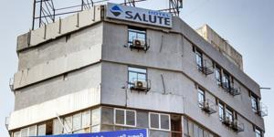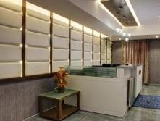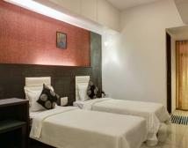
Hotel Kadamb Inn
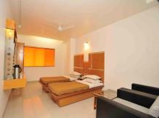
Hotel Kalash Residency
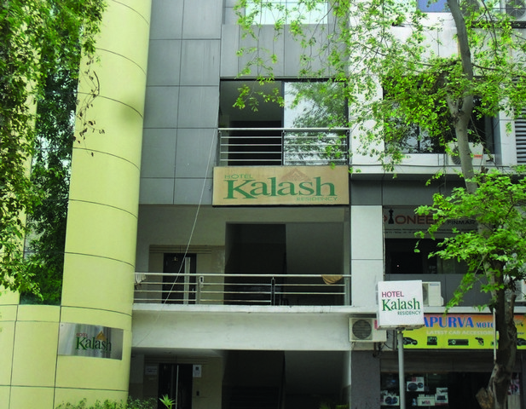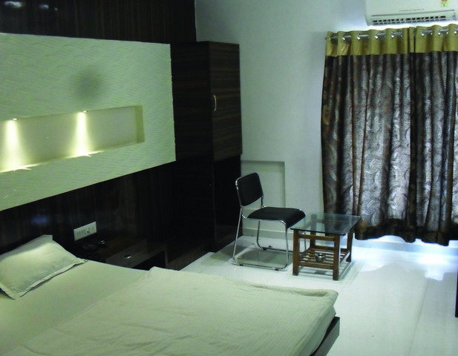
Hotel Crystal
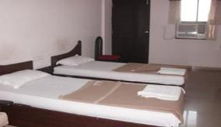
Hotel Kanchan Palace
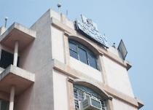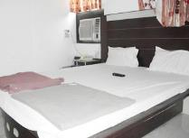

29th National U-9 Chess Championship-2015 (Boys and Girls)

Entry Form
To
The Secretary,
Gujarat State Chess Association
Dear Sir,
Sub: Entries for 29th National U-9 (Boys & Girls) Chess Championship - 2015

Kindly enroll the entry of our players for the 29th National U-9 (Boys and Girls) Chess Championship – 2015. Entry fee has been paid by DD favoring “Gujarat State Chess Association”, payable at Ahmedabad. We understand that the Championship is held only for All India Chess Federation (AICF) registered players. All the team members will abide by the Rules and Regulations of AICF.

Sr. No | Name of player | FIDE rating | Date of Birth | Ordinary / Special Entry Rs.  DD no/ online receipt no. | AICF  Regi. Amt.  in  Rs.250/- &  DD No. | Mobile/  Resident No.
1
2
3
4
5
6
7
8
9
10

With this form, please send following documents:
1) Xerox copy of birth certificate and passport.
2) Entry fee demand draft.
3) A.I.C.F. registration form with registration amount Rs.250/- demand draft in favor of “Gujarat State Chess Association” payable at Ahmedabad. If player is already registered then kindly get the receipt of the details of A.I.C.F. registration for the year 2015-16.

Place: State Chess Association
Date:(Name of the Unit)
Affiliate of All India Chess Federation

Secretary
Seal

To:
The Divisional/ Commercial /Area Superintendent,
………………………Railway………………

Dear Sir,

Sub: Rail Concession

This is to certify that the following players and officials are bona-fide participants of the 29th National U-9 (Boys and Girls) Chess Championship - 2015 to be organized by us on behalf of All India Chess Federation at Ahmedabad from 11th June to 19th June, 2015. This is a recognized event of the All India Chess Federation.

Sr.  No. | Name of the Player | Date of Birth
1
2
3
4
5

We therefore, request the Rail Concession order may please be issued to them to travel from _____________________to Ahmedabad and back. The game of Chess is recognized for Rail Concession by the Railway Board by their letter no TC/11I2035/76, dated 5th April 1971.

Thanking you.

Yours faithfully,

(Mr. Bhavesh Patel)
Hon. Secretary
Gujarat State Chess Association

