Prospectus
RamRatna 42nd National Women Challengers Chess Championship 2015
(AICF Event Code: 115576 /MAH/ 2015)
Hosted by
Diaspora Times
(www.DiasporaTimes.In)
on behalf of
AICF | MCA | TDCA
From 2nd July to 11th July 2015
VENUE
Essel World Road, Uttan Village, Bhayander (West), Mumbai - 401106
Tel # +9122 2845 0101 / 2 / 3 (Destination Directions)
Keshav Srushti (http://keshavsrushti.com/), RMP Complex (http://rmponweb.org/)

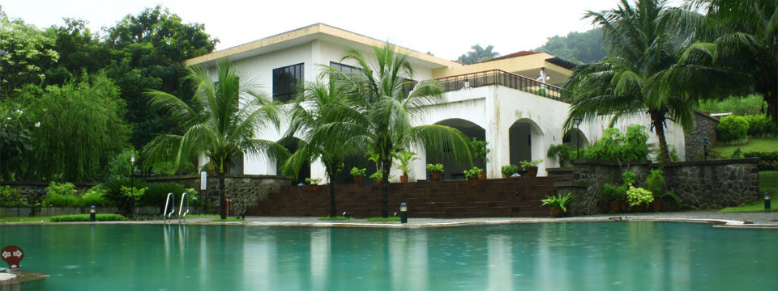

https://www.google.com/maps/dir///@19.229633,72.822776,14z?hl=en-US

Total Prize Fund : Rs. 3,00,000/-
First Prize Rs.72,000/- |  | Second Prize Rs.52,800/- |  |  |  | Third Prize Rs.38,400/-
4th Prize Rs.28,800/- |  | 5th Prize Rs.21,600/- |  |  |  | 6th Prize Rs.16,800/-
7th Prize Rs.12,000/- |  | 8th Prize Rs.9,600/- |  |  |  | 9th Prize Rs.7,200/-
10th Prize Rs.4,800/- |  | 11th Prize Rs.3,600/- each |  |  |  | 12th-20th Prize Rs.3,600/- each
SCHEDULE OF TOURNAMENT
Particulars | Date |  | Time | Particulars | Date |  | Time
Arrival | 1st July 2015 |  | All Day | Introductions | 2nd July 2015 |  | 9.00am
Inauguration | 2nd July 2015 |  | 11.00 am
Round -1 | 2nd July 2015 |  | 3:00 pm | Round -7 | 7th July 2015 |  | 10:00 am
Round -2 | 3rd July 2015 |  | 9:30 am | Round -8 | 8th July 2015 |  | 10:00 am
Round -3 | 3rd July 2015 |  | 4:00 pm | Round -9 | 9th July 2015 |  | 10:00 am
Round -4 | 4th July 2015 |  | 10:00 am | Round-10 | 10th July 2015 |  | 10:00 am
Round -5 | 5th July 2015 |  | 10:00 am | Round-11 | 11th July,2015 |  | 10:00 am
Round -6 | 6th July 2015 |  | 10:00 am | Prize /Closing | 11th July 2015 |  | 3:00 pm

RamRatna 42nd National Women Challengers Chess Championship 2015
PARTICULARS, TERMS AND CONDITIONS OF THE TOURNAMENT

1. Eligibility for Participation:
1. Four players from every affiliated unit and every institutional members of AICF. If any association fails to send its full quota, the vacancies so caused shall not be filled.
2. The top four players from 2014 National Women Challengers Championship other than WGM and WIM
3. The top two rankers from 2014 National Junior Girls Chess Championship.
4. The Champion of 2014 National U-17 Chess Championship for Girls.
5. 2014 World Champion in any girls/women category.
6. Top three finishers from 2014 Asian Women Championship.
  - Asian Junior Girls Champion.
8. All WGMs and WIMs.
9. All Board prize winners from 2014 National Team Women Chess Championship.
10. A nominee of the Secretary of All India Chess Federation.
11. Any woman player who remits the special entry fee of Rs. 5000/-
12. Four players approved by the AICF will be permitted from areas where no State Association exists.
13. The host Chess Association Maharashtra would be entitled to field two additional players.
14. If total numbers of entries is an odd number, then the host association may add one more entry to make it an even number.
15. Only Indian Nationals are eligible to participate in this championship.

2. Entries & Fees:
# | Type of Entries | Fees Rs.
1 | Ordinary | 1,500/-
2 | Special | 5,000/-
3 | Ex- National Women Premier ‘A’ player | 2,500/-
4 | Entries from North Eastern States & Andaman & Nicobar Islands | 50% concession in any entrée fess

All entries should be routed through the respective State Chess Association or the affiliated units.

Entries should be received on or before 20/06/2015 to
Ashok Motwani,
(Organizing Secretary)
42nd NWCCC 2015
A/24, “Chand”, Juhu Road,
Mumbai-400 049.
Tel: +91 222 624 1338 Mobile No. +91 986 998 8884.
Entrance fees and banking will be via our account in
HDFC Bank – Juhu Versova Branch – Mumbai – 400 053.
Title: DIASPORA TIMES; a/c # 50200 01088 8648, IFSC Code HDFC0000019

Late Fee: A late fee of Rs. 250/- will be collected on all entries received from 21/06/2015 to 30/06/2015. No entry will be entertained after 01/07/2015.

3. Players Registration:

All participants in the 42nd National Women Challengers Chess Championship must be registered with AICF for the year 2015-2016. Application forms are available in the website www.aicf.in. Those who have already done registration with AICF should send proof for the same. Those who have not registered with AICF for the year 2015-2016 should send an amount of Rs.250/- towards AICF registration fee along with the duly filled and signed AICF player’s registration form plus one passport size photo.

Participants from Maharashtra State are required to obtain MCA Registration for the year 2015-2016 by sending an amount of Rs.150/- towards MCA registration fee along with the duly filled and signed MCA player's registration form plus one passport size photograph in addition to the entry fees.

4. Lodging and Boarding for seeded/selected players:
a) Lodging: Free lodging will be provided from 01/07/2015 (After 1200 hrs onwards to 12/07/2015 up to 9.00 hrs) to seeded/selected players and one accompanying official nominated by the concerned state chess association of each state and the affiliated unit of AICF. To avail this facility, the player/association concerned has to inform the same on or before 20/06/2015. No request for accommodation will be entertained after 30/06/2015. The accompanying person should carry the nomination letter from the respective state association to avail this facility. All others will have to make their own arrangement for their stay. If informed well in advance hotel reservation will be arranged by organizers on payment basis.
b) Boarding: A lump sum of Rs.1000/- (Rupees One Thousand only) per player will be paid by the AICF through the organizers towards the boarding expenses only to the ( Representing State) players who play this championship under normal entry (qualified and seeded players).

Beautiful accommodation facilities at Environment Friendly RMP Green Complex are available, 3 players in a room are planned, and Guests accompanied by player will pay nominal room charges + any special services. More help from Venue PR Chief Mr Hemant Deodhar will be available.

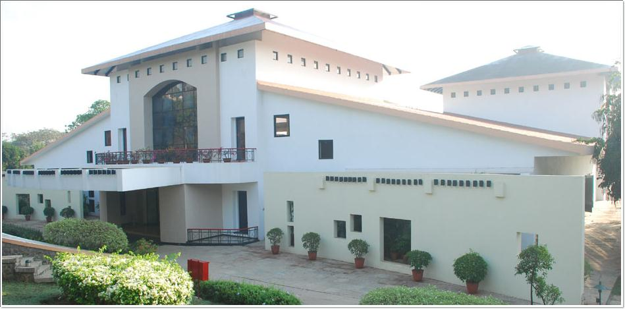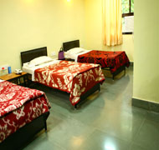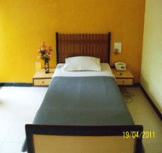

(Rounds will be played in the same Complex, which has recreation facilities like Table Tennis, Swimming Pool, Walking, Jogging Track, Full size Playground, Library and Wi-Fi Services, with consensus of authorities on one of the days visit to nearby Esselworld & World Class Pagoda Likely to be arranged)

5. Tournament Regulations:
The Championship would be played under FIDE Laws of Chess and the Swiss system. A total eleven rounds shall be played unless otherwise decided by the Tournament Committee before the commencement of the Championship.

6. Zero Tolerance Rule:
The “Zero tolerance” rule will be followed (i.e.): “Any player who arrives at the chess board after the start of the session shall lose the game. Thus the default time is zero minutes.”

7. Time Control:
The time control is 90 minutes each for the first 40 moves followed by 30 minutes each for the rest of the game with an increment of 30 seconds per move from move one.

8. Chess Clocks:
Each participating association and affiliated unit must provide at least two DGT XL or 2010 chess clocks in working order for every four players entered by them in the championship. It has been made mandatory by the AICF to have chess clocks on each and every all board.

9. Tie Break:
Buchholz tie-break system will be applied.
1. Buchholz Cut-1, 2.Buchholz Cut-2, 3.Sonneborn Berger, 4.Buchholz Median
For unplayed games and byes, it has to be assumed that the player had played against a virtual opponent in that round as per the rules prescribed in FIDE Handbook – C06 – FIDE Tournament Rules – F. Handling Unplayed Games for Calculation of Buchholz (Congress 2009) (http://www.fide.com/fide/handbook.html?id=20&view=category) .In case of tie, prizes will not be shared.

10. Tournament Committee:
The tournament committee comprising the Chief Arbiter, Secretary of the AICF or his Representative, and the Secretary and two members of the host Association shall be constituted before the commencement of the tournament.

11. Protest:
Protests, if any, against the decision of the Chief Arbiter, shall be made in writing with a protest fee of Rs. 500/- within 30 minutes of the occurrence of the incident. The amount shall be refunded if the appeal is upheld.

12. Appeals Committee:
Before the commencement of the championship, a five member Appeals Committee shall be formed by the AICF/Organizer. All the members and reserves shall be from the different states. No member of the Committee can vote on dispute in which a player from his own state is involved and in such case(s), the reserves shall take his place in the committee. The decision of the Appeals Committee is final and binding on players concerned.

13. Withdrawals:
A player may withdraw from the Championship at any stage, after informing Chief Arbiter in writing.

14. Disqualification:
No player shall leave the venue before the prize distribution function without the permission of the Chief Arbiter. The participants disregarding this rule shall be suspended for one year.

15. Arrears:
The affiliated Association must clear all arrears of affiliation fee / tournament fee including those of current year of the AICF at the time of submitting the entries. Otherwise the entries are liable to be rejected.

16. Interpretation:
For interpretation of the rules and deciding any point not covered by rules, the decision of the Tournament Committee shall be final and binding. The Tournament Committee has every right to make any additional or amendment to these rules, without notice. However, such changes/or inclusion will be subject to AICF clearance. Such changes will, however be displayed at the tournament hall.

RamRatna 42nd National Women Challengers Chess Championship 2014
Entry Form

To Date:
The Organizing Secretary,
DIASPORA TIMES
A/24 “Chand”; Juhu Road
MUMBAI – 400 049.
Tel: +91 222 624 1338; Cell +91 986 998 8884
Email: 42NWccc@GMail.com, Ashok.Motwani@GMail.com

Dear Sir,

Sub: Entries for RamRatna 42nd National Women Challengers Chess Championship 2015
Kindly enroll the entry of our players for the RamRatna 42nd National Women Challengers Chess Championship 2015 at Keshav Shrusti – Mumbai, Entry fee has been paid by DD favoring DIASPORA TIMES, Payable at MUMBAI. We understand that the Championship is held only for All India Chess Federation (AICF) registered players. All the team members will abide by the Rules and Regulations of the (AICF).

Sl. No. | Name of the Player | FIDE Rating | FIDE ID | Date of Birth | Ordinary(0) / Special (S) Entry Rs. & DD No. | AICF Reg .. fee. Rs.250/- | Mobile No. / Res. No.
1
2
3
4

Please send following documents with this form.
1. Entry Fee Demand Draft in favor of “DIASPORA TIMES” Payable at Mumbai, with Your Pan card copy & Bank A/c Details.
2. AICF registration form with registration amount Rs.250/-. If the players is already registered the details of AICF, registration of the year 2015-16 with registration proof.

…………………State Chess Association
(Name of the Unit)
Affiliated to All India chess Federation
Secretary/Seal
______________________________________________________________________________________________________
RECEIPT
Received with thanks from Ms./Team ________________________________ of ____________________ Rs…………………. entrée fee for …… players to participate in the RamRatna 42nd National Women Challenger Chess Championship 2015, Keshav Shrusti Complex, Uttan , Mumbai from 2nd July to 11th July 2015.

For DIASPORA TIMES Receipt No.______ Date: _________

MAHARASHTRA CHESS ASSOCIATION
(Affiliated to A.I.C.F.)

Mr. Dilip Pagay (Hon. Gen. Secretary)
C/o Devashree Properties, Block 1, IInd Floor,
J. P. Chamber, Shraddhanandpeth, Nagpur- 440010
Maharashtra, India.
Contact No: +91-808 700 5069
Email: MaharashtraChess@GMail.com

Date:
To
The Divisional Commercial Superintendent
Dear Sir,
Sub: Rail Concession certificate in connection with RamRatna 42nd National Women Challengers Chess Championship 2015 at KESHAV SHRUSTI from 02-07-2015 to 11-07-2015

This is certified that the following players and one official of the ____________________ State Chess Association are entitled to participate in the above mentioned Chess Championship.
No. | Name of the Player/Official | Date of Birth
1
2
3
4
5
6
7
8

We therefore, request the Rail Concession order may please be issued to them to travel from _____________________ to MUMBAI (MAHARASHTRA) and back. The game of Chess is recognized for Rail concession by the Railway Board by their letter No.TC/11/2035/67, dated, 5th April 1971.
Thanking you,
Yours Faithfully,

ASHOK MOTWANI
(Organizing Secretary)
42nd NWCCC – MUMBAI
Date: 15/05/2015.

