GTC CLASSIC Chess 2015
22 to 26 July 2015
Celebrating 5 years of GTC Chess foundation
AICF Event Code 116365/NE/2015

ORGANIZED BY
GTC Chess Foundation
A UNIT OF
Gauhati Town Club

Recognized by
All Assam Chess Association
All India Chess Federation
World Chess federation

VENUE

Gauhati Town Club, Judges Field, Guwahati 781001

TOTAL PRIZE FUND
Rs 1, 50,000/-

(Limited to 200 players only on first come first serve basis)

PRIZE STRUCTURE :

Rank | Prize Amount in Rupees
1 | 25000/- + Trophy
2 | 20000/- + Trophy
3 | 15000/- + Trophy
4 | 12000/-
5 | 10000/-
6 | 8000/-
7 | 7000/-
8 | 6000/-
9 | 5000/-
10 | 4000/-
11th to 15th | 2500/- each
16th to 20th | 2000/- each

SPECIAL PRIZES :

Rating Upto 1799 : 1st 2000/- + Medal
2nd 1500/- + Medal

Best North-East : 1st 2000/- + Medal
2nd 1500/- + Medal

Best Assam : 1st 2000/- + Medal
2nd 1500/- + Medal

Best Unrated : 1st 2000/- + Medal
2nd 1500/- + Medal

Best GTC Player : 1500/- + trophy

CATEGORY PRIZES :

Under-9 : 1st Trophy
2nd Trophy

Under-11 : 1st Trophy
2nd Trophy

Under-13 : 1st Trophy
2nd Trophy

Under-15 : 1st Trophy
2nd Trophy

Best Girl (Under-15) : 1st Trophy
2nd Trophy

TOURNAMENT SCHEDULE

Date | Time | Round
22/07/2015 | 9-00 AM | Inauguration
 | 10-00 AM | Round 1
 | 4-00 PM | Round 2
23/07/2015 | 9-00 AM | Round 3
 | 4-00 PM | Round 4
24/07/2015 | 9-00 AM | Round 5
 | 4-00 PM | Round 6
25/07/2015 | 9-00 AM | Round 7
 | 4-00 PM | Round 8
26/07/2015 | 8-00 AM | Round 9
 | 1-30 PM | Round 10
 | 6-30 PM | Closing & Prize Distribution

ENTRY FEE:

Rs 1000/- for GTC Chess Foundation players
Rs 1200/- for all other players

The entry fee should be submitted in the form of a Demand Draft drawn in favour of “Gauhati Town Club”, payable at “Guwahati” and sent to:

Biswajit Bharadwaj Online transfer
Gauhati Town Club UTI Bank (guwahati branch) A/c no: 140010100281805
Judges field, Panbazar IFSC CODE: UTIB0000140
Guwahati 781001
Assam

LATE FEE: Entries received after 10/07/2015 will be subject to a late fee of Rs. 200/- per player.

AGE PROOF:

Birth certificate registered within one year of birth is compulsory for group prize.

SYSTEM OF PLAY:

The tournament will be played under the FIDE Laws of Chess and Swiss system. Total 10 rounds shall be played unless otherwise decided by the Tournament Committee.

SESSION:

The rate of play shall be 90 minutes each with an increment of 30 seconds per move from the starting move.

CHESS CLOCK: Players are requested to bring their own DGT chess clock.

TIE-BREAKS: Buchholz tie-break system will be applied in case of tie, cash prizes will not be shared.

PROTEST: Protest, if any against the decision of the chief arbiter shall be made in writing with a protest fee of Rs.500/- within 30 minutes of the occurrence of the incident.
The protest fees will be refunded if the appeal is upheld.

APPEALS COMMITTEE: Before the commencement of the tournament, a five members committee shall be formed by the organizers.

INTERPRETATION: For interpretation of the rules and deciding any point not covered by the above rules of the tournament, the decision of the tournament committee shall be final and binding on all. The tournament committee has every right to make any decision or amendment to those rules, without notice. Such changes will however be displayed in the tournament hall.

REGISTRATION OF PLAYERS: All participants should be registered with AICF and All Assam Chess Association for the year 2015-16.

ACCOMODATION: Lodging is not provided for participants. However arrangement can be made on prior information and payment.

ORGANIZING COMMITTEE

Dr Himanta Biswa Sarma Devajit Saikia Amarendra Nath
(Chairman) (Secretary) (Finance Secretary)

Nandan Buragohain Sajjad Zahir hussain Biswajit Bharadwaj
(Organizing Secretary) (Convener) (Tournament Director)
(M) 9864443051 (M) 9864026704 (M) 9954136181

Deep Borah Padma Gogoi Rakesh Dubey Bulbul Choudhury Akhtaruddin Ahmed
(Publicity Secretary) (Executive Members)
(M) 9864035253

Binod Khemka
(Adviser)

gtcchessfoundation@gmail.com
www.facebook.com/gtcchess
Website: www.gauhatitownclub.com
www.assamchessclub.com

Photo clippings of our previous events

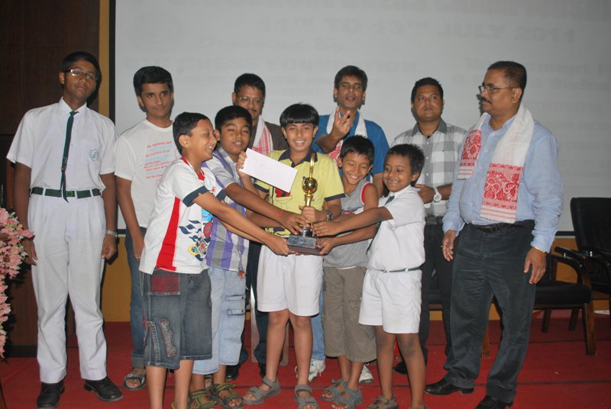
Figure 1 GTC School Chess Championship 2011

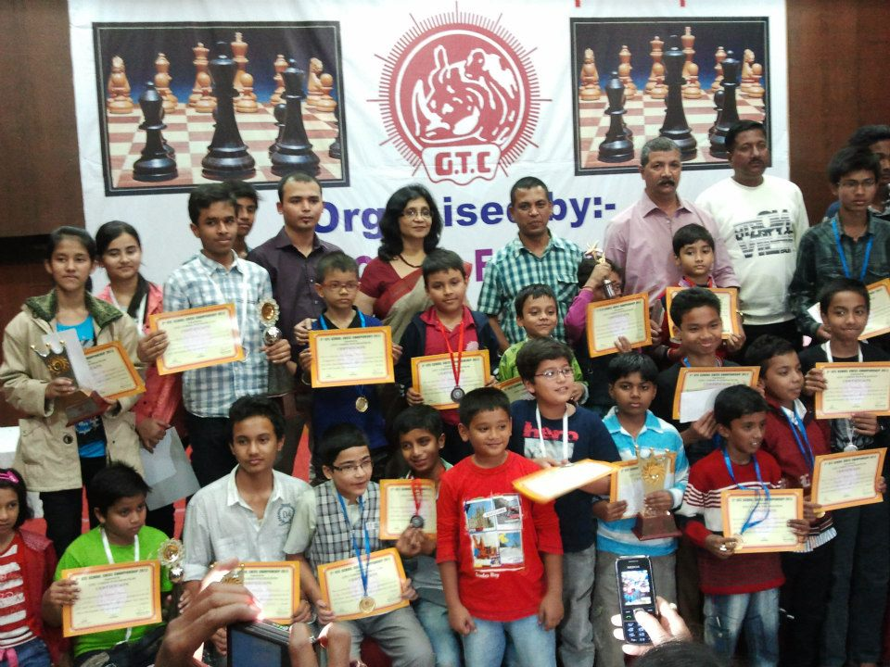
Figure 2 GTC School Chess Championship 2012

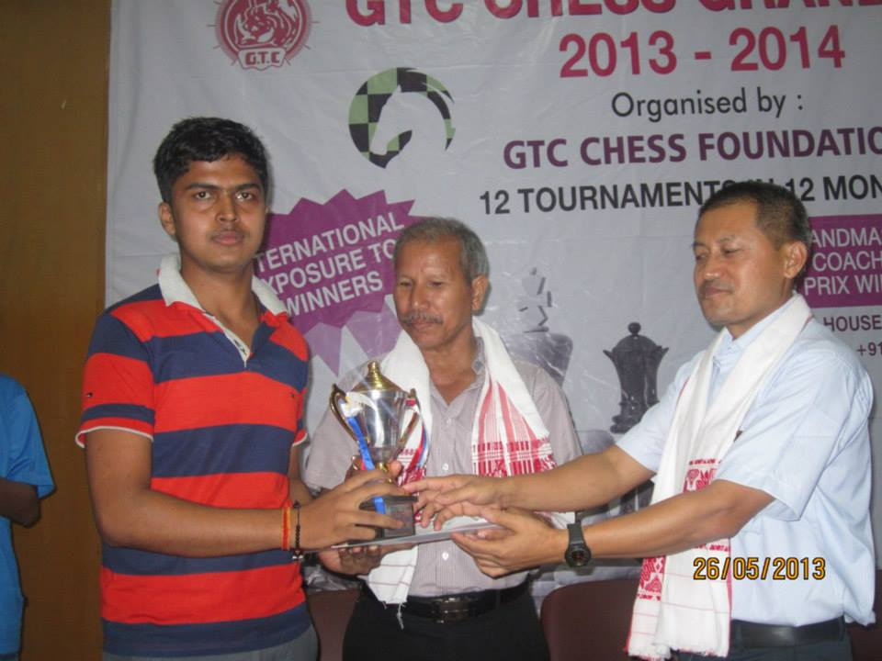
Figure 3 GTC Grand Prix 2013-2014

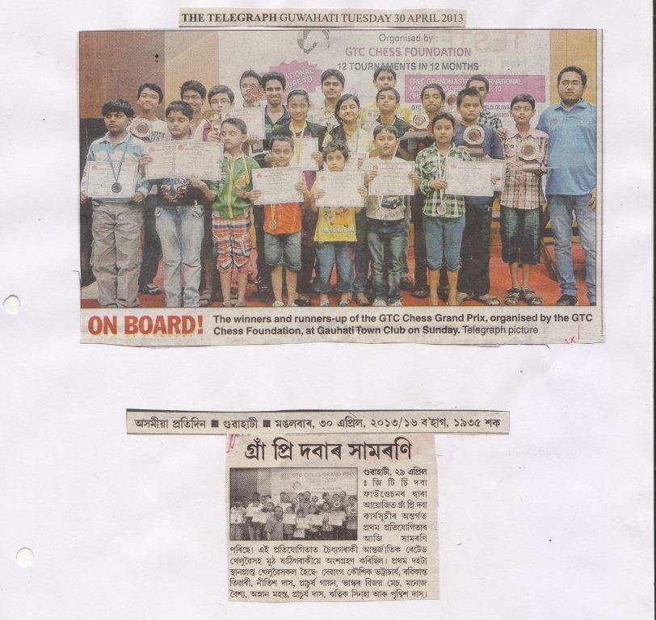
Figure 4 GTC Grand Prix 2013-2014 news clippings

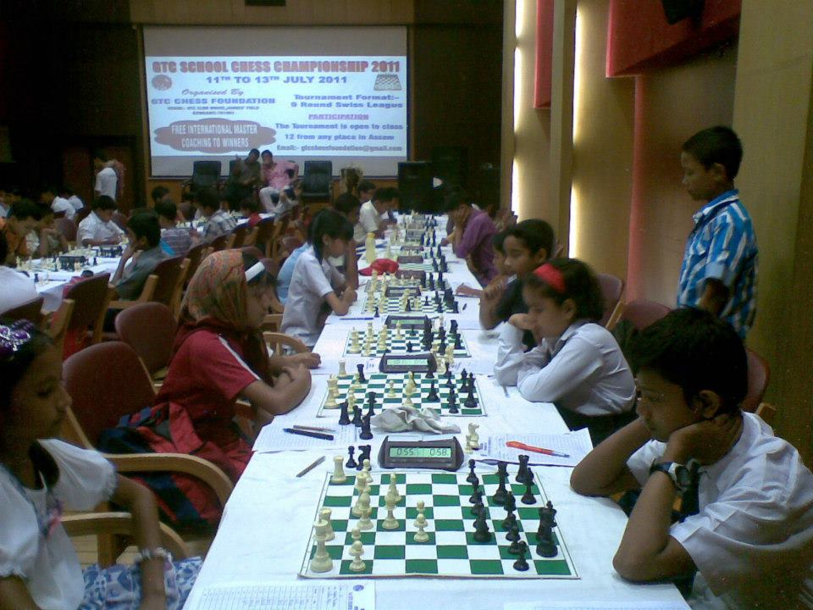
Figure 5 Air conditioned tournament hall

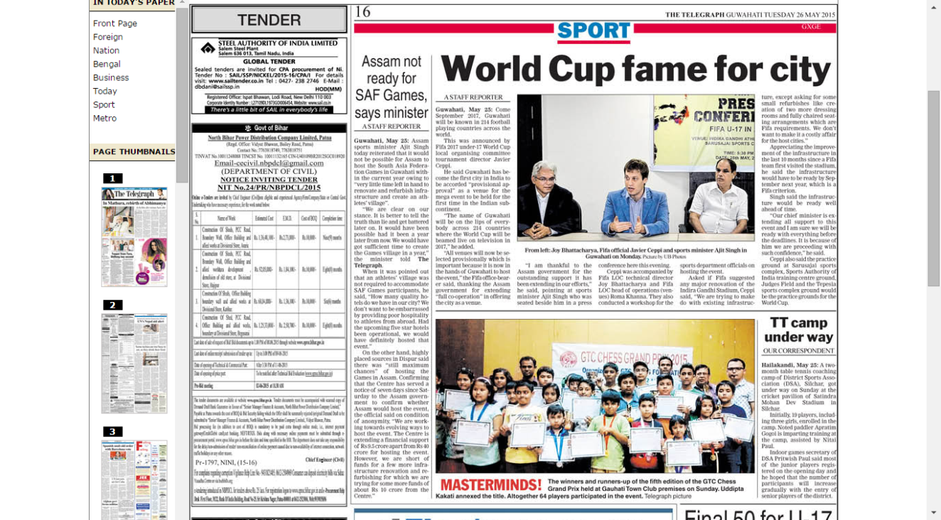
Figure 6 Newspaper clipping of May 2015 Grand Prix

