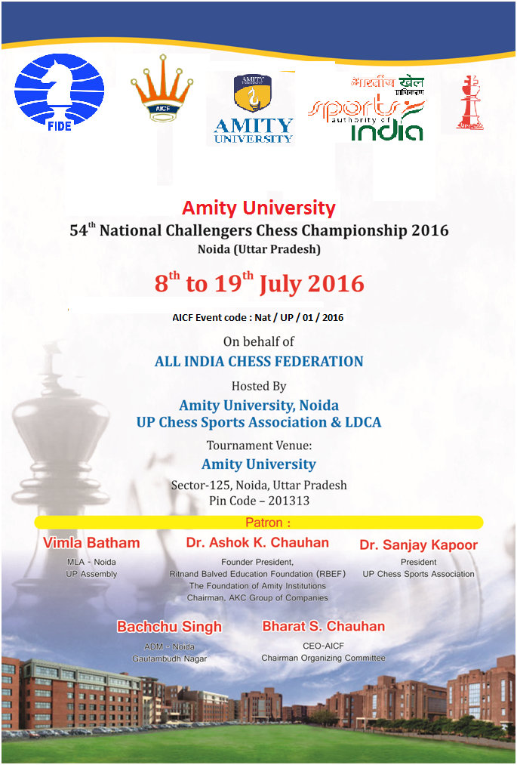

This is not a FIDE Rated chess championship.
Tournament Schedule

08 July 2016 | Arrival | Friday | 09:00 am onwards
08 July 2016 | Inauguration | Friday | 04:00 pm
08 July 2016 | Players Meeting | Friday | 06:00 pm
09 July 2016 | Round-1 | Saturday | 03:00 pm
10 July 2016 | Round-2 | Sunday | 09:30 am
10 July 2016 | Round-3 | Sunday | 04:00 pm
11 July 2016 | Round-4 | Monday | 10:00 am
12 July 2016 | Round-5 | Tuesday | 09:30 am
12 July 2016 | Round-6 | Tuesday | 04:00 pm
13 July 2016 | Round-7 | Wednesday | 10:00 am
14 July 2016 | Round-8 | Thursday | 10:00 am
15 July 2016 | Round-9 | Friday | 10:00 am
16 July 2016 | Round-10 | Saturday | 10:00 am
17 July 2016 | Round-11 | Sunday | 10:00 am
18 July 2016 | Round-12 | Monday | 10:00 am
19 July 2016 | Round-13 | Tuesday | 10:00 am
19 July 2016 | Closing Ceremony | Tuesday | 03:00 pm

Total Prize Fund Rs. 5,00,000/-

Rank | Prize Fund | Rank | Prize Fund
1st | 1,50,000 | 7th | 17,500
2nd | 87,500 | 8th | 12,500
3rd | 62,500 | 9th | 10,000
4th | 37,500 | 10th | 7,500
5th | 30,000 | 11th -20th | 3,750
6th | 22,500 | 21st -30th | 2,500

Dress Code :
As per AICF regulations on Dress code for players participating in all the National championships, all State Associations should send their players including special / Donor entry players with proper uniform (As regards special/donor entry players, the respective state chess associations may collect the cost of the uniform from the players). Players should at least wear uniform T'Shirts / formal shirts (same colour and brand with the name of the State printed prominently at the back and the state chess emblem in the front left side). The name / logo of the sponsors can be permitted. Girls / Women to be also given appropriate uniform dress. The above rule will also be applicable to Special units. Players without proper uniform will not be permitted to take part in the championship. This will be strictly enforced.
Lodging:
Free accommodation will be provided to all the selected participants and one Accompanying official (manager) nominated by concerned State Chess Association for each State. Players and officials availing this facility have to inform the same on or before 02nd July 2016

***Accompanying persons and special entries have to make their own arrangements. If they want to avail this facility may contact the organizers (UP Chess Sports Association) on or before 02nd July 2016.***

Eligibility:
1. Every Affiliated State Association / Institutional Members of All India Chess federation shall be entitled to send four entries. Any state association / institution failed to send its full quota, the vacancies so caused shall not be filled.
2. All Grandmasters, International Masters and Women Grandmasters are seeded.
3. First 6 players from previous National Challengers rankings other than GMs, IMs and WGMs.
4. First 2 players from 2015 under-25 Chess Championship.
5. National Junior Chess Champion from 2015.
6. Winner & Runner-up of the 2015 National Women Challengers Chess Championship.
7. Current World Champion in any category.
8. Current Asian Junior Champion and first three from last Asian Men Chess Championship.
9. The host Association UPCSA shall be entitled to fill additional entries of 2 players.
10. All Board prize winners of the 2015 National Team Chess Championship.
11. Four players approved by AICF will be permitted from areas where no State Chess Association exists.
12. Any Player who remits the prescribed Special Entry fee of Rs. 12,000/- (for Ex- National Premier and National ‘A’ players Rs. 6,000/-). All special entries should come through their respective State Association / Affiliated Unit of AICF. However the AICF/ UP Chess Sports Association/ Organizers reserve the right to accept or reject such entries without assigning any reason thereof.
13. A Nominee of Hon. Secretary of AICF.
14. If total numbers of entries is an odd number, then the host association may add one more entry to make it an even number.
15. Only Indian Nationals are eligible to participate in this championship.

Entries & Entry Fee :

Regular entry Rs. 2,000/- , Special Rs. 12,000/- Ex-National Premier and National ‘A’ players Rs. 6,000/-.
Note: There will be 50% concession in entry fee for participants from North Eastern States and Andaman & Nicobar Islands.

Entries should be received on or before 01 July 2016 at the following address by DD drawn in favor of “UP Chess Sports Association” Payable at Lucknow and thereafter confirm through mail. Late entries will be accepted with late fee of Rs. 250/- per player till 05th July 2016. No entry will be entertained after 05th July 2016
To transfer NEFT/RTGS transaction has to be done in favor of UP Chess Sports Association A/C Union Bank of India, Sachivalaya Branch, Lucknow.

Bank Details
Name of Beneficiary: UP Chess Sports Association
Bank Name: UNION BANK OF INDIA
Branch Name: SACHIVALAYA LUCKNOW
Account No.: 381502010104584
IFSC Code: UBIN538159
City: LUCKNOW

Players Registration:
All participants in the 54th National Challengers Chess Championship must be registered with AICF for the year 2016-2017. Application forms are available in the website www.aicf.in. Those who have already done registration with AICF should send proof for the same. Those who have not registered with AICF for the year 2016-2017 should send an amount of Rs.250/- towards AICF registration fee along with the duly filled and signed AICF player’s registration form plus one passport size photo.
Participants from Uttar Pradesh State are required to obtain UPCSA Registration for the year 2016-2017 by sending an amount of Rs.200/- towards UPCSA registration fee along with the duly filled and signed UPCSA player's registration form plus one passport size photograph in addition to the entry fees.

Tournament Regulations:
1. The tournament will be played under the laws of chess & FIDE Swiss System. Players from the same state should not be paired against each other in the last round of a National championship, except National Premier and Women Premier. However, they may be paired if there is no compatible opponent with the same point group or score group with a maximum difference of 1 point.

2. Zero Minute Rules: The zero tolerance rules will be followed “any player who arrives at chess board after the start of the session shall lose the game. The default time is zero minutes”

3. Total of 13 rounds shall be played.

4. Time control of 90 minutes of each for first 40 moves followed by 30 minutes each for the rest of game with an increment of 30 seconds per move from move no.1

5. Top 9 rankers of this championship will qualify for forthcoming National Premier championship.

6. Smoking & use of alcohol and any other “drugs/Drink” are strictly prohibited inside the venue.

Chess Clocks:
Each participating association must provide at least two DGT chess clocks in working order for every four players sent by that association in the championship.
Tie Break: Following is the order of tie-break:
1) Direct encounter
2) The greater number of wins
3) Buchholz Cut 1
4) Buchholz
5) Sonneborn Berger
In case of tie, cash prizes will not be shared.
Tournament Committee:
The tournament committee consists of Chief Arbiter, Secretary of AICF or his representative, and the secretary and two members of the host association shall be constituted before commencement of the tournament.
Protests:
Protest if any, against the decision of the chief arbiter shall be made in writing with protest fee Rs. 1000/- within 30 minutes of occurrence of the incident. The amount shall be refunded if appeal is upheld. The decision of the appeals committee is FINAL AND BINDING on all players concerned.

Appeals Committee :
Before commencement of the tournament Five Member Appeals Committee shall be formed by AICF/Organizers. All members and the reserves shall be from the different states. No Members of the committee can vote on the dispute in which a player from his own state is involved in such case(s) reserve member(s) shall take his place in the committee. The decision of the appeals committee is Final and Binding on all players concerned.

Withdrawals:
If any player withdraws from the last two rounds in any National Championship on medical grounds, he/she should undergo treatment by a Doctor recommended and supervised by the tournament committee.

Disqualification:
No player shall leave the venue before the prize distribution function without the permission of the Chief Arbiter. The participants disregarding this rule shall be suspended for one year.

Arrears:
The affiliated Association must clear all arrears of affiliation fee / tournament fee including those of current year at the time of submitting the entries. Otherwise the entries are liable to be rejected.

Interpretation:
For interpretation of the rules and deciding any point not covered by rules, the decision of the Tournament Committee shall be final and binding. The Tournament Committee has every right to make any additional or amendment to these rules, without notice. However, such changes/or inclusion will be subject to AICF clearance. Such changes will, however be displayed at the tournament hall.

Boarding:
A lump sum of Rs.1000/- (Rupees One Thousand only) per player will be paid towards
the boarding expenses only to the players who play this championship under normal
entry (qualified and seeded players).

Contact for more Details and confirmation of entry:
Registration and Entry Fee Payment:
Address:- UP Chess Sports Association,
C/o. Mr. A.K. Raizada, Secretary,
H.No. 548, Sector-13, India Nagar
Lucknow UP- 226016
Call : 09451247160, 7703009445
E-mail:- upcsa@rediffmail.com, akraizada@gmail.com

Accommodation:-
1. Shri Arun Kumar Mishra
Mob. : 91 9650475257
2. Shri - Shri Deepak Saigal
Vice President
Up Chess Sports Association
Mob. : +91 8795154369, +91 9415302958
Email : deepak.saigal51@gmail.com

In the case of emergency please contact
1. Shri A.K. Verma 2. Shri Vinay Anand
Hon. Secretary Hon. Treasurer
Delhi Chess Association Up Chess Sports Association
Email : akverma101010@gmail.com Mob. : +91 9893086001
+91 7860000003

For other details please contact

1. Mr. A.K. Raizada 2. Dr. Kalpana Sharma
Hon. Secretary, ( UPCSA ) Director
Call : 09451247160, 7703009445 Amity School of Physical
Education & Sports Sciences
(ASPESS) Call : 9871010619

- How to reach Amity University, Noida
- Noida is NCR territory of Delhi
- Reach Delhi/New Delhi than Catch a Metro Train for Botanical-Noida, there you will get the bus service of Amity University or catch a Auto for Amity University, Sector-125, Noida, Uttar Pradesh
ENTRY FORM
54th National Challengers Chess Championship 2016
Noida (Uttar Pradesh)
8th to 19th July 2016

Name of The Players ………………..…………………….........................................…..…………………………… Open……………………………..…………………………………..…………...............……………. Normal Entry /Special
Entry: ………………………………………..…………………………………. D. D. No.: ……………………...………... Drawn
on : ………………………….………….. Branch: ……………………………………….. Dated: ………………………......……..

Sl. No. | Name of Player | FIDE ID. | AICF ID. | FIDE Rating
1
2
3
4
5
Manager

Association / Affiliated Member Signature & Seal
(Name, Designation & Stamp)

RTGS/NEFT
Name of Beneficiary: UP Chess Sports Association
Bank Name: UNION BANK OF INDIA
Branch Name: SACHIVALAYA LUCKNOW
Account No.: 381502010104584
IFSC Code: UBIN538159
City: LUCKNOW
RAILWAY CONCESSION FORM

To,
The Divisional/Commercial/Area Superintendent,
……………………… Railway,
Dear Sir,
Sub: Rail Concession.
This is to certify that the following players and officials are bona fide participants of the 54th National Challengers Chess Championship 2016 at Amity University, Noida (Uttar Pradesh) from 8th to 19th July 2016 to be organized by UP Chess Sports Association on behalf of All India Chess Federation. This is a recognized event of the All India Chess Federation.
Sl. No. | Name of Player/Official | Date of Birth
1
2
3
4
5

We therefore, request the Rail Concession order may please be issued to them to travel from…………………………… to Delhi and back. The game of Chess is recognized for Rail concession by the Railway Board by their Letter No. TC/11I2035/76, dated 5th April, 1971.
Thanking You,
Yours faithfully,
U P Chess Sports ssociation

(A.K. Raizada)
Gen. Sec., UPCA

