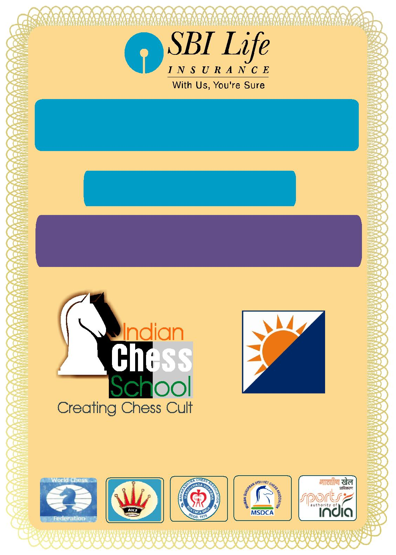

SBI Life 5th NATIONAL AMATEUR

CHESS CHAMPIONSHIP 2016

(AICF EVENT CODE: 142471/MAH/2016)

Dates:

05 -11 November, 2016

Venue:

Thakur College of Science & Commerce

Thakur Village, Kandivali (East), Mumbai - 400101.

ORGANISED BY VENUE PARTNER

T H A K U R

T R U S T S

UNDER THE AEGIS OF

All India Chess Federation

Maharashtra Chess Association

Mumbai Suburban District Chess Association

Arrival | 05 Nov. 2016 | 09.00 hrs.
Managers’/Players’ Meeting | 05 Nov. 2016 | 12.00 hrs.
Inauguration | 05 Nov. 2016 | 14.00 hrs.
Round – 1 | 05 Nov. 2016 | 15.00 hrs.
Round – 2 | 06 Nov. 2016 | 09.30 hrs.
Round – 3 | 06 Nov. 2016 | 15.00 hrs.
Round – 4 | 07 Nov. 2016 | 09.30 hrs.
Round – 5 | 07 Nov. 2016 | 15.00 hrs.
Round – 6 | 08 Nov. 2016 | 09.30 hrs.
Round – 7 | 08 Nov. 2016 | 15.00 hrs.
Round – 8 | 09 Nov. 2016 | 09.30 hrs.
Round – 9 | 09 Nov. 2016 | 15.00 hrs.
Round – 10 | 10 Nov. 2016 | 09.30 hrs.
Round – 11 | 11 Nov. 2016 | 09.30 hrs.
Prize Distribution | 11 Nov. 2016 | 15.30 hrs.

FIDE organizes Amateur Chess Championships under three categories, namely, below 2300, below 2000 and below 1700. But our National amateur Chess Championship will be held only under one category i.e. below 2300 ELO.

However, it was decided that placings will be given as per the above three categories of rating. Therefore, it was resolved that the players should inform in writing the category that they would like to be identified with, to the organizers before the start of the first round of the National Amateur Chess Championship and they would be permitted to participate only in that category in Asian/ World Amateur Chess Championship as per the championship regulations.

2. Eligibility:

i. For the under-2300 section, a player must not have a published FIDE rating of 2300 or greater for at least one year prior to the start of the championship. All players must not hold any title above FM (or WFM for women) in the section Under-2300.

ii. For the Under-2000 section, a player must not have a published FIDE rating of 2000 or greater for at least one year prior to the start of the championship.

All players must not hold any title above CM (or WCM for women) in the sections Under-2000.

iii. For the Under-1700 section, a player must not have a published FIDE rating of 1700 or greater for at least one year prior to the start of the championship. All players must not hold any title above CM (or WCM for women) in the sections Under-1700.

iv. All players registered with their respective State Associations/ AICF affiliated units are eligible to participate in the National Amateur Championship.

  - The State Chess Associations/ AICF affiliated units have the right of sending any number of entries.

  - The National Amateur Women Championship shall be held as a part of National Amateur Chess Championship and female participants are eligible to win both the titles as per performance. However, all the entries should be forwarded by the respective State Chess Associations/Affiliated Units of the players.

  - Only Indian Nationals are eligible to participate in the Championships.

- Dress Code:

As per AICF regulations on Dress Code for players participating in all the National championships, all State Associations should send their players including special/

donor entry players with proper uniform (As regards special /donor entry players, the respective state chess associations may collect the cost of the uniform from the players). Players should at least wear uniform T Shirts /formal shirts (same colour and brand with the name of the State printed prominently at the back and the state chess emblem in the front left side). The name / logo of the sponsors can be permitted. Girls / Women to be also given appropriate uniform dress. The above rule will also be applicable to Special units. Players without proper

uniform will not be permitted to take part in the championship. This will be strictly enforced.

4. Entries/Entry Fee:

All entries including special entries should come through the concerned State Association. Entry fee is Rs. 2000 /- for each player. Players from North East and Andaman and Nicobar Islands will get a discount of 50% on the entry fee. The entry fee should be paid by Demand Draft in favor of Indian Chess School Private Ltd. payable at Mumbai and posted to Mr. Praful Zaveri, 605, Shanti Darshan Apartment, Near Devki Nagar, Off. Eksar Road, Borivali (W), Mumbai – 400103.

The Bank Details for payment via NEFT/RTGS are as follows:

 |  | Bank | Karnataka Bank Limited
 |  | Branch | Vazira Branch, Borivali (W), Mumbai – 400091.
 |  | Account No | 5092000100044001
 |  | Account Type | Current
 |  | IFSC | KARB0000509
 |  | Beneficiary | Indian Chess School Private Limited
Late Fee: Entries received after 20th October, 2016 will be subject to a late fee of Rs. 250/- per player.
No entries will be accepted after November02, 2016

- Prizes:

Total Prize Fund of Rs.1,00,000/- (Rs. One Lakh only)

Prizes | Open(Rs.) | Women(Rs.)
1 | 21,000/- | 10,000/-
2 | 12,000/- | 6,000/-
3 | 8,000/- | 5,000/-
4 | 7,000/- | 4,000/-
5 | 6,000/- | 3,000/-
6 | 5,000/- | 2,000/-
7 | 4,000/-
8 | 3,000/-
9 | 2,000/-
10 | 2,000/-

- System of Play:

The Championship will be played under FIDE’s Laws of Chess and the Swiss system. Totally eleven rounds shall be played.

Players from the same state should not be paired against each other in the last round of a National championship, except National Premier and Women Premier. However, they may be paired if there is no compatible opponent with the same point group or score group with a maximum difference of 1 point. It is applicable only for the top 50% score of the penultimate round.

- Default Time:

The default time for each round will be 15 minutes as per regulations of All India Chess Federation.

- Time Control:

The rate of play shall be 90 minutes with an increment of 30 seconds per move from move number one.

- Tie Break:
Following is the order of tie-break:
- Direct encounter
- The greater number of wins (forfeit included)

- Buchholz Cut 1

- Buchholz
- Sonneborn Berger

In case of tie, cash prizes will not be shared.

- Protest :

Protest, if any, against the decision of the Chief Arbiter shall be made in writing with a protest fee of Rs.1000/- within 30 minutes of the occurrence of the incident. The protest fee will be refunded if the appeal is upheld.

- Appeals Committee:

Before the commencement of the tournament, a five member appeals committee shall be formed by the AICF/organizers. All the members and reserves shall be from different states. No member of the Committee can vote on a dispute in which a player from his own

States is involved and in such case(s) the reserves member(s) shall take his place in the committee.

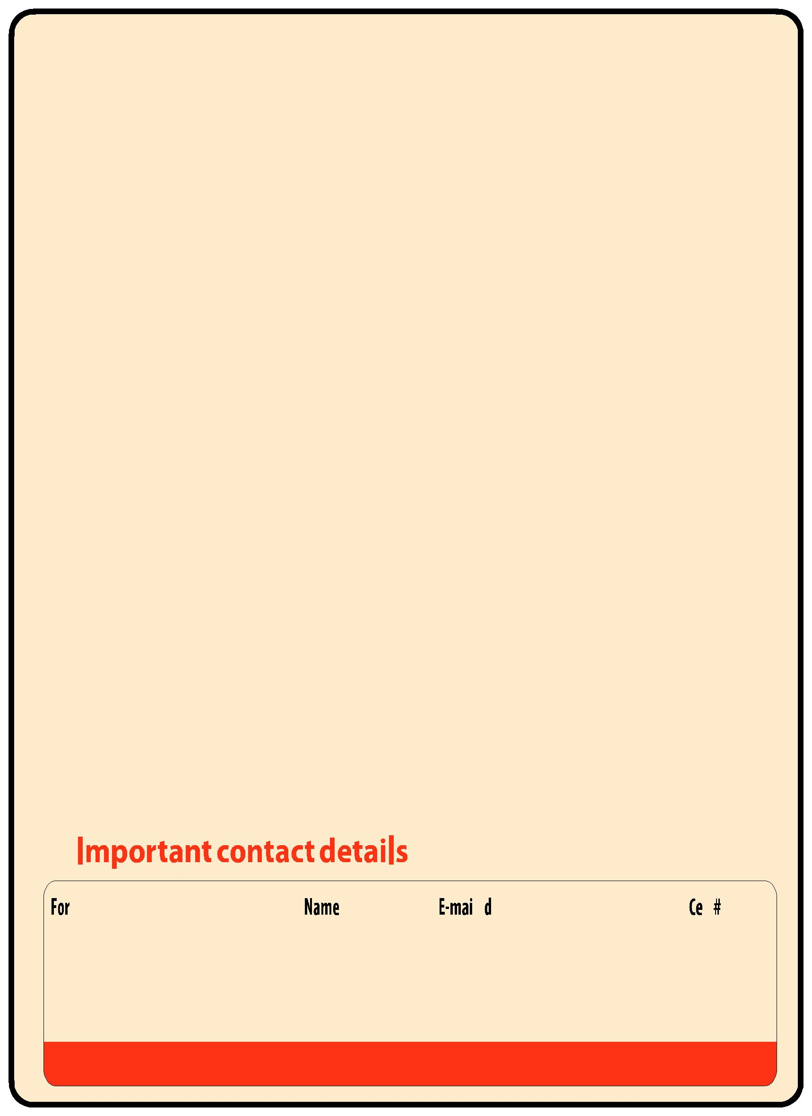
- Tournament Committee:

The organisers will form a tournament committee for the smooth conduct of the National Championship.

- Interpretation:

For interpretation of the rule(s) and deciding any point not covered by the above rules of the tournament, the decision of the Tournament Committee shall be final and binding on all. The Tournament Committee has every right to make any addition or amendment to these rules, without notice. However, such changes/ or inclusion will be subject to AICF clearance. Such changes will, however, be displayed in the tournament hall.

- Withdrawal:

If any player withdraws from the last two rounds in any Nationa Championship on medical grounds, he/she should undergo treatment by a Doctor recommended and supervised by the tournament committee.

15. Disqualification:

No participant will leave the venue before the Prize Distribution function without the permission of the Chief Arbiter. The participants disregarding this rule will be suspended for one year.

16. Registration of Players with AICF:

All participants in the National Championship should be registered with AICF for the year 2016-17. Application forms are available in the website www.aicf.in. Those who have already obtained registration cards from AICF Website for 2016-17 should send photo copy of the same. Those who have paid the AICF Registration fee but are yet to receive the AICF Registration card should send a photo copy of the acknowledgment for having paid the fee to organizers of earlier tournaments or to their association.

17. Arrears:

All arrears of affiliation fee/tournament fee including those of current year must be cleared by the Affiliated Association at the time of submitting the entries; otherwise the entries are liable to be rejected.

- Lodging:

All players have to make their own arrangement for accommodation.

- Rights of Admission:

The organizer has every right to accept or reject any entry without assigning any reasons thereof and the right to admission to the venue also rests with the organizers.

 | FOR | Name | E-Mail id |  | Cell #
 | General Information | Kiran Wadia | kiranwadia@indianchessschool.com |  | 8828421881
 |  | Sandesh Nagarnaik | sandeshnagarnaik@indianchessschool.com |  | 8828421882
 | Tournament Director (Emergency only) | FI. Praful Zaveri | prafulzaveri@indianchessschool.com |  | 8828421888

E-mail: info@indianchessschool.com Website: www.indianchessschool.com

SBI Life 5 ^{th} NATIONAL AMATEUR CHESS CHAMPIONSHIP 2016

Entry Form

(To be completely filled, use CAPITAL letters)

- Full Name

- Father’s Name

- Full Address

4 | Phone No. | Mobile No.
- E-mail

- Date of Birth

7 |  | FIDE ID. |  | 8. FIDE Rating
9 |  | Categories |  | 1700 |  |  |  | 2000 |  |  |  | 2300
10 St ate
11 |  | AICF |  | If previouslyDone
 |  | Registration |  | Name of tournament
 |  |  |  | In current tournament |  |  |  | Receipt No. |  |  |  | Form with Photo
12 |  | MCA |  | If previouslyDone
 |  | Registration |  | Name of tournament
 |  |  |  | In current tournament |  |  |  | Receipt No. |  |  |  | Form with Photo
Fees |  | to be paid :
1) | Tou rnament Entry Fee |  |  |  | Rs. 2000/- |  |  |  | DD No.:
2) | AICF Registration |  |  |  | Rs.250/- |  |  |  | Bank :
3) | MCA Regist^{r}ation |  |  |  | Rs.150/-
4) | Late Fee |  |  |  | Rs.250/- |  |  |  | Date:
TOTAL Rs.
 |  |  |  |  | Signature of player :
 |  |  |  |  | Form Received & verified by:
 |  |  |  |  |  | (Sign and Date)

I hereby declare that all the information provided is true to my belief and knowledge. I will obey all the rules and

Regulations of the Tournament. .

.
…………………………………………………………………………………………......................................................

 |  |  |  |  | Temporary Receipt
Received with thanks from |  |  |  |  |  |  |  |  | the sum of Rupees
by Cash / Demand Draft |  |  |  | Dated |  |  |  | Drawn on____________________
 |  | account of Entry fee of |  |  |  | SBI Life National Amateur Chess Championship

2016, and / or AICF and / or MCA registration fee and / or accommodation charges.

Place:

Date: Receiver’s Signature

