"We are one Family"
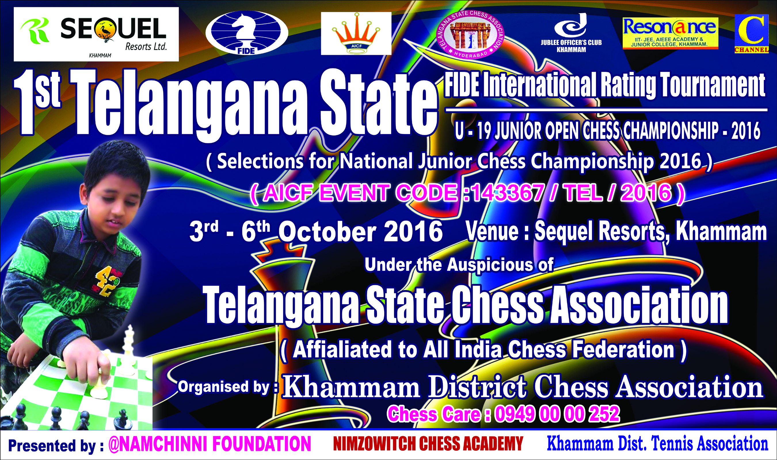
Venue:

1. TOURNAMENT SCHEDULE:

Date | Schedule | Time
3rd October 2016 | Managers’ Meeting  1st Round | 1.00 P.M.  03.00 P.M.
4th October 2016 | 2nd Round  3rd Round | 09.00 A.M  03.00 P.M.
5th October 2016 | 4th Round  5th Round | 09.30 A.M.  03.00 P.M.
6th October 2016 | 6th Round  7th Round | 08.30 A.M  02.30 P.M.
 | Prize Distribution  Departure | 06.30 P.M.  08.00PM

2. Age Limit: Players should be born on or after 1.1.1997
Age Proof: Each participant must produce a valid certificate to prove his / her age. Certificates from School are not enough. Certificates should preferably be from the Panchayat, Municipality or Corporation obtained soon after birth. Players without date of birth certificates will not be allowed to participate.

The date of birth certificates registered within one year of the birth of the child alone will be recognized and allowed to participate. No Dist. association shall recommend any player who doesn’t come under the above criteria.

If any doubt arises about the claimed age of a player, the Tournament Committee has the right to refer the player during the championship for a due evaluation of age by competent medical experts. A player if declared over-age by such experts shall not continue in the championship and the matter shall be reported to TSCA. Protest about the age of players may be made to the Chief Arbiter in writing along with a fee of Rs. 5000/- per player. This will not be refunded. No Protest about over age of a player will be entertained after 2nd round of the championship.

Only the Coach or Manager deputed by participating Dist. Chess Association can lodge such protests. The Tournament Committee has the right to decide the day, time and place for such medical evaluation of age. AICF / Organisers will have the right to refer any player to the medical evaluation of age at any time during the Championship. Players refusing to take the test as decided by the Tournament Committee shall be deemed to have failed the test and shall be disqualified from the Championship.

3. Eligibility: Subject to age limit following players can participate:

i) Four players in each category from every affiliated District Association of TSCA. If any Association fails to send its quota, the vacancies so caused will not be filled.
- Selection : Top 4 in each category will represent Telangana State in National Juniors ( to be held at Rajahmundry, AP from 8th to 16th October 2016)
- Note: Boys category is Fide Rated event. AICF Regn is must.
- TSCA members only can take part in these selections.

- Entry Fee: BOYS Official (District selected top 4 players) Rs. 800/- each., Special Entry : Rs. 1200/- each. FOR GIRLS ENTRY FEE: OFFICIAL: 300/- SPECIAL: 500/- TSCA membership for 2016-17 Rs.200/- is must for all participants.
- The entry form along with entry fee by Demand Draft in favor of A.VENKATESWARA RAO, PRESIDENT, KHAMMAM DISTRICT CHESS ASSOCIATION
ANDHRA BANK, Bastand branch, 075010027001317
2. All entries including special entries should come through the concerned affiliated District Association of TSCA. However, the TSCA will have the right to accept or reject any special entry without assigning any reason thereof.

Entries should be sent to: Sequel Resorts, Khammam.
Late Fee: The last date of receipt of entry is 28.09.2016. Entries received after the last date will attract a late fee of Rs. 250/-. However, no entry will be entertained after 01.10.2016.

3. System of Play: The Championship will be played under FIDE’s Laws of Chess and the
Swiss system. Totally seven rounds shall be played.
Players from the same District should not be paired against each other in the last round of a National championship, except National Premier and Women Premier. However, they may be paired if there is no compatible opponent with the same point group or score group with a maximum difference of 1 point. It is applicable only for the top 50% score of the penultimate round.
4. Default Time: Latest Fide Rules applicable Swiss – League 7 Rounds
5.Time Control: The rate of play shall be 90 minutes with an increment of 30 seconds per move from move number one.

6. Chess Clocks: Each participating District Chess Association must provide at least one clock in working order for every two players entered into the Championship.

- Tie Break: Following is the order of tie-break:
1) Direct encounter
2) The greater number of wins
3) Buchholz Cut 1
4) Buchholz
5) Sonneborn Berger
In case of tie, cash prizes will not be shared.

- Protest : Protest, if any, against the decision of the Chief Arbiter shall be made in writing with a protest fee of Rs.500/-within 30 minutes of the occurrence of the incident. The protest fee will be refunded if the appeal is upheld.

- Appeals Committee: Before the commencement of the tournament, a five member appeals committee shall be formed by the TSCA/organizers. All the members and reserves shall be from different Districts. No member of the Committee can vote on a dispute in which a player from his own District is involved and in the case(s)of the reserves member(s) shall take his place in the committee.

- Tournament Committee: The organisers will form a tournament committee for the smooth conduct of the State Championship.

- Interpretation: For interpretation of the rule(s) and deciding any point not covered by the above rules of the tournament, the decision of the Tournament Committee shall be final and binding on all. The Tournament Committee has every right to make any addition or amendment to these rules, without notice. However, such changes/ or inclusion will be subject to TSCA clearance. Such changes will, however, be displayed in the tournament hall.

- Withdrawal: If any player withdraws from the last two rounds in any State Championship on medical grounds, he/she should undergo treatment by a Doctor recommended and supervised by the tournament committee.

- Disqualification: No participant will leave the venue before the Prize Distribution function without the permission of the Chief Arbiter. The participants disregarding this rule will be suspended for one year.

- Registration of Players with AICF: All participants in the National Championship should be registered with AICF for the year 2016-17. Application forms are available in the website www.aicf.in Those who have already obtained registration cards from AICF Website for 2016-17 should send photo copy of the same. Those who have paid the AICF Registration fee but are yet to receive the AICF Registration card should send a photo copy of the acknowledgment for having paid the fee to organizers of earlier tournaments or to their association.

- Arrears: All arrears of affiliation fee/tournament fee including those of current year must be cleared by the Affiliated District Association at the time of submitting the entries; otherwise the entries are liable to be rejected.
- Lodging: Free Room Wise accommodation will be provided to all the players, officials and office bearers.

- Boarding: Free Boarding
3rd October Dinner, 4^{th,} 5th & 6th October Lunch and Dinner

TSCA Registration: TSCA registration is compulsory for Andhra Pradesh players. TSCA Registration fee is Rs. 200/- for the year 2016-2017. Players registering with TSCA should submit duly filled and signed TSCA Players Registration form along with a copy of their Date of Birth certificate and one passport size photograph. The date of birth certificates registered within one year of birth of the player alone will be recognized and allowed to participate. E-Mail id: anamchinni009@gmail.com.

All unrated players without fide id and playing in a rating tournament for the first time, must compulsorily furnish their e-mail id during registration. Otherwise, their entry will be rejected.

Tournment Committee
- Mr. A. Narasimha Reddy - President TSCA.
- Mr. A.Venkateswara Rao - Tournament Director
- Mr. B.V.Rajagopal - Coordinator
- Mr. Karnati. Veerabhadra Rao - Advisor
- Mr. Ramakrishna Eluri - Advisor
- Mr. K.S.Prasad - Convenor
- Mr. Dr. O.Srinvas Reddy - Co-Convenor
- Mr. K.Karunakar Reddy - Tournment Incharge
- Mr. R.V.Nagendra Kumar - Reception Incharge
10. Mr. Pramodraj Moree - Chief arbiter

For registration please contact Mr.A.Venkateswara Rao at Sequel Resorts, 3rd October 2016 from 1.pm onwards.

Reaching the venue:
1 KM from Railway Station
0.5 KM from RTC Bus stand

ENTRY FORM

To,
The GENERAL Secretary,
Telangana State Chess Association,
State Junior Chess Championships -2016.

Dear Sir,
Sub: Entry for 1st Telangana State Junior Boys (U-19) Open
And
1st Telangana State Junior (U-19) Girls Chess Championships - 2016.

Kindly enroll the entry of our players for the State Under-19 Open and Girls Chess Championships – 2016. We understand that the Championship is held for only TSCA Registered Players. All team members, whose particulars are given below, will abide by the Rules & Regulations of TSCA.

Sr No | Name of the Player | FIDE ID | Date of Birth | Official/  Special (Rs) | AICF  Registration No
 | Open Boys
1
2
3
4
5
6
7
8
 | Girls
1
2
3
4
5
6
7
8

(Copy of age proof should be enclosed)

________________
Signature
Name of Secretary with Seal

____________________________
Name of District unit:(Affiliated to Telangana State Chess Association)
Place: Date:

