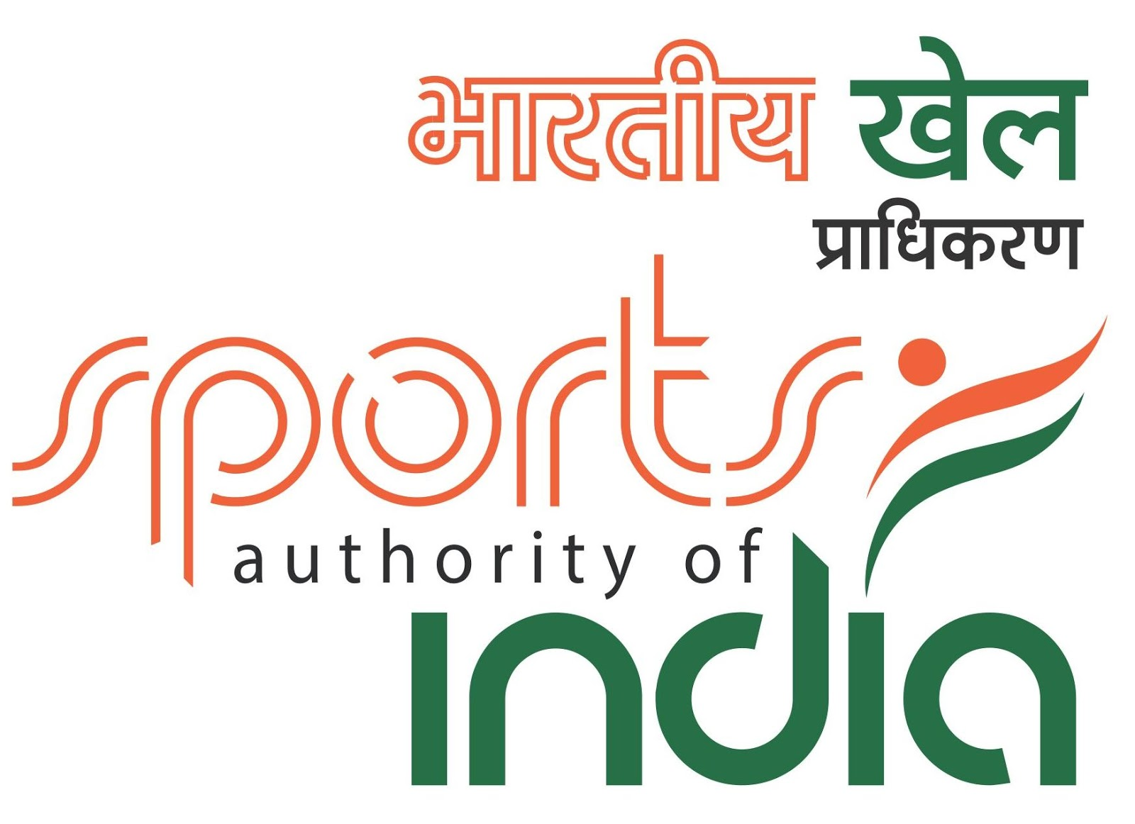
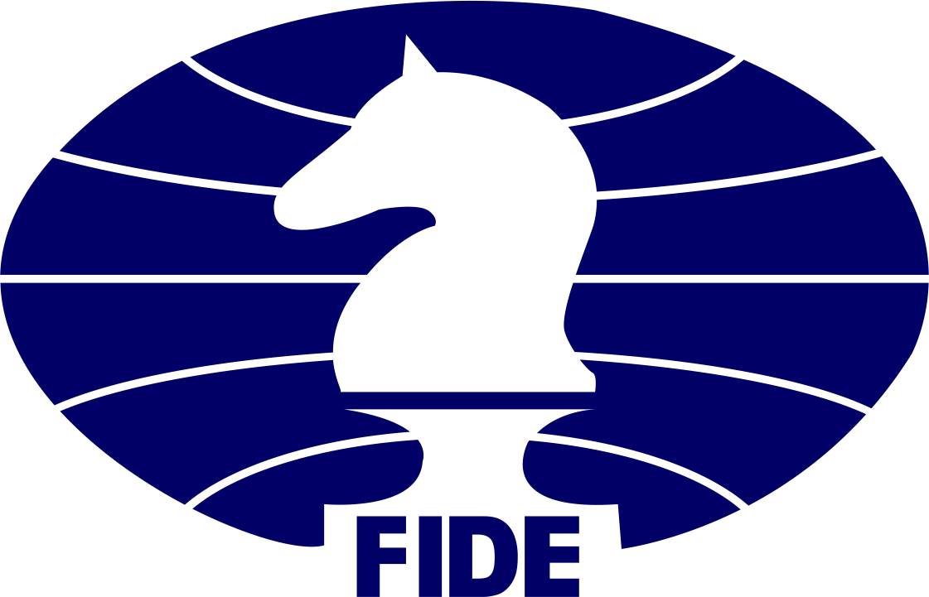
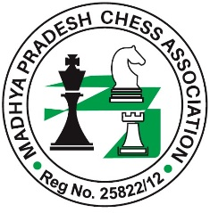
37th NATIONAL TEAM CHESS CHAMPIONSHIP – 2017
(Event Code: 148450 / MP / 2017)
&
15th NATIONAL TEAM CHESS CHAMPIONSHIP FOR WOMEN -2017
(Event Code: 148453 / MP / 2017) Organized by

MADHYA PRADESH CHESS ASSOCIATION

On behalf of
All India Chess Federation (AICF)
From: 02nd to 08th February, 2017
_{Venue:-} Bansal Institute of Science & Technology,
Kokta, Anand Nagar, Bhopal

 | SCHEDULE OF TOURNAMENT
Particulars | Date | Time | Particulars | Date | Time
Arrival | 02Feb..2017 | Before | Registration | 02Feb. | 12.00 hrs
 |  | 10.00 | & Managers | 2017
 |  | hrs. | Meeting
Inauguration | 02 Feb..2017 | 14.00 hrs
Round -1 | 02 Feb..2017 | 16.00 | Round -6 | 05 Feb. | 16.00 hrs
 |  | hrs |  | 2017
Round -2 | 03 Feb..2017 | 09.00 | Round -7 | 06 Feb. | 09.00 hrs
 |  | hrs |  | 2017
Round -3 | 03 Feb.2017 | 16.00 | Round -8 | 07 Feb. | 09.00 hrs
 |  | hrs |  | 2017
Round -4 | 04 Feb.2017 | 09.00 | Round-9 | 08 Feb. | 09.00 hrs
 |  | hrs |  | 2017
Round -5 | 05 Feb.2017 | 09.00 | Prize | 08 Feb. | 16.00 hrs
 |  | hrs | Distribution | 2017

(2) | Total Prize Fund Rs. 2,00,000/-
• Men Team Prizes:
₁st | Rs.25,000/-, 2nd Rs.20,000/-, 3rd Rs.15,000/-, 4th Rs.10,000/-, 5th Rs.7,000/-,
₆th | to 10th Rs. 5,000/- each.
• Women Team Prizes:
₁st | Rs.20,000/-, 2nd Rs.14,000/-, 3rd Rs.10,000/-, 4th Rs.8,000/-, 5th Rs.6,000/-
• Men Team Board Prizes:
₁st | Rs.8,000/-, 2nd Rs.6,000/-, 3rd Rs.4,000/-, 4th | Rs.3,000/-, 5th | Rs.2,000/-
• Women Team Board Prizes:
₁st | Rs.5,000/-, 2nd Rs.4,500/-, 3rd Rs.3,500/-, 4th | Rs.2,500/-, 5th | Rs.1,500/-

+ Trophies & Medals to all Winners.
(3) LODGING :

Sharing Free Non-AC Hostel accommodation will be provided to one selected official, state team members including one reserve and one manager from 02nd to 08thFebruary, 2017. Contact: Mr. Mohit Nayak :- 09893297917
On Payment basis sharing furnished AC rooms are also available on reasonable rates at Kanta Shrawan Palace (A Luxury Hotel)
Address: New fourlane Road,BHEL,Near BPCL petrol pump,Bhopal
For detail Contact- Mr. Sanjay Mishra (General Manager):07583029804
OYO OYO Romms also Available at reasonable rates.
Contact Miss Poonam :8769688369

- ELIGIBILITY :
  - Each affiliated State Association and Institution members of AICF shall be

entitled to send one team for each championship. Additional team shall be treated as special entry and shall pay the special entry fee.

- The host Madhya Pradesh Chess Association is entitled to field one additional team in each championship.

- Any club recommended by the respective AICF affiliated State Association can field a team for each championship by paying the special entry of Rs. 5,000/- per team.
- Only Indian Nationals are eligible to participate in the championships.

- COMPOSITION OF THE TEAM :
Each team (Men & Women) shall consist of four players and one reserve

player. The seeding of the teams will be done on the basis of the average rating of the top 4 players. While sending entries, the names of all the players with their FIDE ID and their respective FIDE ratings, if any, should be given to enable the arbiters to arrive at the teams’ average rating for ranking purposes. These names and ratings should be reconfirmed in person at the Technical Meeting. The Board Order could be decided by the respective team Captain/Manager, before the commencement of the championship.

Dress Code: As per AICF regulations on Dress code for players participating in all the National championships, all State Associations/Institution Members should send their players with proper uniform. Players should at least wear uniform T'Shirts / formal shirts (name of the State/Institution printed prominently at the back and the state chess/Institution emblem in the front left side). Players without proper uniform will not be permitted to take part in the championship. This will be strictly enforced.

- SYSTEM OF PLAY :
The Tournament shall be played under the FIDE Laws of Chess.

- SESSION OF PLAY & TIME CONTROL:
Team Swiss with a time control of 90 minutes each plus 30 seconds

Increment per move from move number one.

- CHESS CLOCKS

Each team must bring at least two DGT chess clocks in working condition.

- TIE BREAK:

Latest tie breaking rules will be applied.

- Default time:

The default time is 15 minutes.

- APPEALS COMMITTEE:
Before the commencement of the Championship a five member committee

of Appeal with two reserves shall also be formed from amongst the senior participants and officials present at the Technical meeting. All the five members and reserves will be from different states. No member of the committee shall vote on a dispute in which a player from as own unit is involved and in such cases the reserve members(s) shall take his/their places in the committee.

- TOURNAMENT COMMITTEE: The organisers will form a tournament committee for the smooth conduct of the National Championship.

- PROTESTS :
Protests, if any, against the decision of the Chief Arbiter shall be made in

Writing to the Chief Arbiter at least within 30 minutes of the incident with a protest fee of Rs. 1000/- which shall be refunded if the appeal is upheld. The decision of the appeals committee shall be FINAL and BINDING on all the participants.

- ARREARS :

All arrears of affiliation fee, tournament fee including that of the current

Year must be cleared by the Affiliated Association / Unit at the time of submitting the entries. Otherwise the entries are liable to be rejected.

- DISQUALIFICATION: No participant will leave the venue before the Prize Distribution function without the permission of the Chief Arbiter. The participants disregarding this rule will be suspended for one year.

- INTERPRETATION: For interpretation of the rule(s) and deciding any point not covered by the above rules of the tournament, the decision of the Tournament Committee shall be final and binding on all. The Tournament Committee has every right to make any addition or amendment to these rules, without prior notice. However, such changes should be approved by the AICF. Such changes will, however, be displayed in the tournament hall.

- REGISTRATION OF PLAYERS WITH AICF IS COMPULSORY :

All participants should get their names registered with AICF. Registration

Forms will be available at the venue on payment of Rs. 250/- for the year 2016-2017. No unregistered player will be allowed to participate in the tournament. If a player is already registered with AICF must show proof thereof.

(18) ENTRIES & ENTRY FEES:
(a) Normal Entry: Rs. 3,000/-, (b) Special Entry: Rs. 5,000/-

The entry fee shall be paid By DD drawn in favor of “Madhya Pradesh chess association” Payable at Bhopal.Madhya Pradesh chess association A/C No. “32804703037”, State Bank of India, Arera hills branch, IFSC Code- SBIN0030461 and thereafter confirm thru mail. Entries with payment should be sent to :

Madhya Pradesh Chess Association,112 Deen Dayal Parishar Bhopal.
Contact No. 09425016455.

Email: mpchess64@gmail.com& cc to : kapilsaxena28@yahoo.com Website: www.mpchess64.com

Last date for entries to be received on or before 27.01.2017 (Late entries will be received till 31.01.2017 with a late fee of Rs. 1000/-). Please note that Cheques/Non MICR DD’s will not be accepted. All entries have to be accompanied with filled in entry form given below.

Registration/Accommodation:

Mr. Sanjay Nayak, ,Event Manager,MPCA, Mob :09584475171
Mr. Mohit Nayak Mob:09893297917
Miss. Harshita Shukla Mob: 08109218988
Mr. Anil Shrivastava, Mob: 09826585046
Mr. Deepak Chiwande, Secretary,BDCA, Mob: 09826325147

Contacts (if Required):

Mr.Kapil Saxena, Hon. Secretary, MPCA , 09425016455

ENTRY FORM

37th NATIONAL TEAM CHESS CHAMPIONSHIP – 2017
&

15th NATIONAL TEAM CHESS CHAMPIONSHIP FOR WOMEN – 2017

Name of Team: ……………..……………………….……………………………………………

Open/Women: ……………..……………………………..………………………………………

Normal Entry/ Special Entry: ………………….………………………………..……………..

D. D. No.: ……………………...…… Drawn on: …………….…………………………………

Branch: …………………………….……………... Dated: ……………………………………..

Sl. No. | Name of Player | FIDE ID | AICF ID | FIDE Rating
1
2
3
4
5
(Reserve)
Manager

Association/Affiliated Member
(Name, Designation & Stamp)

