


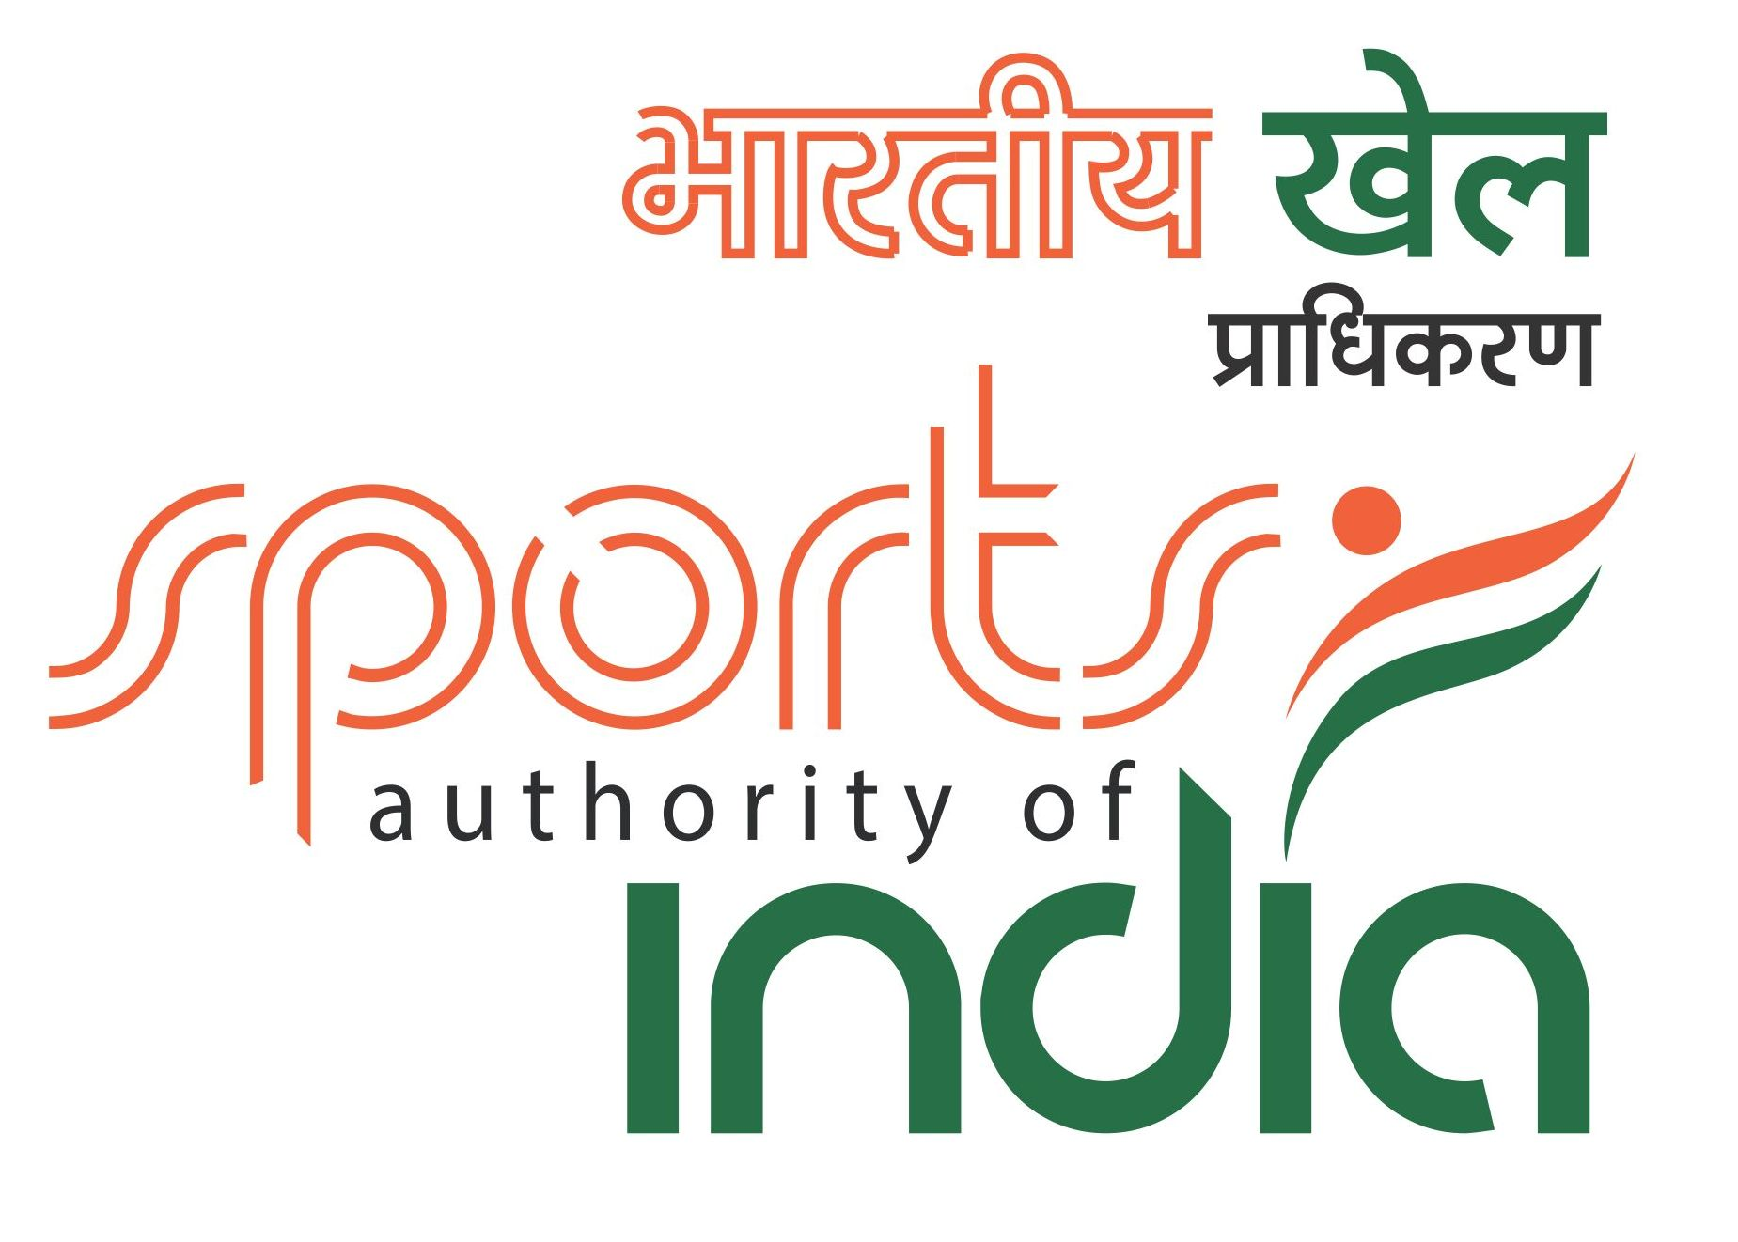

55th NATIONAL CHALLENGERS CHESS
CHAMPIONSHIP-2017
Organized by
GUJARAT STATE CHESS ASSOCIATION
On behalf of
ALL INDIA CHESS FEDERATION
supported by Ministry of Youth Affairs & Sports ( MYAS )
AICF Event Code : 159057/GUJ/2017
Venue : Karnavati Club (A.C. Hall), S. G. Highway, Ahmedabad

Date : 12.8.2017 to 23.8.2017
: Supported by :
Sports Authority of Gujarat, Gandhinagar

: Venue Partner :



: Accommodation Partner :


TOURNAMENT SCHEDULE
12 Aug 2017 | Arrival | Saturday | 09:00 am onwards
12 Aug 2017 | Inauguration | Saturday | 04:00 pm
12 Aug 2017 | Players Meeting | Saturday | 06:00 pm
13 Aug 2017 | Round-1 | Sunday | 03:00 pm
14 Aug 2017 | Round-2 | Monday | 09:30 am
14 Aug 2017 | Round-3 | Monday | 04:00 pm
15 Aug 2017 | Round-4 | Tuesday | 10:00 am
16 Aug 2017 | Round-5 | Wednesday | 09:30 am
16 July 2017 | Round-6 | Wednesday | 04:00 pm
17 Aug 2017 | Round-7 | Thursday | 10:00 am
18 Aug 2017 | Round-8 | Friday | 10:00 am
19 Aug 2017 | Round-9 | Saturday | 10:00 am
20 Aug 2017 | Round-10 | Sunday | 10:00 am
21 Aug 2017 | Round-11 | Monday | 10:00 am
22 Aug 2017 | Round-12 | Tuesday | 10:00 am
23 Aug 2017 | Round-13 | Wednesday | 10:00 am
23 Aug 2017 | Closing Ceremony | Wednesday | 03:30 pm

Total Prize Fund Rs.5,00,000/-

Rank | Prize Fund | Rank | Prize Fund
1st | 1,50,000/- | 7th | 17,500/-
2nd | 87,500/- | 8th | 12,500/-
3rd | 62,500/- | 9th | 10,000/-
4th | 37,500/- | 10th | 7,500/-
5th | 30,000/- | 11th -20th | 3,750/-
6th | 22,500/- | 21st -30th | 2,500/-

Dress Code: As per AICF regulations on Dress Code for players participating in all the National Championships, all State Associations should send their players including Special / Donor entry players with proper uniform (As regards special/donor entry players, the respective state chess associations may collect the cost of the uniform from the players). Players should at least wear uniform T Shirts / formal shirts (same colour and brand with the name of the State printed prominently at the back and the state chess emblem in the front left side). The name / logo of the sponsors can be permitted. Girls / Women to be also given appropriate uniform dress. The above rule will also be applicable to Special units. Players without proper uniform will not be permitted to take part in the championship. This will be strictly enforced.

Lodging:
Free accommodation will be provided to all the selected participants and one Accompanying official (manager) nominated by concerned State Chess Association for each State. Players and officials availing this facility have to inform the same on or before 4th August, 2017

***Accompanying persons and special entries have to make their own arrangements. If they want to avail this facility may contact the organizers (Gujarat State Chess Association) on or before 4th August, 2017.***

Eligibility:
1. Every Affiliated State Association / Institutional Members of All India Chess Federation shall be entitled to send four entries. Any state association / institution failed to send its full quota, the vacancies so caused shall not be filled.
2. All Grandmasters, International Masters and Women Grandmasters are seeded. Such entries should come through their respective State Association / Affiliated Unit of AICF.
3. First 6 players from previous National Challengers rankings other than GMs, IMs and WGMs.
4. First 2 players from 2016 Under-25 Chess Championship.
5. National Junior Chess Champion from 2016.
6. Winner & Runner-up of the 2016 National Women Challengers Chess Championship.
7. Current World Champion in any category.
8. Current Asian Junior Champion and first three from last Asian Men Chess Championship.
9. The host Association Gujarat State Chess Association shall be entitled to fill additional entries of 2 players.
10. All Board prize winners of the 2016 National Team Chess Championship.
11. Four players approved by AICF will be permitted from areas where no State Chess Association exists.
12. Special Entries
Any Player who remits the prescribed Special Entry fee of Rs. 10,000/- (for Ex- National Premier and National ‘A’ players Rs. 6,000/-). All such entries should come through their respective State Association / Affiliated Unit of AICF. However the AICF reserve the right to accept or reject such entries without assigning any reason thereof.

13. A Nominee of Hon. Secretary of AICF.

14. If total numbers of entries is an odd number, then the host association Gujarat State Chess Association may add one more entry to make it an even number.

15. Only Indian Nationals are eligible to participate in this championship.

Entries & Entry Fee :

- Regular entry Rs.2,000/- (Rupees two thousand only)
- Special Rs.10,000/- (Rupees twelve thousand only)
- Ex-National Premier players Rs.6,000/- (Rupees six thousand only)

Note: There will be 50% concession in entry fee for participants from North Eastern States and Andaman & Nicobar Islands.

All Entries including Special entries should come through the concerned State Chess Association/Institutional Members of AICF. However, AICF will have the right to accept or reject any entry without assigning any reason.

Entries should be received on or before 4th August, 2017 at the following address by DD drawn in favour of “Gujarat Sate Chess Association” Payable at Ahmedabad and thereafter confirm through mail. Late entries will be accepted with late fee of Rs.250/- per player till 8th August, 2017. No entry will be entertained after 8th August, 2017.

Entries and Enquiries should be sent to:
Mr. Bhavesh Patel, Hon. Secretary, Gujarat State Chess Association, Rifle Club, Nr. Bhavan’s College, Khanpur, Ahmedabad-380001, Gujarat, INDIA.
(M): +91 9426064702 E-mail: bhavesh.chess@gmail.com

To transfer NEFT/RTGS transaction has to be done in favour of Gujarat State Chess Association account Bank of Baroda, Dariapur Branch, Ahmedabad.

Bank Details
Name of Beneficiary: Gujarat State Chess Association
Bank Name: BANK OF BARODA
Branch Name: Dariapur Branch
Account No.: 03230100024766
RTGS/NEFT/IFSC Code: BARB0DARIAP
City: Ahmedabad

AICF Players Registration:
All participants in the 55th National Challengers Chess Championship must be registered with AICF for the year 2017-18. Application forms are available in the website www.aicf.in. Those who have already done registration with AICF should send proof for the same. Those who have not registered with AICF for the year 2017-18 should send an amount of Rs.250/- towards AICF registration fee along with the duly filled and signed AICF player’s registration form plus one passport size photo.
System of Play: The Championship will be played under FIDE’s Laws of Chess and the Swiss system. Totally thirteen rounds shall be played.
Players from the same state should not be paired against each other in the last round of a National championship, except National Premier and Women Premier. However, they may be paired if there is no compatible opponent with the same point group or score group with a maximum difference of 1 point. It is applicable only for the top 50% score of the penultimate round.

Default time: Default time for arriving to the chess board is 15 minutes.

Time Control: Time control of 90 minutes of each for first 40 moves followed by 30 minutes each for the rest of game with an increment of 30 seconds per move from move no.1

Qualifiers: Top 9 rankers of this championship will qualify for forthcoming National Premier Championship.

Venue : Karnavati Club (A.C. Hall), S. G. Highway, Ahmedabad
Smoking & use of alcohol and any other “Drugs/Drink” are strictly prohibited inside the venue.

Chess Clocks:
Each participating association must provide at least two DGT chess clocks in working order for every four players sent by that association in the championship.
Tie Break: Following is the order of tie-break:
1) Direct encounter
2) Buchholz Cut 1
3) Buchholz
4) Sonneborn Berger
5) The greater number of wins (forfeit included)

In case of tie, cash prizes will not be shared.

Tournament Committee: The organisers will form a tournament committee for the smooth conduct of the National Championship.

Protests:
Protest if any, against the decision of the chief arbiter shall be made in writing with protest fee Rs.1000/- within 30 minutes of occurrence of the incident. The amount shall be refunded if appeal is upheld. The decision of the appeals committee is FINAL AND BINDING on all players concerned.

Appeals Committee :
Before commencement of the tournament Five Member Appeals Committee shall be formed by AICF/Organizers. All members and the reserves shall be from the different states. No Members of the committee can vote on the dispute in which a player from his own state is involved in such case(s) reserve member(s) shall take his place in the committee. The decision of the appeals committee is FINAL and BINDING on all players concerned.

Withdrawals:
If any player withdraws from the last two rounds in any National Championship on medical grounds, he/she should undergo treatment by a Doctor recommended and supervised by the tournament committee.

Disqualification:
No player shall leave the venue before the prize distribution function without the permission of the Chief Arbiter. The participants disregarding this rule shall be suspended for one year.

Arrears:
The affiliated association must clear all arrears of affiliation fee / tournament fee including those of current year at the time of submitting the entries. Otherwise the entries are liable to be rejected.

Interpretation:
For interpretation of the rules and deciding any point not covered by rules, the decision of the Tournament Committee shall be final and binding. The Tournament Committee has every right to make any additional or amendment to these rules, without notice. However, such changes/or inclusion will be subject to AICF clearance. Such changes will, however be displayed at the tournament hall.

Lodging:
Free Dormitory A.C. (Air Conditioned) accommodation on six person sharing basis and transportation from accommodation venue to tournament venue will be provided to seeded/selected players (normal entries) and one accompanying official (Manager or Coach) nominated by the concerned State Chess Association for each State. The address of accommodation for seeded/selected players (normal entries) is GSC Bank, 132’ ring road, Nr. Pallav Cross Road, Nr. Ankur Jain Temple, Naranpura, Ahmedabad. Request for official accommodation must reach before 4th August, 2017 otherwise players/officials have to make their own arrangements. Special Entries and other accompanying persons those who want to avail AC (Double Sharing) accommodation have to contact Mr. Ankit Dalal on (M) +91 7878860008 and Mr. Amit Parikh on (M) +91 9898087374.
This should be paid in advance, while sending their entries, before 4.8.2017 (Separate D.D. favoring “Gujarat State Chess Association” payable at Ahmedabad).

Boarding:
A lump sum of Rs.1000/- (Rupees One Thousand only) per player will be paid towards the boarding expenses only to the players who play this championship under normal entry (qualified and seeded players).

The venue is Karnavati Club, S. G. Highway, Ahmedabad. Nearest Railway Station is Sarkhej and then Kalupur Railway Station. Direct Auto and Bus service to venue is available from Kalupur Railway Station. The nearest major Railway Station in Indian Railway network apart from Sarkhej Railway Station is Kalupur, Sabarmati Railway Station. Nearest Airport is Sardar Vallabhbhai Patel International Airport, Ahmedabad.
Organizing Committee
Ajay Patel
President, Gujarat State Chess Association
Bhavesh Patel
Hon. Secretary, Gujarat State Chess Association
bhavesh.chess@gmail.com

Rakesh Shah Jayesh Modi
Mayur Patel GM Tejas Bakre
Joy Chauhan Ankit Dalal
Samir Shah Dharmendra Pandya
I. G. Parmar Arpi Shah
Nirav Rajasubba Vimal Srivastava

: For Registration :
Bhavesh Patel (E-mail: bhavesh.chess@gmail.com)
Amit Parikh (M) 98980 87374

: For Accommodation :
Ankit Dalal (M) 78788 60008
Amit Parikh (M) 98980 87374

55th National Challengers Chess Championship-2017

Entry Form
To
The Secretary,
Gujarat State Chess Association

Dear Sir,

Sub: Entries for 55th National Challengers Chess Championship - 2017

Kindly enrol the entry of our players for the 55th National Challengers Chess Championship – 2017. Entry fee has been paid by DD favoring “Gujarat State Chess Association”, payable at Ahmedabad. We understand that the Championship is held only for All India Chess Federation (AICF) registered players. All the team members will abide by the Rules and Regulations of AICF.

Sr. No | Name of player | FIDE ID | AICF ID | FIDE Rating
1
2
3
4
5
Manager

With this form, please send following documents:
1) Xerox copy of birth certificate and passport.
2) Entry fee demand draft.
3) A.I.C.F. registration form with registration amount Rs.250/- demand draft in favour of “Gujarat State Chess Association” payable at Ahmedabad. If player is already registered then kindly get the receipt of the details of A.I.C.F. registration for the year 2017-18.

Place: State Chess Association
Date: (Name of the Unit)

Affiliate of All India Chess Federation
Secretary
Seal

To:
The Divisional/ Commercial /Area Superintendent,
………………………Railway………………

Dear Sir,

Sub: Rail Concession

This is to certify that the following players and officials are bona-fide participants of the 55th National Challengers Chess Championship-2017 to be organized by us on behalf of All India Chess Federation at Ahmedabad from 12th to 23rd August, 2017. This is a recognized event of the All India Chess Federation.

Sr.  No. | Name of the Player | Date of Birth
1
2
3
4
5

We therefore, request the Rail Concession order may please be issued to them to travel from _____________________to Ahmedabad and back. The game of Chess is recognized for Rail Concession by the Railway Board by their letter no TC/11I2035/76, dated 5th April 1971.

Thanking you.

Yours faithfully,

(Mr. Bhavesh Patel)
Hon. Secretary
Gujarat State Chess Association

