1st GDCA OPEN FIDE RATED RAPID CHESS TOURNAMENT
AICF EVENT CODE: 161055(R)/KAR/2017
On 12th & 13th August, 2017
Organized by
Gulbarga District Chess Association,
& Promods Chess Academy
In Association with Inner Wheel Club of Gulbarga Suncity

Under the auspices of United Karnataka Chess Association,
All India Chess Federation & FIDE

Venue: Paul Hari’s Auditorium, Rotary club School, Public Garden, Gulbarga.
Total Prize Fund Rs 1 Lakh.

We are Happy to inform you that ‘Promods Chess Academy’ is
Conducting this event for the first time in Gulbarga

Tournament Director: | Gnanadeep M  09986945962
Chief Arbiter | Promodraj Moree  09844042170
Deputy Arbiter | Omkar S Dandoti  9886100178
Assistant Arbiters | Girish Reddy, Kori Amitanand
For online Entry Queries Contact: | Promodraj Moree
For accommodation details hotels | Omkar S Dandoti

ENTRY FEE: ‐ Rs.500/‐ for all
GMGMM
GM, IM, WGM, WIM, and rated players above 2399 will get free entry.
Last date of entry without late fee 5th August 2017,
After that late of Rs 200 till 11th August 2017.
CASH PRIZES:

Open Category Prizes | In Rs | Rating 1799-1999
1st Prize | 20000 +Trophy | 1st Prize | 1000
2nd Prize | 15000 | 2nd Prize | 750
3rd Prize | 10000 | 3rd Prize | 500
4th Prize | 7000
5th Prize | 5000 | Rating 1600-1799
6th to 10th Prize each | 2500 | 1st Prize | 1000
11th to 20th Each | 2000 | 2nd Prize | 750
21st to 25th Each | Rs 1100 | 3rd Prize | 500
 |  | Rating 1400-1599
Best Veteran (Above 55)-1st Prize | Rs 1000 | 1st Prize | 1000
Best Woman (Above 18)-1st Prize | Rs 1000 | 2nd Prize | 750
 |  | 3rd Prize | 500
 |  | Rating 1000-1399
 |  | 1st Prize | 1000
 |  | 2nd Prize | 750
 |  | 3rd Prize | 500

SPECIAL PRIZES: 30 Trophies, will be given to the Top 3 places in
Under 8,10,12,14,16 age groups (Boys & Girls separately in each category)
ENTRY FEE: ‐ Rs.500/‐ for all

Last date of entry fee: 1st August, 2017 (Without late fee) ; With late fee of Rs.200/‐ 11th August ,2017
Entry Limited to first 250 entries. No Spot Entries !!!!!!

Kindly Transfer amount by NEFT or IMPS and send screenshot of payment by wastapp or add details in online entry form. (please note cash deposite in account will not be entertained).
Account Details :
Gulbarga District Chess Association: Acc no.3245101001010, Canara Bank, Savings Account, Adarsh Nagar Branch. Kindly send DD in the name of Gulbarga District Chess Association, payable at Gulbarga. Or NEFT can be done on the same branch the IFSC code is CNRB0003245.
watsapp- 9844042170, email: more_9@rediffmail.com
After transferring the amount by NEFT or IMPS Kindly fill the details of transaction in the online entry form which is available on karnatakachess.com or gulbargachess.weebly.com.

For further details contact: Promodraj Moree: 09844042170
Email: moree_9@rediffmail.com

Rules & Regulations:
1. AICF registration for the year 2017-18 is compulsory for all the players.
2. Unregistered Players can register their name to AICF by paying Rs.250/‐ at the venue with
two passport size photos and birth certificate for the players below 20 years.
3. The Organizer has the right to reject any entry at any time of the tournament without
Showing any reason.
4. The tournament will be conducted under the FIDE laws of chess & Swiss system.
5. Appeals committee: A five member Appeals committee shall be formed on 12‐08‐2017.
6. Tie‐break: Buchholz system will be applied in tie‐break. Prize money will not be shared.
7. Total numbers of rounds are 9 with the time control of 25 minutes + 5 seconds per move
Increment from move 1.
8. Date of Birth certificate is mandatory for claiming category prizes.
9. Any Protest against the decision of Chief Arbiter shall be made in writing with the protest
fee of Rs.500/‐within 15 minutes of the incident occurred. Protest fee will be refunded, if
The appeal is upheld.

Players can get the event results and pairing at website: www.chess‐results.com
Schedule of the tournament
Rd No | Date | Time
1 | 12th August 2017 | 10.30 am
2 | 12th August 2017 | 12.00 pm
 | Lunch Break
3 | 12th August 2017 | 02.00 pm
4 | 12th August 2017 | 4.30 pm
5 | 12th August 2017 | 6.00 pm
6 | 13th August 2017 | 9.00 am
7 | 13th August 2017 | 10.30 am
8 | 13th August 2017 | 12.00 pm
 | Lunch Break
9 | 13th August 2017 | 02.00 pm
Prize Distribution | 13th August 2017 | 5 pm

Players have to make their own arrangement of accommodation, the nearby hotel contact numbers are given below:
1) Pariwar Hotel (is at walking distance from venue), Station Road, Gulbarga: 08472 221522, 9243621522.
2) Prashant Hotel, Beside Railway Station, Gulbarga; Ph- 08472 222351
3) Kapila Lodge (in front of bus stand), Gulbarga: ph 08472-238239/9880737231
4) Hotel Prince: (in front of bus stand), Gulbarga: Ph 08472-251088/251089
5) Hotel Aditya(Around 1 km from venue): 08472 224040, 08472 224042, 9740478140
6) Hotel Udhyan, (Around 1 km from venue): 08472-250786
Other hotels can also be found on -http://www.gulbarga.biz/gulbarga-yellow-pages-hotels--lodging.html

Places of Visit in Gulbarga:
1)Buddha Vihar - A Home of Equality
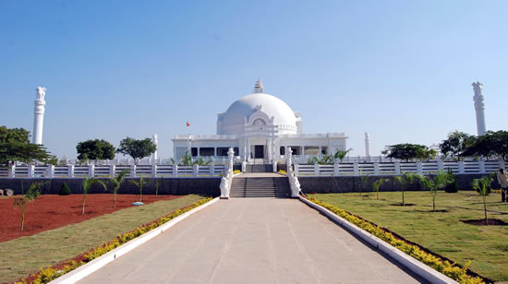
The Buddha Vihar has been constructed under the aegis of the Siddhartha Vihar Trust that was established in 1994. The Vihara hopes to spread the message of peace, compassion and non-violence as taught by the Buddha in order to create a peaceful, egalitarian society where there is tolerance and understanding. The completion of the Vihara is a result of the hard work and generosity of countless workers, volunteers and well wishers towards this noble cause.
The Buddha Vihar is located about six kilometers from Gulbarga city on Sedam Road. The Vihara is spread over 24 acres of land and rises 60 feet above the ground level. The Buddha Vihar is situated on a hillock and is on three levels. Each level is about a hundred feet long. The path to the vihara is covered by greenery on both sides and the Vihara itself is surrounded by gardens, flowers and fruit bearing trees.
2) Sai Mandi r- Situated Nearby ram Mandir, around 3 km from bus stand
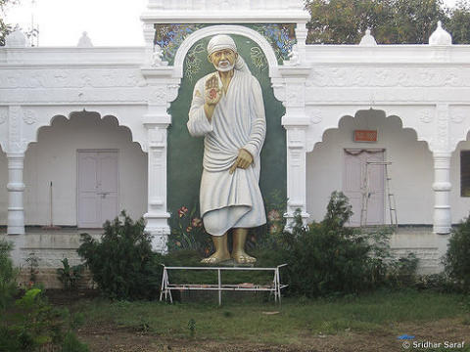
3) Ram Mandir- just around 3 km from bus stand nearby Sai mandir
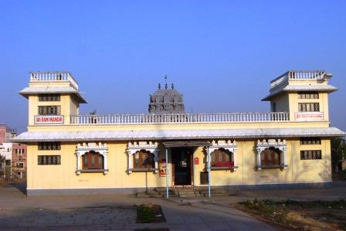

4) Sharanabasaveshwar Temple- The temple houses the Samadhi of Sharana Basaveshwara at the center called the garbha gudi. It has a lake adjacent to it which attracts many devotees and tourists.^{[3]} The lake is currently undergoing renovation and Rs. 1 Crore has been allocated for its development. Its around 2 km from the bus stand & railway station
A chariot festival, Jatra, is held every year in honor of Sharana Basaveshwara; it attracts huge crowds.
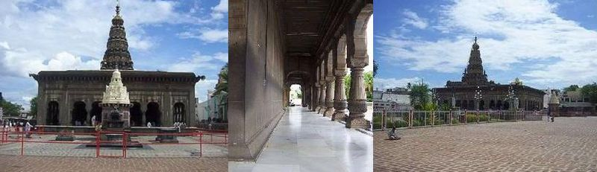

5) Laxmi nagaryan temple- located around 2 km from budh vihar. And around 6 km from railway station
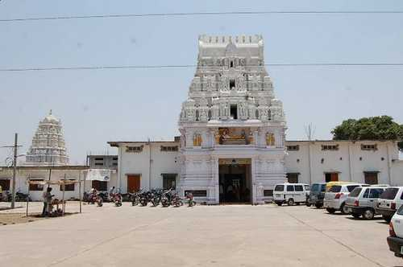

6) Koranti hanuman temple- 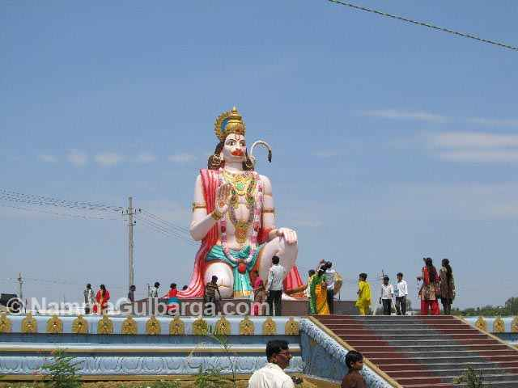
Located around one km from railway station and around 2 km from bustand
7) Asian Mall-
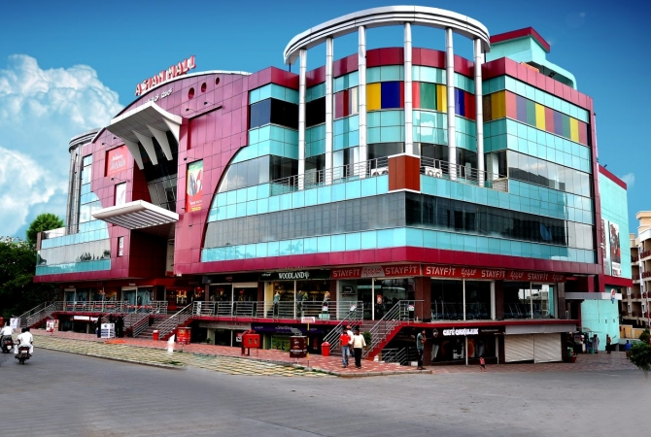
3) Brahmakumar’s Ashram, with models of 12 Jyotirling of shiva

