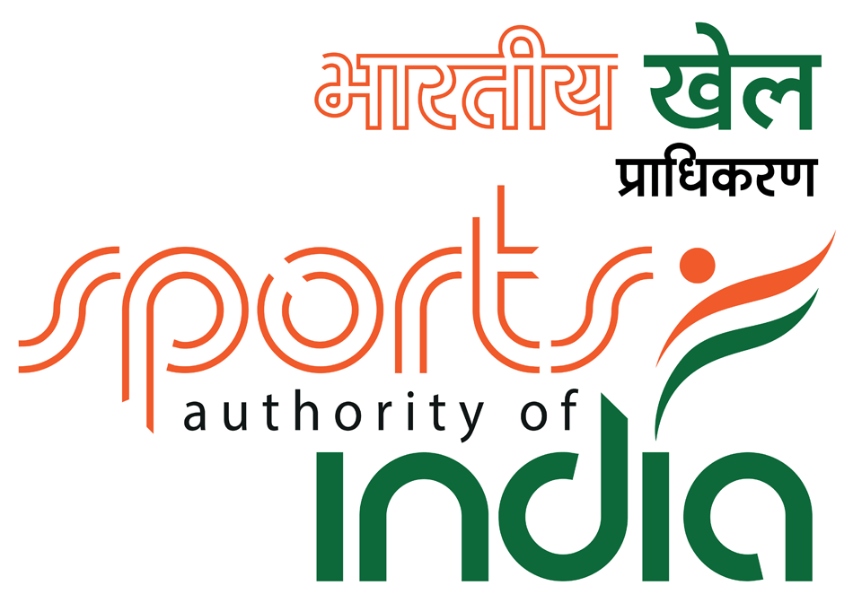

7th NATIONAL SCHOOL CHESS CHAMPIONSHIP - 2018
FIDE Rated event

(AICF Event code no:175406/175407/175408/175409/175410/175411 /175413 / 175414 / 175416 / 175417 / 175418 / 175420 / ORI / 2018)

28thJanuary to 1stFebruary 2018

On behalf of

ALL INDIA CHESS FEDERATION
Under the Aegis of
All Orissa Chess Association
Organized by

KIIT UNIVERSITY
Venue

International Chess Hall, Campus-15(B),
KIIT University, Bhubaneswar, Odisha

1. Invitation :

KIIT University on behalf of All India Chess Federation (AICF), have the honour to invite all the State Associations and all schools* (any Syllabus) in India to participate in the 7thNationalSchool Chess Championships-2018 (Under-7, Under-9, Under-11, Under-13, Under-15 & Under-17 for Open & Girl’s categories) which is going to be held at International Chess Hall, Sports Complex, Campus-15(B), KIIT University, Bhubaneswar.

2. Schedule : Individual Championship

Registration at the Venue | 27th Jan 2018 | 09:00 A.M to 09:00 P.M.
Inauguration / Managers meeting | 28th Jan 2018 | 09:00 A.M.
Round – I | 28th Jan 2018 | 10:00 A.M.
Round – II | 28th Jan 2018 | 03:30 P.M.
Round – III | 29th Jan 2018 | 09:00 A.M.
Round – IV | 29th Jan 2018 | 03:00 P.M.
Round – V | 30th Jan 2018 | 09:00 A.M.
Round - VI | 30th Jan 2018 | 03:00 P.M.
Round - VII | 31st Jan 2018 | 09:00 A.M.
Round - VIII | 31st Jan 2018 | 03:00 P.M.
Round – IX | 01st Feb 2018 | 09:00 A.M.
Prize Distribution | 01st Feb 2018 | 03:00 P.M.

3. Eligibility for Participation:

Only Individuals who are school students and who are Indian Nationals are eligible to participate in this Championship. Players who are Foreign Nationals, and who are with PIO or OCI card cannot participate.

- * All entries should be strictly routed through the respective AICF affiliated state chess association. No direct entries shall be entertained in any circumstances.

- Each State Association or School Association or Schools may enter an unlimited number ofplayers in each of the 12 age groups. The player should be a bona-fide student of a school (anysyllabus). In case that one girl group is less than 10 participants then it will be merged with the same open age group category.

- Entitled to participate are players (Boys & Girls) who shall not have reached the age of 7,9,11,13,15,17 before 1 January, 2018.

- Under 07:Born on or after 1 January, 2011;

- Under 09: Born on or after 1 January, 2009;
- Under 11: Born on or after 1 January, 2007;

- Under 13: Born on or after 1 January, 2005;
- Under 15: Born on or after 1 January,2003;

- Under 17: Born on or after 1 January, 2001;

- **Since there is no separate National School Chess Championship for under 5, players for the Under 5 Asian School Chess Championship 2018, will be identified as per rankings from among the participants in the National School under 7 Chess Championship 2018 subject to their age. Therefore, those planning to participate in the Asian Youth Under - 5 - 2018 (if held) should participate in the National School Under - 7 Chess Championship 2018 to be eligible for consideration.

4. Age Proof: Each participant must produce a valid certificate to prove his / her age. Certificates fromSchool are not enough. Certificates should preferably be from the Panchayat, Municipality or Corporation obtained soon after birth. Players without date of birth certificates will not be allowed to participate.

The date of birth certificates registered within one year of the birth of the child alone will be recognized and allowed to participate. No state association shall recommend any player who doesn’t come under the above criteria.

If any doubt arises about the claimed age of a player, the Tournament Committee has the right to refer the player during the championship for a due evaluation of age by competent medical experts. A player if declared over-age by such experts shall not continue in the championship and the matter shall be reported to AICF. Protest about the age of players may be made to the Chief Arbiter in writing along with a fee of`5000/- per player. This will not be refunded. No Protest about over age of a player will be entertained after 2nd round of the championship.

Only the Coach or Manager deputed by participating State Chess Association can lodge such protests. The Tournament Committee has the right to decide the day, time and place for such medical evaluation of age. AICF / Organizers will have the right to refer any player to the medical evaluation of age at any time during the Championship. Players refusing to take the test as decided by the Tournament Committee shall be deemed to have failed the test and shall be disqualified from the Championship.

5. Dress Code: As per AICF regulations on Dress Code for players participating in all the Nationalchampionships, all State Associations should send their players including special / donor entry players with proper uniform (As regards special / donor entry players, the respective State chess associations may collect the cost of the uniform from the players).

Players should at least wear uniform T Shirts / formal shirts (same color and brand with the name of the State printed prominently at the back and the state chess emblem in the front left side). The name / logo of the sponsors can be permitted. The girls / women are also given appropriate uniform dress. The above rule will also be applicable to Special units. Players without proper uniform will not be permitted to take part in the championship. This will be strictly enforced.

6. Registration:
- Entry fee : `1,500/- (One thousand five hundred only)
Players can pay the entry fee directly to the following account through NEFT and must upload the transaction/ receipt while filling online. Please note that cash deposit inaccount will not be entertained.

Name of Account : All Orissa Chess Association
S.B. Account Number : 523202010019483
Name of the Bank : Union Bank of India
IFSC Code : UBIN0552321
Name of the Branch : Nayapalli, Bhubaneswar

- Online entry
- Online entries can be made at :https://goo.gl/forms/eA3wHLYRmPyfcbMt2

- Names, FIDE ID, DOB will be sent to respective state association for approvals. Registration to participate will be subject to respective state association approvals.

- Online Procedure :
Proper attachments has to be uploaded along with the form.Keep ready the following before filling the form :

- Scanned Pass-port size photograph (size : up to 1 MB)
- Scanned copy of your birth certificate from Panchayat / Municipality / Corporation, registered within one year from birth only be accepted). (size : up to 1 MB)
- AICF Certificate (if medical test qualified. (size : up to 10MB)
- Payment proof (size : up to 1 MB)
- The certificate from the school mentioning that he/she is a bonafide student of the school. (size : up to 1 MB)

Entry queries regarding registration can be mailed to

Suresh Chandra Sahoo
International Arbiter,
Email :scsbadal@gmail.com
Mobile : +91-9776118644

- Last date for receipt of entry: Last Date 15thJanuary 2018, with Late Fee `300/- Till 24thJanuary 2018, After this date, organizers reserve the right to refuse or decline late registrations.
- Players should come with following documents :
- Pass-port size photo
- Original Date of Birth Certificate.
- AICF Certificate (if medical test qualified)
- Payment Proof
- The certificate from the school mentioning that he/she is a bonafide student of the school.

Note: No Entry fees will be accepted through any other agencies.

7. AICF Registration:

All participants in the National Championship should be registered with AICF for the year 2017-18. Online AICF Registration is available in the website www.aicf.in. Those who have already obtained registration cards from AICF Website for 2017-18 should send photo copy of the same. Those who have paid the AICF Registration fee but are yet to receive the AICF Registration card should send a photo copy of the acknowledgment for having paid the fee to organizers of earlier tournaments or to their association. Before the championship all the players must be registered with AICF for the year 2017-18. No entry will be accepted without AICF Player’s Registration for 2017-18.

8. AOCA Registration:
Players from Odisha State are required to obtain AOCA Registration for the year 2017 – 2018 by sending an amount of `150/- towards AOCA registration fee along with dully filled and signed AOCA Player’s Registration form (available in the website www.odishachess.com) plus one passport size photograph in addition to the entry fees.

9. System of Play:
The Championship will be played under FIDE Laws of Chess and total nine rounds shall be played in each category. In case that one girl group is less than 10 participants then it will be merged with the same open age group category.

Players from the same state should not be paired against each other in the last round of a National championship, except National Premier and Women Premier. However, they may be paired if there is no compatible opponent with the same point group or score group with a maximum difference of 1 point. It is applicable only for the top 50% score of the penultimate round.

10. Default Time: Default time for arriving to the chessboard is 15 minutes.

11. Session: The rate of play shall be 90 minutes with an increment of 30 seconds per move from move number one.

12. Chess Clocks: Each participating State Chess Association must provide at least one clock in working order for every two players entered into the Championship.

13. Tie Break: Following is the order of tie-break:
- Direct encounter
- Buchholz Cut 1

- Buchholz

- Sonneborn Berger
- The greater number of wins (forfeit included)
14. Appeals Committee:

Before the commencement of the championship, a five member Appeals Committee shall be formed by the AICF/ Organizers. All the members and reserves shall be from the different states. No member of the Committee can vote on dispute in which a player from his own state is involved and in such case(s), the reserves shall take his place in the committee. The decision of the Appeals Committee is final and binding on players concerned.

15. Protest:
Protests, if any, against the decision of the Chief Arbiter, shall be made in writing with protest fee of `1,000/- within one hour of the occurrence of the incident. The amount shall be refunded if the appeal is upheld.

16. Interpretation:
For interpretation of the Rules and deciding any point not covered by Rules, the decision of the Tournament Committee shall be final and binding. The Tournament Committee has every right to make any additional or amendment to these rules without prior Notice. However, such changes or inclusion will be subject to AICF clearance. Such changes, however, will be displayed at the Championship venue.

17. Prizes/Medals/Merit Certificates:
Chess books/chess CDs will be given as prizes apart from Trophy and medals. Trophies/Medals and Merit Certificates will be given to top 3 players of each category plus the youngest boy and the youngest girl in the championship. All players will be given certificate of participation. It is mandatory for all the participants to attend the Inauguration and Prize distribution Ceremony.

18. Tournament Committee: The organizers will form a tournament committee for the smooth conduct of the National Championship.

19. Accommodation:
Players have to make their own arrangement for their stay during the event.Sufficient accommodation (Dormitory / Furnished / Guest House) are available at nominal cost. Interested participants/ accompany can avail on spot.

The Accommodation offered during the National School Chess Championship 2018 is given as below.

1. 1 BHK Quarter Accommodation : (Non A/c)
Type of rooms : 1 Bed room, 1 hall, 1 kitchen and 1 bathroom
No. of Person : 6 nos max. ; Tariff : Rs. 1500/- Per day.
Distance from Tournament venue : 0.5 km
Limited Availability - First Come First Serve Basis.

2. Boys/ Girls Hostel A/C Accommodation :
Type of Rooms : A/C Twin Sharing attached bathroom
No. of Persons : 2-3 nos ; Tariff : Rs.1000/- per day
Distance from Tournament venue : 0.5 km
NOTE : ONLY GENTS ARE ALLOWED IN BOYS HOSTEL & LADIES IN GIRLS HOSTEL
For availing both Hostel and Quarter accommodation, the confirmation should be sent by Mail in : sports@kiit.ac.in

3. Dormitory Accommodation :
Sufficient Furnished Dormitory Accommodation are available during the event and can be avail on spot during the registration.
Rs.100 per person/Per day

4. Guest House Accommodation :
KIIT Hospitality offers different types of rooms with the given tariff :
KIIT Residency
58 Executive Room & 2 (Two) Suites
Executive Rooms @ Rs. 2500.00
Suite Room @ Rs. 3500.00
Distance from the Venue : 1.2 km

KIIT Guest House (Campus – 6)
35 Deluxe Rooms
Deluxe Rooms @ Rs. 2500.00
Distance from Tournament venue : 0.5 km

KIIT Guest House (Corporate)
15 Standard rooms
Standard Room @ Rs. 1500.00
Distance from the Venue : 1.2 km
(Taxes as applicable)
For Booking in any Guest House Accommodation , Please contact :
KIIT Guest House
Ph- 0674-2726301 /Mr.Prasant : 7978963107
email : kiitguesthouse@kiit.ac.in

N.B.FAMILIES CAN ONLY AVAIL QUARTER/GUEST HOUSE ACCOMMODATION.

20. Cafeteria / Refreshment and other food Amenities: Food will be available on payment basis. Other refreshment available in near by Food Courts of KIIT University.

Any queries may contact through mail

Miss.Aparajita Gochhikar,
Manager-Administration, KIIT
Email : sports@kiit.ac.in

7th NATIONAL SCHOOL CHESS CHAMPIONSHIP – 2018
OPEN / GIRLS
Category : U-7 / U-9 / U-11 / U-13 / U-15 / U-17

FIDE ID : __________________ AICF ID : ______________________

Name in Full : ______________________________________________________

Date of Birth : __________________ Birth Registration Date : _______________

Name of School : ____________________________________________________

Address : __________________________________________________________

__________________________________________________________________

District : ___________________________State : _________________________

Mobile : ______________________ Email : ______________________________

AOCA (Only for Odisha players) Registration for 2017-18 : YES/ NO

AICF Registration for 2017-18 : YES / NO

Payment Details :___________________________________________________

I have understood the enclosed rules & regulations. I agree to abide by them.

Signature of the Participant

Secretary/Seal
State Chess Association/
Affiliated to All India Chess Federation

Encl. : (i) Pass-port size photo, (ii) Original Date of Birth Certificate, (iii) AICF Certificate (if medical test qualified), (iv) Payment Proof, (v) The certificate from the school mentioning that he/she is a bonafide student of the school.

