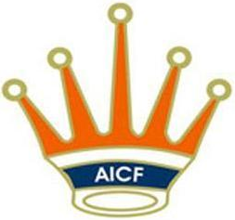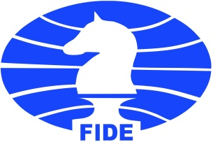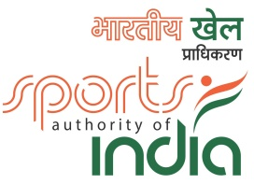
44th National Under-15 Open &
35th National Under-15 Girls Chess Championships-2018

AICF Event Code:188626 / 188627 / WB / 2018

Date :17th – 25th JULY, 2018

: Organized By :

Bengal Chess Association

Under the Aegis of In Association With

: VENUE :

JIS COLLEGE OF ENGINEERING
Block A, Phase III,
Kalyani, Nadia - 741235 West Bengal

: Supported by :
Ministry of Youth Affairs & Sports

Sports Authority of India
DEPARTMENT OF SPORTS AND
YOUTH AFFAIRS, GOVT. OF WEST BENGAL

- Tournament Schedule:

Particulars | Date | Day | Time
Arrival | 17th July 2018 | Tuesday | 0600 hrs.
Manager’s Meeting | 17th July 2018 | Tuesday | 1000 hrs.
Inauguration | 17th July 2018 | Tuesday | 1300 hrs.
Round - 1 | 17th July 2018 | Tuesday | 1400 hrs.
Round - 2 | 18th July 2018 | Wednesday | 0930 hrs.
Round - 3 | 18th July 2018 | Wednesday | 1530 hrs.
Round – 4 | 19th July 2018 | Thursday | 1100 hrs.
Round - 5 | 20th July 2018 | Friday | 0930 hrs.
Round - 6 | 20th July 2018 | Friday | 1530 hrs.
Round - 7 | 21stJuly 2018 | Saturday | 1100 hrs.
Round - 8 | 22ndJuly 2018 | Sunday | 1100 hrs.
Round - 9 | 23rdJuly 2018 | Monday | 1100 hrs.
Round - 10 | 24thJuly 2018 | Tuesday | 1100 hrs.
Round - 11 | 25th July 2018 | Wednesday | 1100 hrs.
Prize Distribution | 25th July 2018 | Wednesday | 1600 hrs.
Departure | 25th July 2018 | Wednesday | 1900 hrs.

- Age Limit: Players should be born on or after 1.1.2003

Age Proof: Each participant must produce a valid certificate to prove his /her age. Certificates from School are not enough. Certificates should preferably be from the Panchayat, Municipality or Corporation obtained soon after birth. Players without date of birth certificates will not be allowed to participate.

The date of birth certificates registered within one year of the birth of the child alone will be recognized and allowed to participate. No state association shall recommend any player who doesn’t come under the above criteria.

If any doubt arises about the claimed age of a player, the Tournament Committee has the right to refer the player during the championship for a due evaluation of age by competent medical experts. A player if declared over-age by such experts shall not continue in the championship and the matter shall be reported to AICF. Protest about the age of players may be made to the Chief Arbiter in writing along with a fee of Rs.5000/- per player. This will not be refunded. No Protest about over age of a player will be entertained after second round of the championship.

Only the Coach or Manager deputed by participating State Chess Association can lodge such protests. The Tournament Committee has the right to decide the day, time and place for such medical evaluation of age. AICF / Organisers will have the right to refer any player to the medical evaluation of age at any time during the Championship. Players refusing to take the test as decided by the Tournament Committee shall be deemed to have failed the test and shall be disqualified from the Championship.
- Prizes

The cash prizes will be awarded to 20 players in each category amounting to Rs.2,50,000/- as below:

Prizes | Boys | Girls
1 | 25,000 | 25,000
2 | 18,000 | 18,000
3 | 15,000 | 15,000
4 | 12,000 | 12,000
5 | 10,000 | 10,000
6 | 7,000 | 7,000
7 | 6,000 | 6,000
8 | 5,000 | 5,000
9 | 4,000 | 4,000
10 | 3,000 | 3,000
11 to 20 | 2,000 each | 2,000 each

- Eligibility: Subject to age limit following players can participate:

- Four players in each category from every affiliated State Association of AICF. If any Association fails to send its quota, the vacancies so caused will not be filled.

- Top four players from 2017 National Under-15 Open & Girls Chess Championships are eligible to participate as seeded players in their respective categories.

- The top two players from 2017 National U-13 Open and Girls Championships are eligible to participate as seeded players in their respective categories.

- The Champions from 2017 National Under-11 Open & Girls Chess Championships are eligible to participate as seeded player in their respective category.

- 2017 World Champion in any category subject to age stipulation.

- 2017 World No.2 & 3 Under-14 and Under-16 categories subject to age stipulation.
- 2017 Asian U-16 top three rankers subject to age stipulation.

- 2017 Asian Under-14 Champion.

- The winner and runner up of 2017 National U-15 Girls Championship are eligible to play in open section subject to age stipulation.

- The winner of 2017 National Under-13 Girls Championship is eligible to play in open section.

- Current National Champion in any higher category subject to age stipulation.

- All GMs / IMs are seeded in Open Section and all WGMs / WIMs are seeded in Girls Section subject to age stipulation.
- Any other player who remits the prescribed Special Entry Fee of Rs.5,000/-. Such entries should come through the respective affiliated State Association.

- Host Bengal Chess Association is entitled to fill two additional players in each category.

- The AICF Secretary has a discretionary seat in each category in this Championship

- Two players in each category approved by AICF will be permitted from areas where no State Association exists.

- If the number of participants at the start of the championship is an odd number in a category, the host association can add one entry to make it even.

- Only Indian Nationals are eligible to participate in the championships.
- In addition to the above, three additional entries from the state which won Gold, two entries from the State which won the Silver and one additional entry from the State which won the Bronze in the National Sub Junior Chess Championships 2017 shall beaccepted.Open: Maharashtra (Gold) 3, West Bengal (Silver) 2 and Telengana (Bronze) 1. Girls: Maharashtra (Gold) 3, Uttar Pradesh (Silver) 2 and Odisha (Bronze) 1.
And these entries from the State Associations shall be given only from the Rank list of their respective State Championships with proof and not to anybody else.

- Dress Code: As per AICF regulations on Dress Code for playersparticipating in all the National championships, all State Associations should send their players including special / donor entry players with proper uniform (As regards special / donor entry players, the respective state chess associations may collect the cost of the uniform from the players). Players should at least wear uniform T Shirts / formal shirts (same colour and brand with the name of the State printed prominently at the back and the state chess emblem in the front left side). The name / logo of the sponsors can be permitted. Girls / Women to be also given appropriate uniform dress. The above rule will also be applicable to Special units. Players without proper uniform will not be permitted to take part in the championship. This will be strictly enforced.

- Entries/Entry Fee: All entries including special entries should comethrough the concerned State Association. However, AICF will have the right to accept or reject any entry without assigning any reason. The Entry form should be sent together with attested copy of original date of birth certificate (Birth Certificates from Panchayat / Municipality /Corporation only accepted)

Entry Fee Structure:

Ordinary entry: Rs.1000/- (Rupees one thousand only) Special entry: Rs.5000/- (Rupees five thousand only)

There will be a 50% concession in entry fee for participants from North Eastern
States and Andaman & Nicobar Islands.
All entries including Special entries should come through the concerned
State Association. However, the AICF will have the right to accept or reject
any entry without assigning any reason.
Entry fee will be accepted strictly online through:
http://aicf.in/national-tournament-registration/
for clarification and guidance regarding submission of entries, please
contact: aicfnationalentries@gmail.com

Late fee: Please note entry fee structure is valid till 10th July, 2018.Thereafter a late fee of Rs.250/- per player will be levied. No entry will be entertained after 15thJuly, 2018 (up to 18:00 hrs.).

System of Play: The Championship will be played under FIDE’s Lawsof Chess and the Swiss system. Totally eleven rounds shall be played.

Players from the same state should not be paired against each other in the last round of a National championship, except National Premier and Women Premier. However, they may be paired if there is no compatible opponent with the same point group or score group with a maximum difference of 1 point. It is applicable only for the top 50% score of the penultimate round.

- Default Time: Default time for arriving to the chessboard is 15minutes.

- Time Control: The rate of play shall be 90 minutes with an incrementof 30 seconds per move from move number one.

- Chess Clocks: Each participating State Chess Association mustprovide at least one clock in working order for every two players entered into the Championship.

- Tie Break: Following is the order of tie-break:

  - Direct encounter

  - Buchholz Cut 1

  - Buchholz

  - Sonneborn Berger

  - The greater number of wins (forfeit included)

In case of tie, cash prizes will not be shared.

11. Draw Agreement: Players shall not agree for a draw without the consent of the arbiter, before each player makes 30 moves.

- Protest: Protest, if any, against the decision of the Chief Arbiter shallbe made in writing with a protest fee of Rs.1000/- within 60 minutes of the occurrence of the incident. The protest fee will be refunded if the appeal is upheld.

- Appeals Committee: Before the commencement of the tournament,a five member appeals committee shall be formed by the AICF/organizers. All the members and reserves shall be from different states. No member of the Committee can vote on a dispute in which a player from his own States is involved and in such case(s) the reserves member(s) shall take his place in the committee.

- Tournament Committee: The organisers will form a tournamentcommittee for the smooth conduct of the National Championship.

- Interpretation: For interpretation of the rule(s) and deciding anypoint not covered by the above rules of the tournament, the decision of the Tournament Committee shall be final and binding on all. The Tournament Committee has every right to make any addition or amendment to these rules, without notice. However, such changes/ or inclusion will be subject to AICF clearance. Such changes will, however, be displayed in the tournament hall.

- Withdrawal: If any player withdraws from the last two rounds in anyNational Championship on medical grounds, he/she should undergo treatment by a Doctor recommended and supervised by the tournament committee.

- Disqualification: No participant will leave the venue before the PrizeDistribution function without the permission of the Chief Arbiter. The participants disregarding this rule will be suspended for one year.

- Registration of Players with AICF:
The participants are informed that AICF player’s registration is mandatory and it should be done well before participating in any tournament. From 01st September, 2017 all registration by players will be accepted only through online. For renewal of AICF Registration of existing players, please see the link
http://aicf.in/players/ and for fresh AICF registration, please the link htpp://aicf.in/online-player-registration/
Note: One passport size (less than 1 MB) photograph in jpeg format should be uploaded.

- Arrears: All arrears of affiliation fee/tournament fee including those ofcurrent year must be cleared by the Affiliated Association at the time of submitting the entries; otherwise the entries are liable to be rejected.

- Accommodation:

Free dormitory accommodation will be provided to all the selected and seeded players.
For special entries, separate arrangement has been made at the venue on payment basis. Contact our accommodation in charge for details and booking.

- Boarding:
A lump sum of Rs.1500/- (Rupees one thousand fivehundred only) will be paid by the organizers towards the boarding expenses, only to the affiliated State Associations’ seeded and selected players who play this championship under normal entry fee.

ORGANIZING COMMITTEE

Patron-In-Chief: Prof. Saikat Maitra (Vice Chancellor, MAKAUT)
Patron: Mr. Taranjit Singh (MD, JIS Group)
Chairperson Organizing Committee: Prof. Sila Singh Ghosh
Joint Organizing Secretary: Mr. Ashtam Sau
Mr. Pradyut Kar
Convener: Mr. Atin Sengupta
Tournament Director: Mr. Atanu Lahiri
Entries & Enquiry: Mr. Souvik Chakraborty (9051054136)
Lodging: Mr. Antarip Roy (9051298038)
Reception & Transport :Mr. Amar Roy:(8697681808)

VENUE MAP

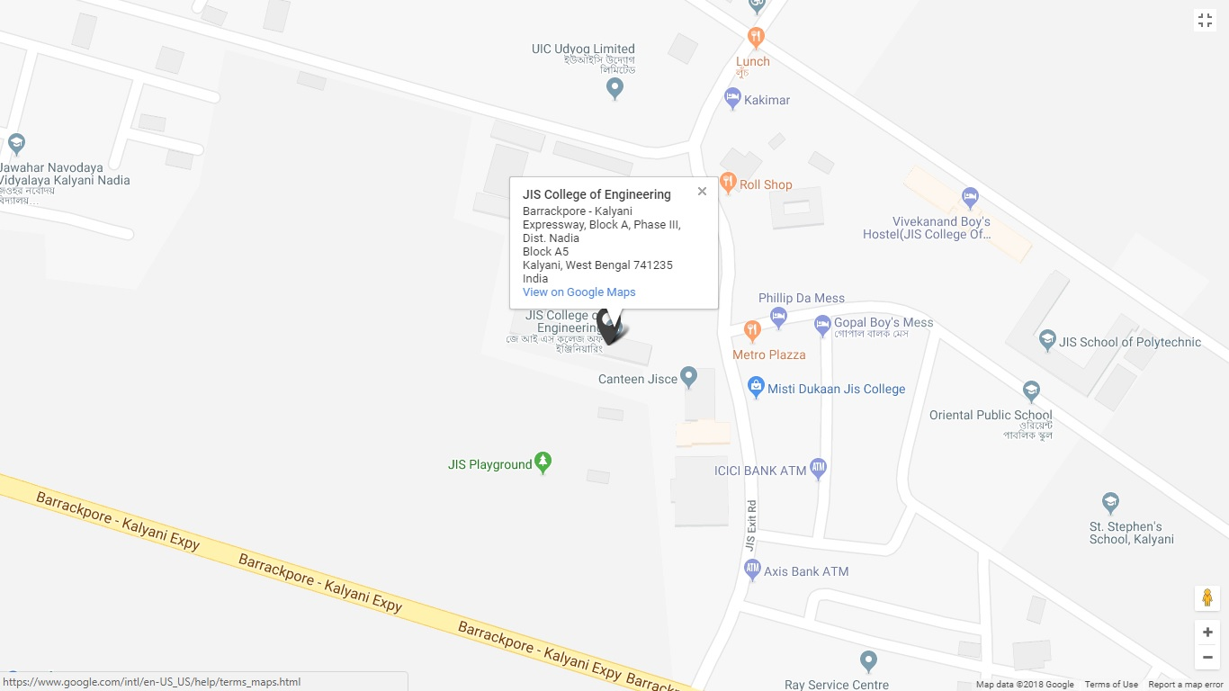
https://www.google.co.in/maps/search/jis+college+of+engineering/@22.959563,88.4466449,17z/data=!3m1!4b1
Kalyani: It is the first planned township of West Bengal, located 45 Kilometres North of Kolkata on the bank of River Hooghly. It is accessible by local trains from Sealdah in Kolkata which run frequently and takes 75 minutes. Alternatively, National Highway and Kalyani Expessway take an hour ride by road.

Places of Interest Near Kalyani:
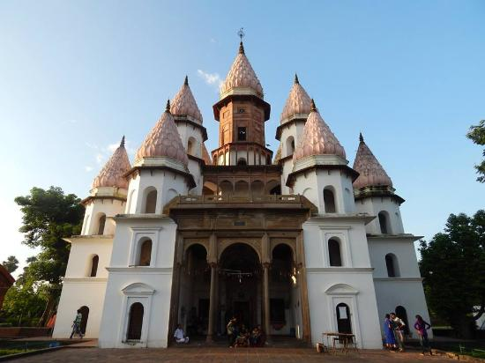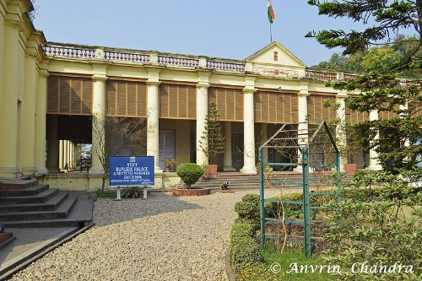
Hangseshwari Temple Shrine Basilica Bandel Chandannagar Museum

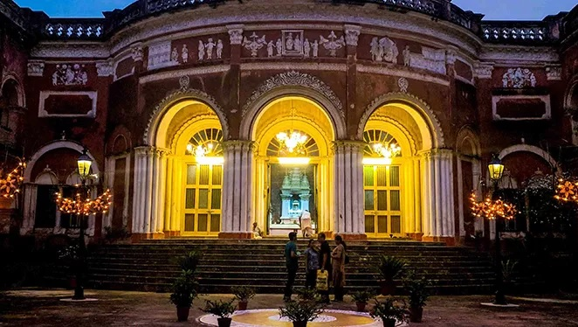
ItachunaRajbari

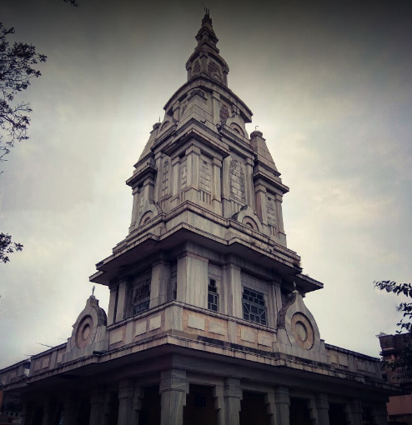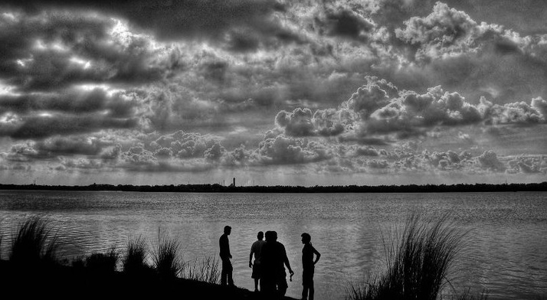
Shanderswartala Temple Middle field Island.

44th National Under-15 Open & 35th National Under-15
Girls Chess Championships-2018

Entry Form
To
The Secretary,

Bengal Chess Association

Dear Sir,

Sub: Entries for 44th National Under-15 Open & 35th National Under-15 Girls Chess Championships - 2018

Kindly enroll the entry of our players for the “44thNational Under-15 Open & 35th

National Under-15 Girls Chess Championships–2018”.Entry fee has been paid through online.We understand that the Championship is held only for All India Chess Federation (AICF) registered players. All the team members will abide by the Rules and Regulations of AICF.

Sr. No Name of player | FIDE ID | AICF ID FIDE Rating

1

2

3

4

5

Manager

With this form, please send following documents:
- Xerox copy of birth certificate and passport.

- Proof for entry fee payment

- Receipt of the details of A.I.C.F. registration for the year 2018-19.

Place: State Chess Association

Date:

(Name of the Unit)

Affiliate of All India Chess Federation

Secretary
Seal

44thNational Under-15 Open & 35thNationalUnder-15 Girls Chess Championships-2018

To:
The Divisional/ Commercial /Area Superintendent,

………………………Railway………………

Dear Sir,

Sub: Rail Concession

This is to certify that the following players and officials are bona-fide participants of the “44thNational Under-15 Open & 35thNationalUnder-15 Girls Chess Championships-2018” to be organized by us onbehalf of All India Chess Federation at Kolkata from 17th – 25thJuly,2018. This is a recognized event of the All India Chess Federation.

Sr. | Name of the Player | Date of Birth
No.
1
2
3
4
5

We therefore, request the Rail Concession order may please be issued to them to travel from _____________________to Kolkata and back. The game of Chess is recognized for Rail Concession by the Railway Board by their letter no TC/11I2035/76, dated 5th April 1971.

Thanking you.

Yours sincerely,

(Mr. Atanu Lahiri)
Secretary

Bengal Chess Association

