1st Sri Anand Chess Wings All India Fide Rated
Open Chess Tournament-2018
ORGANIZED BY
Sri Anand Chess Wings Academy
UNDER THE AIEGES OF
ALL INDIA CHESS Federation , APCA & CAGD
AICF Event Code: Event code: 181773 / AP / 2018 Dates: 16th Feb to 19th Feb -2018
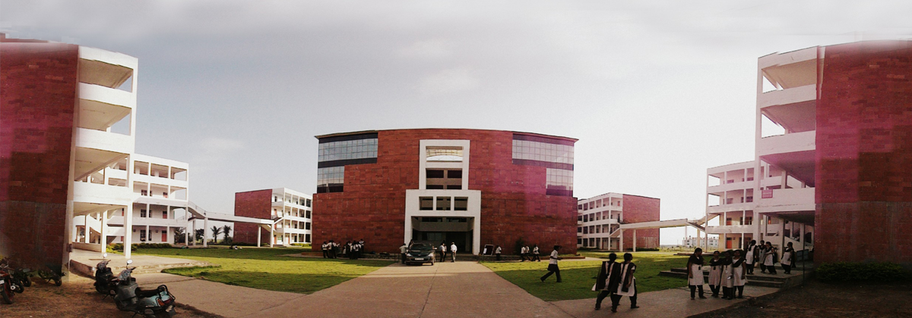
Venue: VVIT Engineering college Nambur , Guntur-522508, Andhra Pradesh

Inauguration: 9:00 am on Friday 16th February -2018.
Players Meeting: 10:00 am
Total Cash Prize: 3,00,100/-
Total No. of Prizes :108
No. of Cash Prizes :- 58 No. of Mementoes :- 50

Main Cash Prizes
Prizes | Main Category | Below 1501 to 1850 | Below 1251 to 1500 | Unrated to 1250
1st | 35,000 + | 15,000 + | 15,000 + | 15,000 +
2nd | 25,000 + | 10,000 + | 10,000 + | 10,000 +
3rd | 15,000 + | 5,000 + | 5,000 + | 5,000 +
4th | 10,000 /- | 4,000 /- | 4,000 /- | 4,000 /-
5th | 8,000 /- | 3,000 /- | 3,000 /- | 3,000 /-
6th | 7,000 /- | 2,000 /- | 2,000 /- | 2,000 /-
7th | 6,000 /- | 2,000 /- | 2,000 /- | 2,000 /-
8th | 5,000 /- | 2,000 /- | 2,000 /- | 2,000 /-
9th | 5,000 /- | 2,000 /- | 1,500 /- | 1,500 /-
10th | 5,000 /- | 2,000 /- | 1,500 /- | 1,500 /-
11th | 4,000 /-
12th | 4,000 /-
13th | 3,000 /-
14th | 3,000 /-
15th | 3,000 /-
16th to 20th | 2,000 /- Each
21st & 22nd | 1,500/- Each

Age Group Prizes
Under-7 | Boys-5 Mementoes & Girls -5 Mementoes
Under-9 | Boys-5 Mementoes & Girls -5 Mementoes
Under-11 | Boys-5 Mementoes & Girls -5 Mementoes
Under-13 | Boys-5 Mementoes & Girls -5 Mementoes
Under-15 | Boys-5 Mementoes & Girls -5 Mementoes

Consolation prizes
Best Veteran(55+) | 1st prize - 2,000 /- | 2nd prize - 1,500 /-
Best Local Player | 1st prize - 2,000/- | 2nd prize - 1,500/-
Best Women(Above 18yrs) | 1st prize - 2,100/- | ------------
Best Physically Handicapped | 1st prize - 1,000 /- | ------------

Indian Income Tax Act and Rules will be applicable
Please Note that one player will be given one (Higher) prize only

Tournament schedule:- Rounds 16th to 19th Feb 2018 , 8 Rounds (Swiss System)
Round-1 11:00 16-02-2018 , Round-5 09:00 18-02-2018
Round-2 16:00 16-02-2018 , Round-6 15:00 18-02-2018
Round-3 09:00 17-02-2018 , Round-7 08:00 19-02-2018
Round-4 15:00 17-02-2018 , Round-8 14:00 19-02-2018 , 18:00 PRIZE DISTRIBUTION
Walk- Over (default time) is only 15 Minutes from start of round

Entry Fee:
Rating above 2400 : Free , Rest all players Rs. 1500/-
No request towards waiver of entry fee will be entertained. The last date of entry : 12th Feb 2018
Entries with late fee of Rs. 250 may accept between 13th Feb to 16th Feb 2018 till 8:30 am
Spot entries will be accepted at venue with late fee till 8:30 am
Eligibility:-
All are Eligible Rated and Unrated Players.
Payment Mode:
Entry fee can be paid through WWW.EASYPAYCHESSENTRY.COM , WWW.PAYCHESSENTRY.COM
Those who are forwarding entry by online are to carry the proof of payment during the event for verification.

Entry Form:
As per FIDE Regulations, Registration and Licensing of players are mandatory. So it is mandatory to forward the entry form in the given format with all details for accepting the entries along with prescribed entry fee. Those don’t have FIDE ID & AICF ID can leave the column blank. Organizers have the right to accept or reject any entry without assigning any reason.

Tournament Rules:
- System of Play The tournament will be conducted as per FIDE Laws of chess and FIDE Swiss system with 8 rounds
- Time Control:- Time control 90 Minutes with Increment of 30 Seconds from 1st move
- Tie Break:- Direct Encounter, BH (Cut 1 least scoring opponent), BH (No Cut ), SB (No Cut), Greater Number of Victories (including forfeits).

Aicf Registraiton:
All Participants should be registered with AICF for the year 2017-2018. Online AICF Registration is available in the website www.aicf.in . Those who have already obtained registration cards from AICF Website for 2017-18 should send photo copy of the same. Those who have paid the AICF Registration fee but are yet to receive the AICF Registration card should send a photo copy of the acknowledgement for having paid the fee to organizers of earlier tournaments or to their association. Before the tournament all the players must be registered with AICF for the year 2017-18.
Note: Players should submit their email ID’S and Date of Birth proof compulsory.
APCA Registraiton: APCA registration for 2017-18 is compulsory for all Andhra Pradesh Participants. The registration fee of Rs. 100/- will be accepted at the venue for the convenience of the players.

Protests: If any is to be given in writing within 15 minutes of the occurrence, with a fee of Rs. 5,00/- which will be refunded if the protest is upheld by the appeals committee.
Withdrawals :- A player may withdraw at any stage of the event, after informing the chief arbiter in writing.
ACCOMMODATION:-
Lodging will be provided free for first 150 Members with first come first serve basis. Rest of all players/ Parents can arrange their own accommodation.

Food Facility:-Good Quality Vegetarian Food and Snacks at reasonable price will be available at the venue.

For Registraion and Accommodation & In emergency Contact
Mr. M Gopinadh (Organizing Secretary )( Accommodation) (Registration) +91- 9703049378
Mr. M. Sambasiva Rao (Organizer) (Registration) +91-73308 30863

Mr. Shaik Abdul Nabi (Organizing )(Registration) +91- 9666725719

Mr. G Venkata Kumar FA (Chief Arbiter) +91- 9848374133

Mr. Vijay Kumar Agarwal FA (Deputy Chief Arbiter) +91- 9948715153

Mr. YD Rama Rao (APCA President)

Mr. Ch Ravindra raju( CAGD Secretary)

Email: anandchesswings64@gmail.com, srianandchesswings@gmail.com

Important note :-
- The entry fee once paid is non-refundable.
- Electronic Devices, Phones , wrist watches, Bags Strictly not allowed in tournament hall.

1st Sri Anand Chess Wings All India Fide Rated Open Chess Tournament-2018
Entry Form
Name ( In Block Letters) | :
Father’s Name | :
Address | :
DOB | :
FIDE ID | :
FIDE Rating | :
Mobile No | :
Email Id (compulsory) | :
AICF Registration | : | Attach Proof of your registration or duly filed registration form along with fee
Accommodation Requirement | :
Payment Details | :

Declaration
I declare that I didn’t participated in any of unauthorized event listed by the All India Chess Federation.

Place:
Date: Signature
------------------------------------------------------------------------------------------------------------------------------------------

Receipt

Received with thanks from Mr/Ms.________________ of ________________________ to participate in the 1st Sri Anand Chess Wings Fide Rated Open Chess Tournament, Guntur from 16th Feb to 19th Feb, 2018.

Authorized Signatory

