1st. MAYNU OPEN
FIDE RATED CHESS TOURNAMENT-2018
Hyderabad, 4th. to 8th.Novembor- 2018
AICF Event Code : 195110/TEL / 2018
Total Prize Fund : Rs. 8,00,100/-
Venue:
GHMC Multipurpose Community Hall
Near Secunderabad Railway station, Bhoiguda,Secunderabad,Telangana-500003.

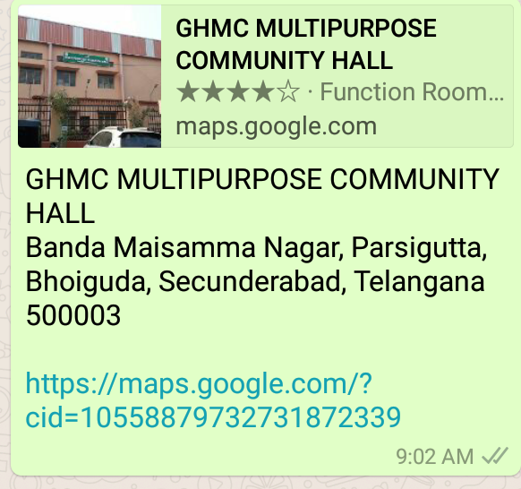

Inauguration: 10:30 am. on Sunday 4th. Novenbor-2018
Organized by:
TELANGANA STATE CHESS ASSOCIATION (TSCA) &
FAYAZ CHESS ACADEMY (FCA)

Total Cash Prizes: Rs. 8,00,0100/-
MAIN CASH PRIZES

Prizes | Main Category | Below 1999 | Below 1699 |  | Below 1399 | Below 1099  And Unrated
1st | 75,100 + | 25,000 + | 25,000 + |  | 25,000 + | 25,000 +
2nd | 50,000 + | 20,000 + | 20,000 + |  | 20,000 + | 20,000 +
3rd | 30,000 + | 15,000 + | 15,000 + |  | 15,000 + | 15,000 +
4th | 20,000 | 10,000 | 10,000 |  | 10,000 | 10,000
5th | 15,000 | 8,000 | 8,000 |  | 8,000 | 8,000
6th | 12,000 | 6,000 | 6,000 |  | 6,000 | 6,000
7th | 10,000 | 5.000 | 5.000 |  | 5.000 | 5.000
8th | 9,000 | 5,000 | 5,000 |  | 5,000 | 5,000
9th | 8,000 | 4,500 | 4,500 |  | 4,500 | 4,500
10th | 7,000 | 4,000 | 4,000 |  | 4,000 | 4,000
11th to 15th | 6,000 Each
16th to 20th | 5,000 Each
21st to 25th | 4,000 Each
SPECIAL CASH PRIZES

Prizes | Best Veteran (60+) | Best Female (20+) | PH. VISU. Challenged (60%) | Best  Telangana | Best  A.P | Best  TN
1st | 5000 + | 5000 + | 5000 + | 5000 + | 5000 + | 5000 +
2nd | 4500 + | 4500 + | 4500 + | 4500 + | 4500 + | 4500 +
3rd | 4000 + | 4000 + | 4000 + | 4000 + | 4000 + | 4000 +
4th | TROPHY | TROPHY | TROPHY | TROPHY | TROPHY | TROPHY
5th | TROPHY | TROPHY | TROPHY | TROPHY | TROPHY | TROPHY
SPECIAL MEDALS/TROPHIES

S,NO CATEGORY TROPHIES |  |  | SL NO CATEGORY TROPHIES
1 | U-7 (Boys&Girls) TOP TEN |  | 8 | Maximum Entries From Academy TROPHY
2 | U-9 (Boys&Girls) TOP TEN |  | 9 | Maximum Entries From School TROPHY
3 | U-11(Boys&Girls) TOP TEN |  | 10 | Best Hyderabad - Male & Female TOP 3
5 | U-15(Boys&Girls) TOP TEN |  | 11 | Best R.R. - Male & Female TOP 3
6 | Best Academy (Top 5 Players) TOP 3 |  | 12 | Best Telangana - Male & Female TOP 3
7 | Best School (Top 5 Players) TOP 3 |  | 13 | Best Non-Telangana - Male & Female TOP3

Indian Income Tax Act and Rules will be applicable
Please note that one player will be given one (higher) prize only.
Tournament Schedule

Arrival 3rd. November- 2018 6.00pm.
Rounds 04.November- 2018 11:30 pm.

Rounds
04.11.2018 11:30 am. Round 1 | 06.11.2018 2:00 pm Round 6
04.11.2018 4:00 pm. Round 2 | 07.11.2018 9:30 am. Round 7
05.11.2018 9:30 am. Round 3 | 07.11.2018 2:00 pm. Round 8
05.11.2018 2:00 pm Round 4 | 08.11.2018 9:30 am. Round 9
06.11.2018 9:30 am. Round 5 | 08.11.2018 3:00 pm. Prize Distribution Ceremony

Entry Fee
Early Bird discount Rs.400/- each for before 30th. September-2018
For GMs, IMs, WGMs, WIMs : Free

Entry Fee: Rs. 3700/-
(Non refundable or Non-transferrable)
Hyderabad,R.R. players : Rs. 3300/- (No lodging will be provided)
A discount of 1200/- in entry fee will be granted to veteran (60 +) & P.C. – VISU. Challenged (60% +)
No request towards waiver of entry fee will be entertained

The last date of entry: 25th.Oct-2018
Entries with late fee of Rs. 500 Up to 1st.Nov- 2018
Entries will also be accepted at the venue till 20:00 Hrs. on 3rd. November-2018 with a late fee of Rs. 1,000/-No request towards waiver of entry fee or waiver of late fee will be entertained.
FREE
- All participants get free lunch
- Free Dormitory accommodation
- Accompanying person shall pay Rs. 2000/- (five nights) for double sharing basis.

Tournament Committee |  | Organizing Committee
- Narasimha Reddy  President-TSCA  Chairmen of tourney |  | SHAIK FAYAZ  Director- FCA  Organizing Secretary
K.S.Prasad  Secretary-TSCA  Tournament Director |  | S,Subbaraju  Jo. Organizing Secretary
M.Anjaiah  Tresurer-TSCA  Tournament-In Charge |  | B.Vijaya Bhaskar  Organizing In charge School
B.V.Rajgopal  Vice President-TSCA  Tournament-In Charge |  | Ramarajasekhara Reddi K  Organizing In charge
Major K.A.Siva Prasad  President-RRDCA  Tournament-In Charge |  | A,Janardhan Reddy  Media Incharge
Entry Form
As per FIDE Regulations, Registration and Licensing of Players are mandatory. So it is mandatory to forward the entry form in the given format with all details for accepting the entries along with prescribed entry fee. Those don’t have FIDE ID & AICF ID can leave the column blank. Organizer’s have the right to accept or reject any entry without assigning any reason.
AICF Registration:
All participants should be registered with AICF for the year 2018-19. Online AICF Registration is available in the website www.aicf.in. Those who have already obtained registration cards from AICF Website for 2018-19 should send photo copy of the same. Those who have paid the AICF Registration fee but are yet to receive the AICF Registration card should send a photo copy of the acknowledgment for having paid the fee to organizers of earlier tournaments or to their association. Before the tournament all the players must be registered with AICF for the year 2018-19.
TSCA Registration: TSCA registration for 2018-19 is compulsory for all Telangana participants. The
registration fee of Rs.250 /- will be accepted at the venue for the convenience of the players.

Protests: If any is to be given in writing within 15 minutes of the occurrence, with a fee of Rs.
1,000/- which will be refunded if the protest is upheld by the appeals committee

IN EMERGENCY PLEASE CONTACT :

Mr. Shaik Fayaz ( Organizing Secretary) +91- 888 5817 666
Mr. S.Subbaraju FA (Registration) +91- 98667 02431
Mr. Sri Nandan ( Accommodation) +91- 912 1414 999
Mr. Promodraj Moree FA (Chief Arbiter) +91- 98440 42170
Email: sky786way@gmail.com - a2hchess@gmail.com

Tournament Rules:
System of Play:
The tournament will be conducted as per FIDE Laws of Chess and FIDE Swiss System with 9 rounds.
Time Control :
90 Minutes with 30 second increment from move 1
Tie Break:
In case of a tie, the latest FIDE Rules shall come in to effect. The Cash prizes however will not be shared and one player will be eligible for one higher prize only.

Entry Registration
All the entries entry fee Pay Online / Transfer online:

Account details :

A/C Name : fayaz chess academy
Axis Bank
Nacharam branch,HYDERABAD
A/c No, : 9180 20080 664905
IFSC Code : UTIB0003241
Or
www.paychessentry.com, www.chessfee.com,

Those who are forwarding entry by bank deposit are to carry the original proof of deposit during the event for verification.

1st.MANUU OPEN FIDE RATED CHESS TOURNAMENT-2018
4th. to 8th.Nov- 2018
AICF Event Code : 195110/TEL / 2018

Entry Form

Name | :
Fathers’ Name | :
Address | :
DOB | :
FIDE ID | :
FIDE Rating | :
Telephone no | :
Mobile no | :
Email id | :
AICF Registration | : | Attach Proof of your registration or duly filled registration form along with fee.
Accommodation Requirement | :
Payment Details | :
Declaration

I declare that I didn’t participate in any of unauthorized event listed by the All India Chess Federation.

Place:
Date: Signature

