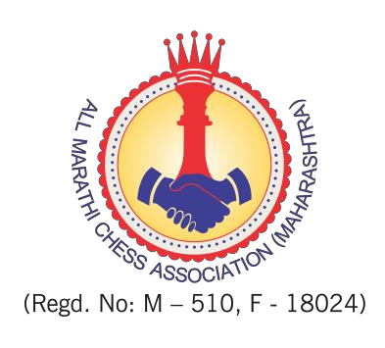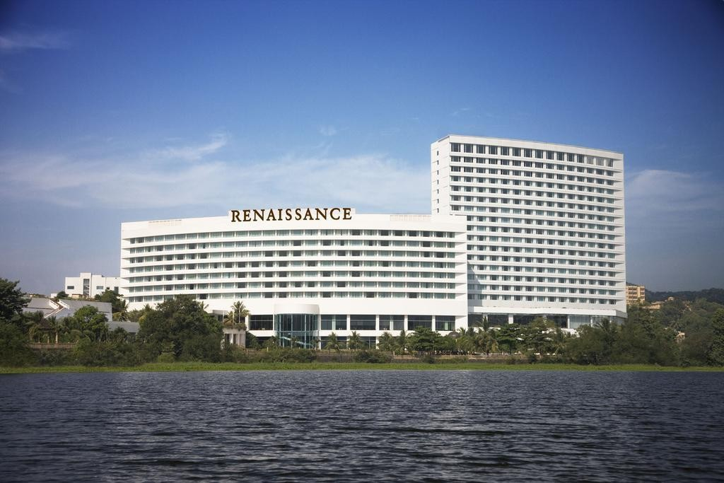

FIDE World Youth Chess Championships (U14, U16, U18 open & girls)
1 - 13 October 2019
Organised By

Venue

Renaissance Hotel and Convention Centre Mumbai, India

- INVITATION
REGULATIONS

This is the official invitation to all national chess federations of FIDE to participate in the World Youth Chess Championships 2019. The championships will be held in Renaissance Hotel and Convention Centre Mumbai. The dates are 1st October (arrivals, technical meeting) to 13th October 2019 (departures).

PARTICIPATION
2.1 Every National Federation can register one official player in each category (under 14, 16, 18 years old, open and girls). This total of six (6) Official Players plus one accompanying official (captain/trainer with a valid FIDE Trainer license) belonging to the national federation are invited by the Organizers. A player must not have reached his/her 14th, 16th or 18th birthday, respectively, before 1st January 2019.
2.2 The players placed 1-3 in the previous World Youth Championships, and the respective Champions of the 2018 Continental Youth Championships, shall have the personal right to participate in the World Youth Championships of the corresponding age-category or a higher age-category if the age stipulation of Art. 2.1 above is met. Such players shall also be classified as Official Players and have to be registered by the national federation.
2.3 Players, other than Official Players shall be classified as Additional Players. Each Federation can register up to 1/3 of the total participants of the championship. For example, in a tournament with 100 players the maximum number of players from any federation should not exceed 33. All other persons, other than players or the Accompanying Official, shall be classified as Accompanying Persons. The National Federation shall be responsible for all the costs of their Additional Players and Accompanying Persons.
2.4 In order to provide appropriate tournament conditions, the Federations must complete carefully the official online registration form and submit to the Organizing Committee by Monday, 2nd August 2019. After this deadline, the official players cannot be registered as invited players. Further participations may not be accepted or an additional fee will be requested according to the FIDE regulations.

FIDE ENTRY FEES
In accordance with FIDE regulations, a FIDE entry fee of 70 € (euros) for each Official Player and 140 € for each Additional player should be paid before the start of the tournament.
The National Federations must send this amount directly to the FIDE bank account or FIDE will charge the National Federation account card.

REGISTRATION AND TRAVEL
4.1 Each player (official, qualified or additional) and each accompanying official/person must pay to the Organizing Committee the amount of 100 € (euros) at the moment of their registration by 2nd August 2019. This registration fee is compulsory and represents a confirmation of participation, otherwise a registration will be invalid and will not be accepted. This payment includes transportation from and to Chhatrapati Shivaji Maharaj International airport (IATA code BOM), accreditation, identification badges and organization costs. The transportation is available on 1st of October (arrival) and 13th October (departure).

4.2 The deadline for registration is 2nd August 2019. After this date, organizers reserve the right to refuse or decline late registrations or a penalty of 80 € (Euros) for each late registration will be charged to participants.
4.3 Federations should register for official players by the above deadline of 2nd August 2019. After this date no official players will be accepted and their application will be treated as if they were additional players. Online registration password, if needed, will be provided to national federations.

4.4 Every registration must include the Federation, FIDE ID, surname, first name, accommodation type, dates of arrival/departure and the passport number of every player and every accompanying person who requires an invitation. It must also include the name, details and phone number/ address/ fax/ email of the head of each delegation. Incomplete registrations will not be accepted.

4.5 All the travel expenses must be paid by the participants or their Federation. Only member Federations of FIDE (not suspended, not in arrears) are entitled to submit registration forms.

4.6 The venue is the Renaissance Hotel and Convention centre Mumbai 4KMs from the international airport.

4.7 A player registered in a lower category of age due to a mistake in specifying his/her birthday will have his/her registration suspended until rectification.

FIDE TECHNICAL OFFICIALS
5.1 The Chief Arbiter will be announced later
5.2 FIDE Technical Delegate will be announced later.

OTHER REGULATIONS
6.1 Type of Clock: DGT 3000

6.2 Dress Code: As per FIDE Norms

6.3 Smoking: Smoking will be allowed in smoking area only. However, as per Indian Regulations persons below the age of 18 years are prohibited from smoking.

6.4 Electronic Devices, Wrist Watches & Pens: Mobile phones, electronic devices, wrist watches (all type of wrist watches) and personal pens are prohibited inside tournament hall.

INFORMATION ABOUT VISAS

7.1 Those who need visas must submit their data the latest on 2nd August 2019.
7.2 The Organizers will issue invitations only after all the pre-payments are made.

PAYMENTS
8.1 Entries must be submitted through the registration forms by 2nd August 2019
8.2 When registering (by 2nd August 2019), the registration fee of 100 € (euros) and a 30% prepayment of the cost for board and lodging shall be paid through the organizing agency’s bank account given.
Account beneficiary holder: All Marathi Chess Association

Account holder address: The Amaltas CHS Ltd. Juhu Versova Link Road, Versova, Mumbai-400053.

IBAN account number: 50100276768340

Bank name & address : HDFC Bank Ltd., Juhu Versova Link Road, Versova, Mumbai Branch.

IFSC Code: HDFC0000019

BIC/SWIFT code: HDFCINBB

8.3 Entry Fees for late registration, withdrawal or no show shall be charged as follow as per FIDE Regulations:

8.3.1 Late registration after the closing date : Two times of stipulated entry fee

8.3.2 Withdrawal after submission of registration : Two times of stipulated entry fee and one night’s hotel expenses.

8.3.3 No show after registration : Two times of stipulated entry fee and two night’s hotel expenses

8.4 Each National Federation will be invoiced by the organisers All Marathi Chess Association. Upon payments confirmed, the Organizing Committee will send to the participating Federation the confirmation of the hotel bookings. Confirmed registrations will then appear on the official website, where Federations may check players’ status on a daily basis.

8.5 All payments must be finalized upon arrival. Players will not be paired until all payments and fees are affected to the Organizing Committee.

HOTEL - BOARD & LODGING
9.1 The official hotel and venue of the event is the Renaissance Hotel and Convention Centre Mumbai.
9.2 Official players and head of delegation from each Federation are offered FREE full board accommodation from 1st October (arrival, lunch) to 13th October (breakfast, departure).
9.3 If a participating Federation does not send a player in any age category, they cannot substitute this for another age category.

9.4 As per FIDE regulations, all players and accompanying persons must be accredited and stay at the official hotel of the event. Bookings and accreditation are possible only through the procedure described in articles 8.1 to 8.4 above.
Hotel Rates for additional extra players and accompanying persons:
- in double rooms: 80 € (euros) per person per day, full board included.
- in single rooms: 115 € (euros) per person per day, full board included.
9.5 Each delegation shall distribute their delegation in an equal proportion of double rooms.
9.6 If needed, the final distribution of hotel rooms will be decided by the Organizing Committee.

TECHNICAL REGULATIONS

10.1 The tournament will be played using the Swiss System with 11 rounds. The national rankings will not be taken into account for pairings. The rate of play will be in accordance with the FIDE rules: 90 minutes for the first 40 moves followed by 30 minutes for the rest of the game with an addition of 30 seconds per move starting from move one. Default time is 15 minutes.
10.2 Tie break criteria: a) the games between the tied players (only if all tied have played each other), b) Buchholz cut 1, c) Buchholz, d) the greater number of games with black (unplayed games count as played with white), e) the greater number of wins.

10.3 No draw offers are allowed before 30 moves by each player, without the consent of the arbiter. All other regulations apply as per FIDE Handbook.

10.4 Chief Arbiter and FIDE Technical officials will be announced by 1st September 2019.

10.5 Direct Titles Available to Winners Subject to Rating Criteria

EVENT | GM/WGM | IM/WIM | FM/WFM | CM/WCM
World U18 | Gold – norm | 1st equal – title;  Silver & Bronze – norm | Silver & Bronze - title
World U16 |  | Gold – title;  1st equal – norm | Silver & Bronze - title
World U14 |  | Gold – norm | 1st equal – title | Silver & Bronze – title

10.6 FIDE over the board title norms are also possible for the other players based on their performance and their opponent’s titles/ratings as per FIDE Handbook requirements.

10.7 FIDE Anti Cheating Measures and guidelines are in effect during the championship.

APPEALS & APPEALS COMMITTEE

Protests against decisions of the Chief Arbiter or his assistants must be submitted in written form to the Chairman of the appeals committee within 30 minutes after the completion of the respective game. The protest must be accompanied with the sum of 200 € as a deposit from the signatory. The deposit must be handed to the Chairman of the appeals committee. If the appeal is granted, the sum shall be returned immediately. If the appeal is refused, the deposit is forfeited to the FIDE.

Appeals Committee will be announced later.

TOURNAMENT SCHEDULE

Tuesday | 1st October |  | Arrival of Delegations
Wednesday | 2nd October | 10.00 | Technical Meeting
 |  | 14.30 | Opening Ceremony
 |  | 15.00 | Round 1
Thursday | 3rd October | 10.00 | Round 2
 | 3rd October | 17.00 | Round 3
Friday | 4th October | 15.00 | Round 4
Saturday | 5th October | 15.00 | Round 5
Sunday | 6th October | 15.00 | Round 6
Monday | 7th October | 15.00 | Round 7
Tuesday | 8th October |  | Free day
Wednesday | 9th October | 15.00 | Round 8
Thursday | 10th October | 15.00 | Round 9
Friday | 11th October | 15.00 | Round 10
Saturday | 12th October | 10.00 | Round 11
 |  | 20.30 | Closing Ceremony
Sunday | 13th October |  | Departure of Delegations

- SECURITY
All delegations should abide by specific security regulations. The National federation shall be responsible for their delegations including damages to property.

TOURNAMENT BULLETIN
Daily there will be free e-bulletins with important information.

PRIZES
Three best Federations, by ranking of medals collected in all categories, will receive a trophy. For first place the number of gold medals will be taken under consideration, if there is a tie, then the number of silver medals, if there is still a tie, then the number of bronze medals. If finally this is still equal, then the total points of medallists will be taken for tiebreak.

Top three places in each tournament will be awarded with cups and medals. Places from 4th to 6th will receive medals. All the winners will be awarded with chess gifts.
All players will be given certificates of participation.
Prize Giving Ceremony will be the celebration, open to all with accreditation.

EXCURSIONS ON THE FREE DAY

- ELECTRICITY
The standard voltage is 220 Volts. Primary Socket Type: Type D (3 pin) plugs are used in India. Europlug and Schuko may also be used with or without an adapter.

WEATHER CONDITIONS

18.1 In the month of October weather in Mumbai will be rather fresh and the temperature around 31°C maximum and 24 °C minimum.

CURRENCY & EXCHANGE
19.1 The local currency is the INR (Indian Rupee). 1 USD is approximately Rs.70/- as on 1st January 2019.

CONTACT INFORMATION
Mr. Ravindra Dongre Tournament Director Mobile: +91 9820185231

Mr. Vijay Deshpande Organising Secretary Mobile: +91 9822954874

Mr.Vitthal Madhav
Secretary Mumbai Suburban District Chess Association Mobile: +91 9702273330
Official Website: http://www.worldyouthchess.com Email: wycc2019@gmail.com
Twitter: https://twitter.com/worldyouth2019

YouTube: World Youth Chess 2019

Facebook: https://www.facebook.com/World-Youth-Chess-Championships-2019-357652291631214

FIDE WORLD YOUTH CHESS CHAMPIONSHIPS-2019

Mumbai, India, 1st to 13th October 2019
Registration Form to be filled by the Players

(Please submit separate entry forms for each player or accompanying person)

Federation :
Name of Player: | Category

Title | FIDE ID |  | Rating | Passport No. |  | Validity
Nationality |  | Place & Date of Birth |  |  | Rooming:  Single Double

Name of Accompanying person (1) Male Female |  | Passport No. |  | Validity
Nationality | Place & Date of Birth |  | Rooming:  Single Double

Name of Authorized person of the National Chess Federation | Signature | Official Seal
Flight Details

Arrival Date: | Arrival Time:
Arriving From: | Flight No.:

FIDE WORLD YOUTH CHESS CHAMPIONSHIPS-2019
Mumbai, India, 1st to 13th October 2019
Registration Form to be filled by the Federation

Federation:
Address:

Telephone: Fax:

E-mail:

CATEGORY | INVITED | ADDITIONAL | TOTAL
Boys U-14
Boys U-16
Boys U-18
Girls U-14
Girls U-16
Girls U-18
Accompanying Persons

Name of Responding Official :
Please return this entry form by 2nd August 2019 to the following Email address:
Email: wycc2019@gmail.com

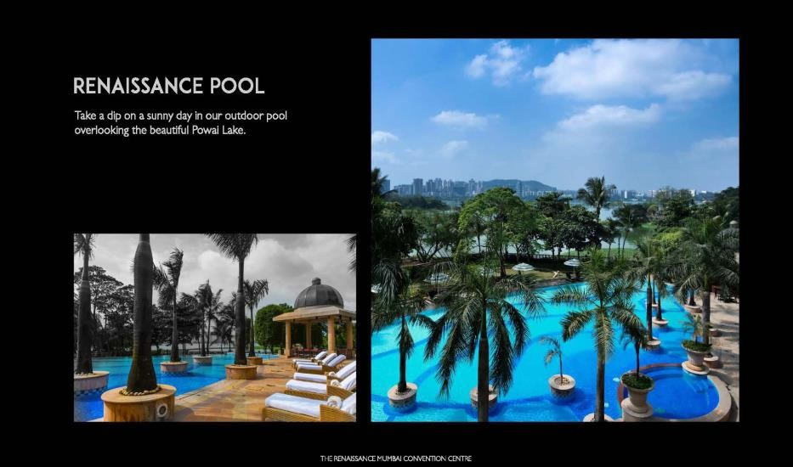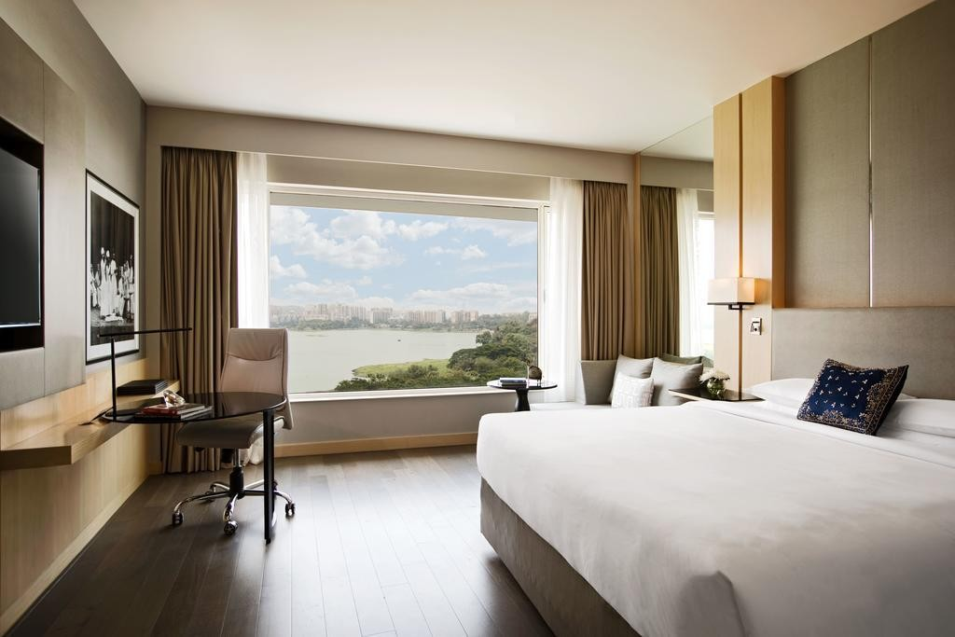OFFICIAL HOTEL
Renaissance Hotel and Convention Centre Mumbai, India
Website: www.renaissancemumbai.com

WORLD YOUTH CHESS CHAMPIONSHIPS-2019
01-13 October 2019, Mumbai

Regulations for Indian players

We are happy to announce that India will be hosting World Youth Chess Championships (Under-14, Under-16 & Under-18) at Mumbai from 01 to 13 October, 2019. In addition to the FIDE regulations, the following rules will apply to the AICF registered players who are desirous of participation.

All Medalist in the 2018 National Under- 13, 15 and 17 in Open & Girls chess championships will be eligible for whom the AICF will bear the entry fee, Board & Lodge, kit and 2nd A/C train travel will be reimbursed on production of original tickets.

1. Top 50 rankers in order of merit from the 2018 National Under-13 / Under-15 / Under-17 chess championships held at Ahemdabad / Kalyani / Sonipat respectively will alone be considered for participation in the championship. Those who have not finished among the top 50 in the above championships are not eligible for participation. However, exemptions are given to the following category of players.

Note: The following players will play as special entries.

(a) GM/IM/WGM/WIM in respective categories, as detailed below:

(i) All GMs in Open/WGMs (Female IMs) in Girls (As per order of rating as on 01 Aug 19) in respective age categories as per their age.

(ii) All IMs in Open / WIMs in Girls (As per order of rating as on 01 Aug 19) in respective age categories as per their age.

(b) 2018 World & 2018 Asian Medal Winners (Standard format) will be considered under special entries as detailed below

- Medal winners in Under – 10 are eligible to participate in Under – 14 category only

- Medal winners in Under – 12 are eligible to participate in Under – 14 or 16 category only

- Medal winners in Under – 14 are eligible to participate in Under –14 or 16 or 18 category

- Medal winners in Under – 16 are eligible to participate in Under –16 or 18 category

- Medal winners in Under – 18 are eligible to participate in Under –18 category only

2. As per FIDE guidelines, the total number of participation from one Country should not exceed 1/3 of the total number of participation. In this connection, only the top 50 ranked players in order of merit from the 2018 National Under-13 / Under-15 / Under17 chess championships held at Ahmedabad / Kalyani / Sonipat respectively alone will be considered for participation. Therefore, the AICF will entertain participation from players strictly on merit as per the following order. :-

(a) 2018 National Under-13/Under-15/Under-17 Open & Girls Chess champions in respective age category

(b) Players having personal right (seeding) as per the championship regulations.

(c) 2nd& 3rdin 2018 National Under-13/Under-15/Under-17 Open & Girls Chess champions in respective age category

(d) All GMs in Open/WGMs (Female IMs) in Girls (As per order of rating as on 01 Aug 19) in respective age categories as per their age.

(e) All IMs in Open / WIMs in Girls (As per order of rating as on 01 Aug 19) in respective age categories as per their age.

(f) 2018 Medal Winners in World Youth Championships mentioned in Para 1(b) as per order of merit.

(g) 2018 Medal Winners in Asian Youth Championships mentioned in Para 1 (b) as per order of merit.

(h)One host entry in each category (Player’s participation in respective national championship is mandatory and in consultation with AICF) as per merit.

3. All entries to be submitted online at www.aicf.in on or before 15 August 2019 with Rs. 12000/- towards FIDE Entry fee.

4 The AICF after finalizing the entries shall post the list on the AICF website http://aicf.in. Those not considered shall get back their money.

5. The short listed players will have to participate with the official uniform.

6. Special entry players should bear travel expenses, board & lodge on their own. However, the organizers can provide board and lodge on payment basis as per tournament regulations.

7. All players must be registered with AICF for the year 2019-2020.

