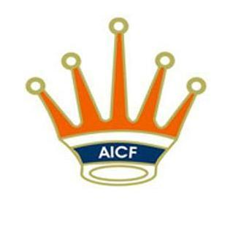

Presents:
33rd
Open&Girls
Chess championshipS
2019
HOST
Premises 01-0279 Plot No. DD 257 Road, Street Number 279, Action Area I,
Newtown, Kolkata, West Bengal 700156

June1st- 6th, 2019

AICF EVENT CODE: 216495 / 216496 / WB / 2019

Date: 1st June to6th June2019

Arrival: 31st May 2019.
Managers Meeting: 1st June 2019, 10:00 AM
Opening Ceremony: 1st June 2019, 10:15 AM

1. PLAYING SCHEDULE
ROUND | DATE | TIME | ROUND | DATE | TIME
1 | 1/06/2019 | 11:00 AM | 7 | 4/06/2019 | 10:00 AM
2 | 1/06/2019 | 4:00 PM | 8 | 4/06/2019 | 3:00 PM
3 | 2/06/2019 | 10:00 AM | 9 | 5/06/2019 | 10:00 AM
4 | 2/06/2019 | 3:00 PM | 10 | 5/06/2019 | 3:00 PM
5 | 3/06/2019 | 10:00 AM | 11 | 6/06/2019 | 10:00 AM
6 | 3/06/2019 | 3:00 PM | PRIZE DISTRIBUTION | 6/06/2019 | 3:00 PM

2. Age Limit: Players should be born on or after 1.1.2012

- Age Proof: Each participant must produce a valid certificate to prove his / her age. Certificates from School are not enough. Certificates should preferably be from the Panchayat, Municipality or Corporation obtained soon after birth. Players without date of birth certificates will not be allowed to participate.

- The date of birth certificates registered within one year of the birth of the child alone will be recognized and allowed to participate. No state association shall recommend any player who doesn’t come under the above criteria.

- If any doubt arises about the claimed age of a player, the Tournament Committee has the right to refer the player during the championship for a due evaluation of age by competent medical experts. A player if declared over-age by such experts shall not continue in the championship and the matter shall be reported to AICF. Protest about the age of players may be made to the Chief Arbiter in writing along with a fee of Rs.5000/- per player. This will not be refunded. No protest about over the age of a player will be entertained after 2ndround of the championship.

- Only the Coach or Manager deputed by participating State Chess Association can lodge such protests. The Tournament Committee has the right to decide the day, time and place for such medical evaluation of age. AICF / Organizers will have the right to refer any player to the medical evaluation of age at any time during the Championship. Players refusing to take the test as decided by the Tournament Committee shall be deemed to have failed the test and shall be disqualified from the Championship.

3. Prizes:

The cash prizes will be awarded to 20 players in each category amounting to Rs.2,00,000/- as below:

RANK | OPEN (AMOUNT IN RUPEES) | GIRLS (AMOUNT IN RUPEES)
1 | 26,000/- | 26,000/-
2 | 20,000/- | 20,000/-
3 | 13,400/- | 13,400/-
4 | 8,000/- | 8,000/-
5 | 5,400/- | 5,400/-
6 | 4,000/- | 4,000/-
7 | 2,000/- | 2,000/-
8 | 2,000/- | 2,000/-
9 | 2,000/- | 2,000/-
10 | 2,000/- | 2,000/-
11 | 2,000/- | 2,000/-
12 | 2,000/- | 2,000/-
13 | 1,400/- | 1,400/-
14 | 1,400/- | 1,400/-
15 | 1,400/- | 1,400/-
16 | 1,400/- | 1,400/-
17 | 1,400/- | 1,400/-
18 | 1,400/- | 1,400/-
19 | 1,400/- | 1,400/-
20 | 1,400/- | 1,400/-

4. Eligibility: Subject to age limit following players can participate:

- Two players in each category from every affiliated State Association of AICF. If any Association fails to send its quota, the vacancies so caused will not be filled.
- Top four players from 2018 National under 7 (Boys & Girls) Chess Championships are eligible to participate as seeded players in their respective categories subject to age stipulation.
- 2018 World Champion in any category subject to age stipulation.
- No. 2 & 3 in the World Under 8 championships 2018, subject to age stipulation.
- Top three rankers in the Asian Under 8 Championships 2018, subject to age stipulation.
- 2018 National Champion in any higher category subject to age stipulation.
- Any other player who remits the prescribed Special Entry Fee of Rs. 5,000 /-. But the entry should come through the respective Affiliated State Association.
- The AICF Secretary has a discretionary seat in each category in this Championship.
- The host BENGAL CHESS ASSOCIATION is entitled to fill one additional player in each category.
- Two players in each category approved by the AICF will be permitted from areas where no State Association exists.
- The winner and runner up of 2018 National U-7 girls are eligible to play in open section, subject to age stipulation.
- If the number of participants at the start of the championship is an odd number in a category, the host association can add one entry to make it even.
- In addition to the above, the following states can field additional seats, as their players had won Gold, Silver and Bronze medals in the previous National Under7 Chess Championships: Open: KARNATAKA(Gold)-3; MAHARASTRA (Silver)-2 and ODISSA (Bronze)-1: Girls: TAMIL NADU (Gold)-3; ANDHRA PRADESH (Silver)-2 and UTTAR PRADESH (Bronze)-1: . And these entries from the State Associations shall be given only from the Rank list of their respective State Championships with proof and not to anybody else.
- Only Indian Nationals are eligible to participate in the championship.

5. Dress Code:
As per AICF regulations on Dress Code for players participating in all the National championships, all State Associations should send their players including special / donor entry players with proper uniform (As regards special entry players, the respective state chess associations may collect the cost of the uniform from the players). Players should at least wear uniform T Shirts / formal shirts (same colour and brand with the name of the State printed prominently at the back and the state chess emblem in the front left side). The name / logo of the sponsors can be permitted. The above rule will also be applicable to Special units. Players without proper uniform will not be permitted to take part in the championship. This will be strictly enforced.

6. Entries/Entry Fee:
All entries including special entries should come through the concerned State Association. However, AICF will have the right to accept or reject any entry without assigning any reason. The Entry form should be sent together with attested copy of original date of birth certificate (Birth Certificates from Panchayat / Municipality / Corporation only accepted) and entry fee* only in online account given below.
Entry fee will be accepted strictly online through: http://aicf.in/national-tournament-registration/
For clarification and guidance regarding submission of entries, please contact: aicfnationalentries@gmail.com
*Entry Fee Structure: Ordinary entry: Rs.1000/- Special entry: Rs.5000/- There will be a 50% concession in entry fee for participants from North Eastern States, Andaman & Nicobar Island. The entries will be accepted by only online, details as given above. Please include a Xerox Copy of Birth Certificate with your entry.

Late Fee: Entries received after 10.05.2019 will be subject to a late fee of Rs. 250/-per player. However, no entry will be entertained after 16.05.2019.

*Since there is no separate National Championship for under 5, players for the Under 6 Asian Youth Chess Championship 2020, will be identified as per rankings from among the participants in the National under 7 Chess Championship 2019 subject to their age. Therefore, those planning to participate in the Asian Youth Under - 6 - 2020 (if held) should participate in the National Under - 7 Chess Championship 2019 to be eligible for consideration.

7. System of Play: The Championship will be played under FIDE’s Laws of Chess and the Swiss system. Totally eleven rounds shall be played.

Players from the same state shall not be paired against each other in the last round of a National championship, except National Premier and Women Premier. However, they may be paired if there is no compatible opponent with the same point group or score group with a maximum difference of 1 point. It is applicable only for the top 50% score of the penultimate round.

8. Default Time: Default time for arriving to the chessboard is 15 minutes.

9. Time Control: The rate of play shall be 90 minutes with an increment of 30 seconds per move from move number one.

10. Draw Agreement: Players shall not agree for a draw without the consent of the arbiter, before each player makes 30 moves. Electronic Devises In addition to the usual regulations for mobile phones and electronic devises, players are forbidden to wear any kind of wristwatch. Players wearing watches will be declared lost.

11. Chess Clocks: Each participating State Chess Association must provide at least one clock in working order for every two players entered into the Championship.

12. Tie Break: Following is the order of tie-break: 1) Direct encounter 2) Buchholz Cut 1 3) Buchholz 4) Sonneborn Berger 5) The greater number of wins (forfeit included) In case of tie, cash prizes will not be shared.

13. Protest: Protest, if any, against the decision of the Chief Arbiter shall be made in writing with a protest fee of Rs.1000/-within 30 minutes of the occurrence of the incident. The protest fee will be refunded if the appeal is upheld.

14. Appeals Committee: Before the commencement of the tournament, a five member appeals committee shall be formed by the AICF/organizers. All the members and reserves shall be from different states. No member of the Committee can vote on a dispute in which a player from his own State is involved and in such case(s) the reserve member(s) shall take his place in the committee.

15. Tournament Committee: The organizers will form a tournament committee for the smooth conduct of the National Championship.

16. Interpretation: For interpretation of the rule(s) and deciding any point not covered by the above rules of the tournament, the decision of the Tournament Committee shall be final and binding on all. The Tournament Committee has every right to make any addition or amendment to these rules, without notice. However, such changes/ or inclusion will be subject to AICF clearance. Such changes will, however, be displayed in the tournament hall.

17. Withdrawal: If any player withdraws from the last two rounds in any National Championship on medical grounds, he/she should undergo treatment by a Doctor recommended and supervised by the tournament committee.

18. Disqualification: No participant will leave the venue before the Prize Distribution function without the permission of the Chief Arbiter. The participants disregarding this rule will be suspended for one year.

19.AICF REGISTRATION: The participants are informed that AICF player’s registration is mandatory and it should be done well before participating in any tournament. For renewal of AICF Registration of existing players, please see the link http://aicf.in/players/ and for fresh AICF registration, please the link htpp://aicf.in/online-player-registration/ Note: One passport size (less than 1 MB) photograph in jpeg format should be uploaded.

20. Arrears:
All arrears of affiliation fee/tournament fee including those of current year must be cleared by the Affiliated Association at the time of submitting the entries; otherwise the entries are liable to be rejected.

21. Lodging:
Free Dormitory accommodation shall be provided to seeded/ selected players (normal entries) and one accompanying official (Manager) nominated by the concerned State Chess Association.

The official accommodation shall be provided only through prior intimation to the lodging in charge by email. No request for lodging will be entertained after the last date.
Special entries and other accompanying persons should make their own arrangement for their stay.

IMPORTANT CONTACTS:
HOSPITALITY PARTNER

For rooms and accommodation at
Discounted rates and special offers for
National Under 7 Chess Championship
Please contact:

AYUSHMAN (7891575971)
SATISH (98186 28721) FOR 4* AND 5*
OFFICIAL ACCOMMODATION:
ANTARIP ROY (09051298038)
nu7kolkata@gmail.com

OTHER QUERIES:
SOUVIK CHAKRABORTY (09051054136),
nu7kolkata@gmail.com

IN CASE OF EMERGENCY: ATANU LAHIRI, SECRETARY, BENGAL CHESS ASSOCIATION, (08961617966)

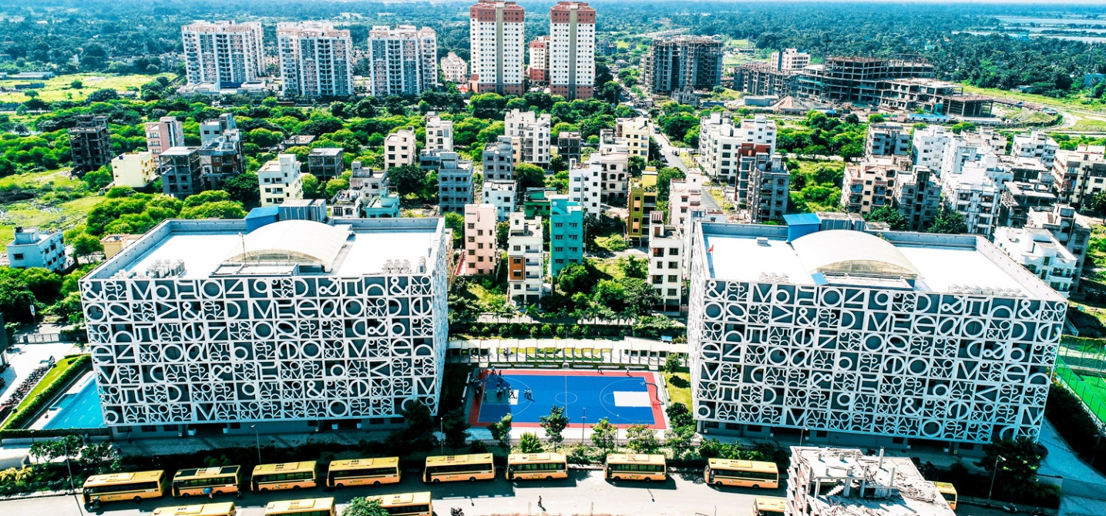
THE NEWTOWN SCHOOL

33rdNational Under-7 Open &33rdNationalUnder-7 Girls Chess Championships-2019

To:
The Divisional/ Commercial /Area Superintendent,

………………………Railway………………

Dear Sir,

Sub: Rail Concession

This is to certify that the following players and officials are bona-fide participants of the “33rdNational Under-7 Open & 33rd National Under-7 Girls Chess Championships-2019” to be organized by us onbehalf of All India Chess Federation at Kolkata from 1st to 6th June,2019. This is a recognized event of the All India Chess Federation.

Sr. | Name of the Player | Date of Birth
No.
1
2
3
4
5

We therefore, request the Rail Concession order may please be issued to them to travel from _____________________to Kolkata and back. The game of Chess is recognized for Rail Concession by the Railway Board by their letter no TC/11I2035/76, dated 5th April 1971.

Thanking you.

Yours sincerely,

(Mr. Atanu Lahiri)
Secretary

Bengal Chess Association

