

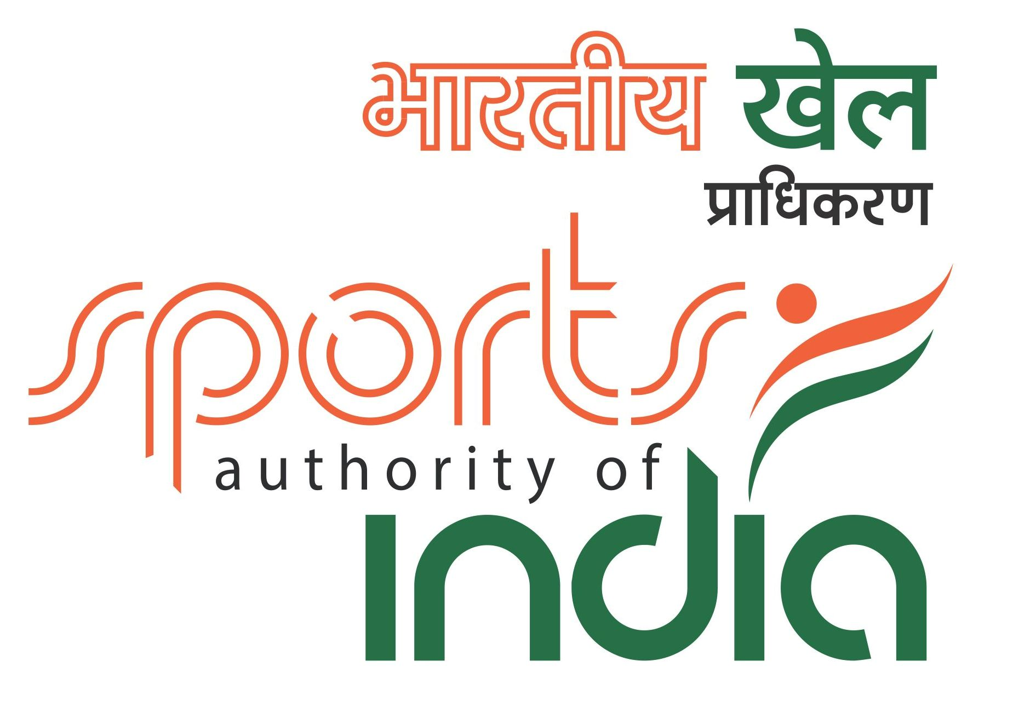





**NATIONAL RAPID & BLITZ CHESS CHAMPIONSHIPS–2019**

**Event Code:**  **213375 /** **213376 / PUN / 2019**

**: Date :**

**25th to 28th May, 2019**

**Organised by**

**Jalandhar Chess Association**

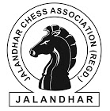

**Under the aegis of**

**Punjab State Chess Association &**

**All India Chess Federation**

**Venue: Lovely Professional University,Jalandhar - Delhi G.T. Road, Phagwara, Punjab 144411**



1. **Tournament Schedule:**

**RAPID**

|  |  |  |  |  |
| --- | --- | --- | --- | --- |
| **Particulars** | **Date** | |  | **Time** |
| Arrival | 24-May-2019 | |  | 1700 hrs. |
| Managers’ Meeting | 25-May-2019 | |  | 1000 hrs. |
| Inauguration | 25-May-2019 | |  | 1100 hrs. |
| Round – 1 | 25-May-2019 | |  | 1400 to 1500 hrs. |
| Round – 2 | 25-May-2019 | |  | 1600 to 1700 hrs. |
| Round – 3 | 25-May-2019 | |  | 1800 to 1900 hrs. |
| Round – 4 | 26-May-2019 | |  | 0900 to 1000 hrs. |
| Round – 5 | 26-May-2019 | |  | 1100 to 1200 hrs. |
| Round – 6 | 26-May-2019 | |  | 1400 to 1500 hrs. |
| Round – 7 | 26-May-2019 | |  | 1600 to 1700 hrs. |
| Round – 8 | 27-May-2019 | |  | 0900 to 1000 hrs. |
| Round – 9 | 27-May-2019 | |  | 1100 to 1200 hrs. |
| Round – 10 | 27-May-2019 | |  | 1400 to 1500 hrs. |
| Round – 11 | 27-May-2019 | |  | 1600 to 1700 hrs. |
|  |  | **BLITZ** | |  |
|  |  | | |  |
| **Particulars** | **Date** | |  | **Time** |
| Round – 1 | 28-May-2019 | |  | 0900 hrs. |
| Round – 2 | 28-May-2019 | |  | 0930 hrs. |
| Round – 3 | 28-May-2019 | |  | 1000 hrs. |
| Round – 4 | 28-May-2019 | |  | 1030 hrs. |
| Round – 5 | 28-May-2019 | |  | 1100 hrs. |
| Round – 6 | 28-May-2019 | |  | 1130 hrs. |
| Round – 7 | 28-May-2019 | |  | 1200 hrs. |
| Round – 8 | 28-May-2019 | |  | 1230 hrs. |
| Round – 9 | 28-May-2019 | |  | 1400 hrs. |
| Round – 10 | 28-May-2019 | |  | 1430 hrs. |
| Round – 11 | 28-May-2019 | |  | 1500 hrs. |
| Prize Distribution | 28-May-2019 | |  | 1630 hrs. |
| Departure | 28-May-2019 | |  | 1730 hrs. |

1. **Dress Code:** As per AICF regulations on Dress Code for players participating inall the National Championships, all State Associations should send their players including Special / Donor entry players with proper uniform (As regards special/donor entry players, the respective state chess associations may collect the cost of the uniform from the players). Players should at least wear uniform T Shirts / formal shirts (same colour and brand with the name of the State printed prominently at the back and the state chess emblem in the front left side). The name / logo of the sponsors can be permitted. Girls / Women to be also given appropriate uniform dress. The above rule will also be applicable to

Special units. Players without proper uniform will not be permitted to take part in the championship. This will be strictly enforced.

1. **Cash Prizes:**

|  |  |  |  |  |  |  |  |  |
| --- | --- | --- | --- | --- | --- | --- | --- | --- |
|  | **Prizes: National Rapid** | | | | **Prizes: National Blitz** | | |  |
| **Total Cash Prizes: Rs.1,75,000/-** | | | | | **Total Cash Prizes: Rs.75,000/-** | | |  |
|  | **Main Prizes** | |  |  | **Main Prizes** | |  |  |
|  | 1st | 50000 |  |  | 1st |  | 20000 |  |
|  | 2nd | 25000 |  |  | 2nd |  | 12000 |  |
|  | 3rd | 15000 |  |  | 3rd |  | 9000 |  |
|  | 4th | 10000 |  |  | 4th |  | 6500 |  |
|  | 5th | 8500 |  |  | 5th |  | 4000 |  |
|  | 6th | 7500 |  |  | 6th |  | 3000 |  |
|  | 7th | 6500 |  |  | 7th |  | 3000 |  |
|  | 8th | 6000 |  |  | 8th |  | 2500 |  |
|  | 9th | 5000 |  |  | 9th |  | 2500 |  |
|  |  |  |  |  |  |  |  |  |
|  | **10**th | 4000 |  |  | **10**th |  | 2500 |  |
|  |  |  |  |  |  |  |  |  |
|  | 11th**–** 25th | 2500 |  |  | 11th**–** 15th |  | 2000 |  |



1. **ELIGIBILITY:**
   1. Every affiliated State Association/Institutional members of the All India Chess Federation shall be entitled to send two entries in each category. If any association / affiliated unit fail to send its fill quota, the vacancies so caused shall not be filled.
   2. All Grandmasters, International Masters and Women Grandmasters.
   3. Top 4 from the previous National Rapid& Blitz chess championships in their respective category.
   4. The host shall be entitled to fill an additional one player in each category.
   5. Two players in each category from areas where no State Chess Association exists. Players from such areas shall write to Hon. Secretary, All India Chess Federation, Hall No.70, Jawaharlal Nehru Stadium, and Chennai for their entries.
   6. For Rapid any player who remits the prescribed special entry fee of Rs.2,000/- . For Blitz any player who remits the prescribed special entry fee of Rs.1,000/-. Such entries should come through the respective affiliated State Association.
   7. The Secretary of the All India Chess Federation can nominate one player in each category.
   8. If the total number of entries is an odd number, then the host association may add one more entry in the respective category to make it an even number.

**5. ENTRIES & ENTRY FEES:**

|  |  |  |
| --- | --- | --- |
| **Category** | **Rapid** | **Blitz** |
| Ordinary | 1,000/- | 500/- |
| Special | 2,000/- | 1,000/- |

There will be 50% concession in entry fee for participants from North Eastern States and Andaman & Nicobar Islands.

**All entries including Special entries should come through the concerned State Association.** However, the AICF will have the right to accept or rejectany entry without assigning any reason.

**For more details please contact:**

Mr. Muneesh Thapar, Hon. Secretary, Punjab State Chess Association & Jalandhar Chess Association, C-104,Hamilton Towers,Near Wadala chowk Nakodar road, Jalandhar INDIA. (M) +81467 29999

E-mail: jalandharchess@gmail.com

**Entry fee will be accepted strictly online through:**

**http://aicf.in/national-tournament-registration/**

**For clarification and guidance regarding submission of entries, please contact: aicfnationalentries@gmail.com**

**Last date of submission of entries with out late fee is 03rdMay, 2019.**

Late entries will be accepted with a late fee of Rs.250/- per participant till **10thMay, 2019.** No entry will be entertained after **10th May, 2019.**

1. **System of Play:** The Rapid Championship shall be played under the FIDE’slaws of Chess (Rapid Rules) and the Swiss System. Totally eleven rounds shall be played.

The Blitz Championship will be played under the FIDE’s laws of Chess (Blitz) and the Swiss System. Totally eleven rounds shall be played.

Players from the same state shall not be paired against each other in the last round of a National championship, except National Premier and Women Premier. However, they may be paired if there is no compatible opponent with the same point group or score group with a maximum difference of 1 point.

1. **Default Time:** For Rapid & Blitz - The “Zero Tolerance” rules will be followedi.e. “Any player who arrives at the chessboard after the start of the session shall lose the game. Thus the default time is zero minute.
2. **Time Control:** In the Rapid Championship, each player will have 15 Minutes +10 seconds additional time per move, starting from move 1.

In the Blitz Championship, each player will have 3 Minutes + 2 seconds additional time per move, starting from move 1.

**9.Chess Clocks:** Each participating State Chess Association must provide at leastone clock in working order for every two players entered into the Championship.

**10. Tie Break**: Following is the order of tie-break:

* 1. Direct encounter
  2. Buchholz Cut 1
  3. Buchholz
  4. Sonneborn Berger
  5. The greater number of wins (forfeits included)

In case of tie, cash prizes will not be shared

1. **Tournament Committee:** The organizers will form a tournament committeefor the smooth conduct of the National Championship.
2. **Protest:** Protest, if any, against the decision of the Chief Arbiter shall be madein writing with a protest fee of Rs.1,000/- within 10 minutes of the occurrence of the incident. The protest fee will be refunded if the appeal is upheld.
3. **Appeals Committee:** Before the commencement of the tournament, a fivemember appeals committee shall be formed by the AICF/Organizers. All the members and reserves shall be from different states/affiliated units. No member of the Committee can vote on a dispute in which a player from his own state/affiliated unit is involved and in such case(s) the reserve member(s) shall take his place in the committee.
4. **Withdrawal:** If any player withdraws from the last two rounds in any NationalChampionship on medical grounds, he/she should undergo treatment by a doctor recommended and supervised by the tournament committee.
5. **Disqualification:** No participant will leave the venue before the PrizeDistribution function without the permission of the Chief Arbiter. The participants disregarding this rule will be suspended for one year.
6. **Interpretation**: For interpretation of the rule(s) and deciding any point notcovered by the above rules of the tournament, the decision of the Tournament Committee shall be final and binding on all. The Tournament Committee has every right to make any addition or amendment to these rules, without **prior** notice. **However, such changes should be approved by the AICF**. Such changes will, however, be displayed in the tournament hall.
7. **Registration of Players:** All participants in the National Championship shouldbe registered with AICF for the year 2019-20 through online **www.aicf.in.** No player shall be paired in the first round if they have not registered with AICF. Those who have already obtained registration cards from AICF website for 2019 -20 should send photo copy of the same. Those who have paid the AICF Registration fee but are yet to receive the AICF Registration card should send a photo copy acknowledgement for having paid the fee to organizers of earlier tournaments or to their association.

Participants from the Punjab State are required to obtain PSCA Registration for the year 2019 by sending an amount of **Rs.150/- towards PSCA registrationfee** along with the duly filled and signed PSCA player's registration form plusone passport size photograph along with Birth Certificate copy in addition to the entry fees.

1. **Arrears:** All arrears of affiliation fee/tournament fee including those of currentyear must be cleared by the Affiliated Association at the time of submitting the entries; otherwise the entries are liable to be rejected.
2. **LODGING:** Free dormitory accommodation will be provided from 24stto 28thMay,2019 to the selected/seeded players (normal entries) and one accompanying official (Manager/Coach) nominated by the concerned State Chess Association of each State. Accompanied persons have to make their own arrangement.

**For accommodation of Special entries and other accompanying persons, you can contact Mr. Varun Kumar on (M) +91 90419 38868 and e-mail: varunrandhawa3008@gmail.com**

**Organizing Committee**

**Mr. Narinder Singh**

**President, Punjab State Chess Association**

**Mr. Muneesh Thapar**

**Hon. Secretary, Punjab State Chess Association**

|  |
| --- |
| **Dr.JS Cheema** |
| **Mr. Ashwani Tiwari** |
| **Mr.Sapan Bedi** |
| **Mr. Kirti Sharma**  **Mr. Rajinder Sharma** |

**: For General Enquiry:**

**(E-mail: jalandharchess@gmail.com)**

**Kirti Sharma (M) 98722-74817**

**: For Accommodation:**

**Varun Kumar (M) 90419-38868**

To:

The Divisional/ Commercial /Area Superintendent,

………………………Railway………………

Dear Sir,

**Sub: Rail Concession**

This is to certify that the following players and officials are bona-fide participants of the “**National Rapid & Blitz Championships- 2019”** to be organized by us on behalf of All India Chess Federation at Jalandhar from **25th to 28thMay, 2019.** This is a recognized event of the All India Chess Federation.

|  |  |  |
| --- | --- | --- |
| Sr. | Name of the Player | Date of Birth |
| No. |  |  |
| 1 |  |  |
| 2 |  |  |
| 3 |  |  |
| 4 |  |  |
| 5 |  |  |

We therefore, request the Rail Concession order may please be issued to them to travel from _____________________to Jalandhar and back. The game of Chess is recognized for Rail Concession by the Railway Board by their letter no TC/11I2035/76, dated 5th May 1971.

Thanking you.

Yours sincerely,

***(Mr. Muneesh Thapar)***

***Hon. Secretary***

***Punjab State Chess Association &***

***Jalandhar Chess Association***